

**SSTRAI Membership Renewal 2018**

The Salmon & Sea Trout Recreational Anglers of Ireland is an all-Ireland federation of affiliated recreational game angling clubs.

Our aim is to

• represent recreational angling clubs in all aspects of the sport and to work towards an abundance of salmon and trout stocks.

• To promote environmentally friendly habitat restoration in all districts.

• To provide up to date relevant information on national and international matters concerning salmon and trout.

• To promote the recreational sport of angling throughout Ireland

www.sstrai.ie

   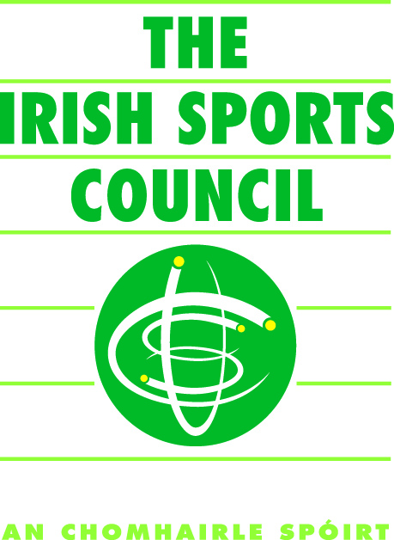 

Supported by Inland Fisheries Ireland 



**SSTRAI Club Membership Renewal 2018**

Club Name: ____________________ Phone number _____________________

Secretaries Name: ________________ E-mail Address _________________________

Please print

Address:

Club Children’s Officer Name:______________________ Phone Number _____________________

E-mail Address ______________________________

Please print

**Insurance requirements 2018: We have Public Liability cover to €6.5 million as this is now the limit required by state agencies such as Inland Fisheries Ireland and County Councils for development projects and leases etc. Public Liability cost €3.00 per member. Personal accident cover which is optional also costs €2.00 per member. Please note to avail of personal accident cover all club members must be covered on the club personal accident policy.**

Membership details, these are required for two purposes, firstly insurance and secondly for the Irish Sports Council annual return of membership to show participation in angling sport.

**NB** Please note an up to date register of membership must be maintained by all affiliated clubs. The figures required below are for 2017 and should be available from the clubs 2017 register of members. Where clubs expect an increase or decrease in membership please allow for this in the table below. Should additional membership cover be required please inform SSTRAI treasurer and he will make arrangements for the additional cover as necessary.

.

|  |  |  |  |
| --- | --- | --- | --- |
| Total number of  Members  A ( ) | Total number of Juveniles U18  B ( ) | Maximum number of Day Tickets sold in any one day  C ( ) | Total A+B+C  __________ |

Total for Public Liability and Personal Accident cover is €5.00 per member i.e. A+B+C ______ @ €5 = €_______

Note: The Personal Accident cover is optional however it is highly recommended, if your club does not require

Personal Accident cover then the Public Liability is Total A+B+C _____ @ €3.00 = € ___________



**Angling Council Ireland Capitation Fee**

**Angling Council Ireland Capitation Fee:**

SSTRAI as members of the ACI are required to pay a capitation fee of €2.00 per adult member. This is required to assist the ACI in its administration, Child Welfare and Protection, development of angling coaching in association with the National Coaching Development Programme for Ireland, Angling for Youth Development AFYD (Irl.), National and International representation. SSTRAI has 3 representatives on the Angling Council of Ireland.

**Angling Council Ireland Register:** Please record the number of all members (Full / Associate). The capitation rate is €2.00 per adult member. i.e. total in Colum C x 2 and entered in the capitation fee section below.

|  |  |  |  |  |  |
| --- | --- | --- | --- | --- | --- |
| A  No of males O/18  _______ | B  No of females O/18  __________ | C  Total no of members O/18  ________ | D  Total number of males U/18  _________ | E  Total number of females U/18  _________ | F  Total number of U /18 members  ________ |

|  |  |  |  |  |  |  |  |  |
| --- | --- | --- | --- | --- | --- | --- | --- | --- |
| Affiliation Fee @ €110  110 | Insurance  Total  ______ | | Capitation Fee @  €2.00 for each adult member  ______ | | Total  ______ | Signed on behalf of club  ______________ | For SSTRAI use: Received by; ……………  Date received  … ………..  Amount received €…………………..  Receipt &Insurance Policy issued date………………….. | |
| €110.00 | | €_______ | | €_________ | € _________ | | |  |

SSTRAI individual membership cards will be issued in bulk to club secretaries on receipt of payment. Cards will have insurance details on them. They can be used to produce evidence of insurance to land owners and for entry to ACI /SSTRAI events and competitions.

|  |
| --- |
| No of disabled angler members or associated members |

Please complete the summary below and send with payment to SSTRAI treasurer Ed Stack, Richmond Bleach Road Kilkenny

E-mail ed.c.stack@gmail.com Phone 056 7765220 Mobile 0863005667