Salmon & Sea Trout Recreational Anglers of Ireland

23
Secretary’s Report Annual General Meeting April 2023
Bob Seward

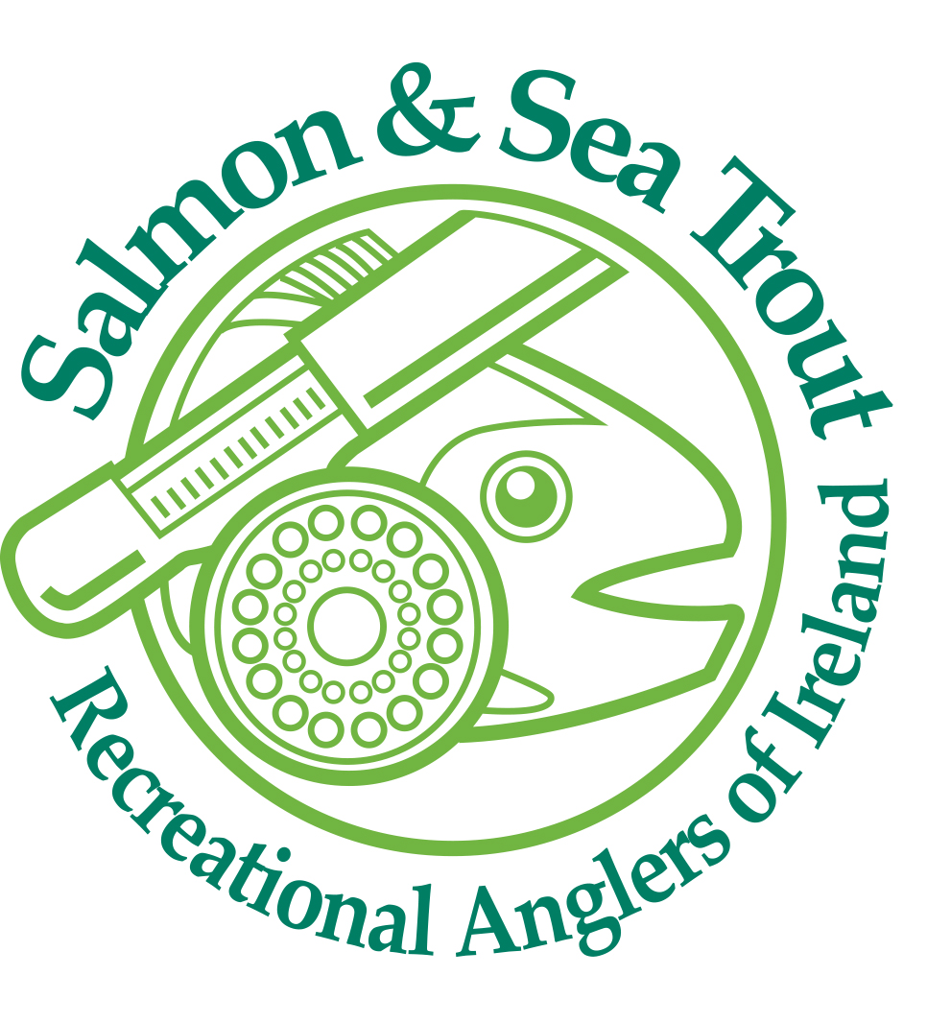

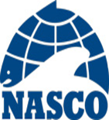 North Atlantic Salmon Conservation Organisation

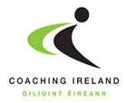Sport Ireland Coaching

Sport Ireland

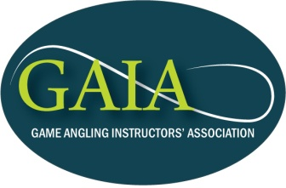

Game Anglers Instructors Association

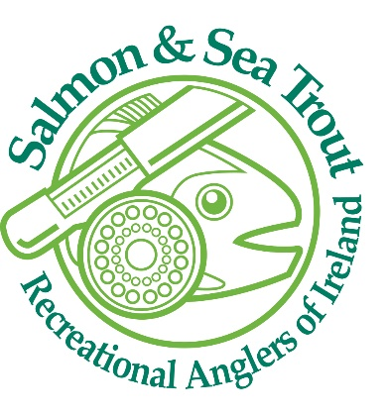 SSTRAI | SSTRAI  ACI Offices  Sports HQ  National Sports Campus  Blanchardstown  Dublin 15  E-mail secretary@sstrai.ie  Phone 00353 85 8436459
Annual Secretary’s Report 2022
I wish to begin by thanking the SSTRAI executive committee members and member clubs for their full support throughout 2022, It has been a pleasure working with such dedicated members. The unity of the organisation has enabled us to grow year on year, we have again attracted a good number of new clubs allowing us to develop in line with our strategy and to deliver on many of our goals for 2022. Thankfully we are over the worst of the effects of Covid 19. We are well placed now going forward in 2023.

I am delighted to report again there were no angler accidents recorded in 2022 or to date and again wish to take this opportunity to remind all anglers to ensure that safety is given serious consideration in planning and participation in all aspects of our angling sport. Recent drowning tragedies each year bring home the message loud and clear to members that safety must be promoted, considered and managed at all levels to protect our members and particularly new members to the sport. Health & Safety and Child Protection should be the first items on the agenda of all SSTRAI club meetings.
The SSTRAI Club Safety Policy was updated in 2022 and again an updated safety statement is available for clubs who are acting as employers for contractors etc. during 2023. This is particularly important for contractor work schemes such as the salmon conservation funded projects or indeed any other development projects where risk exists. The Safety Statements are available to all affiliated angling clubs. Boat certification and suitability in terms of carrying capacity and the waters it will be used on are critical decisions when boats are being purchased however, they are very often overlooked and the results can be catastrophic. SSTRAI has acquired 2 new sea angling boats for our Cork city Lee to Sea angling project. Lee Adventurer and Lee Explorer, these are 2 Jeanneau Cap Camarats 6.5 Mtr Centre Console boats.
We are delighted with the support we received from Sport Ireland, the National Lottery, and the Department of Tourism, Culture, Arts, Gaeltacht, Sport and Media. We have taken delivery of the second boat now and it shall be launched very shortly once some minor works are completed at the Cobh Marina.
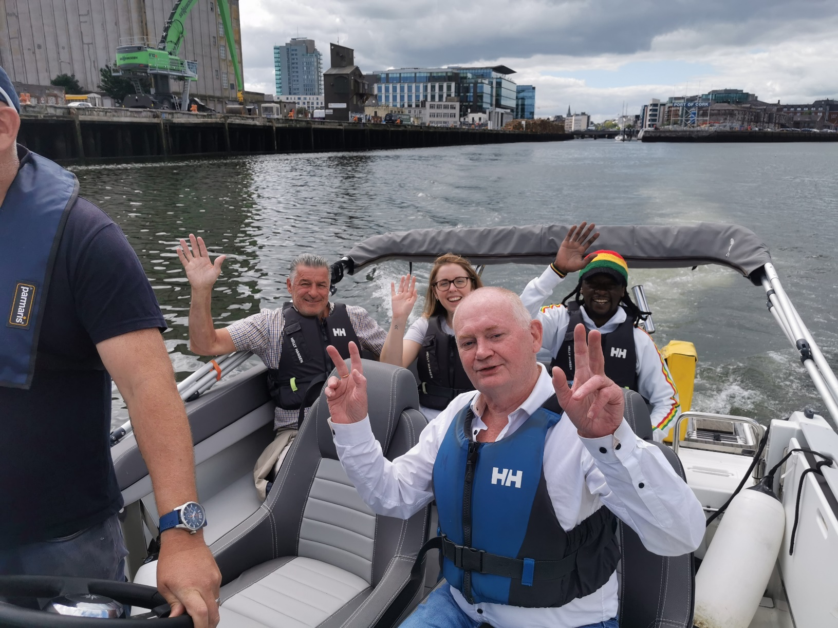
Headway Acquired Brain Injury Angling group leaving Cork City onboard Lee Adventurer for a harbour angling trip as part of our Inclusion Programme during summer 2022.
As part of safety training, we have a number of members trained up to ISA powerboat level 2, I at level 3 and we have a number of members trained and qualified also on VHF. Boat skippers and crew must be qualified and this is SSTRAI policy and those named and approved can only sail the boats. SSTRAI has insured the 2 boats and this also required certain conditions to be met. SSTRAI has arrangements with the RNLI to conduct life jacket (PFD) checks at local club and regional level. We have also introduced the Cold Water Shock DVD as part of our club safety pack with kind permission of the RNLI. In addition to the safety equipment being used for coaching (throw ropes PFD’s, safety glasses and caps) we have now made arrangements through the ACI with a supplier for the compact Life Jackets at a reduced cost for members. Minimum order is (10) we can consolidate for member clubs if required. These are available now and all clubs who need them should avail of them. All life jackets must be inspected and tested annually, we all have a duty of care to ensure this is being carried out correctly and we must take full responsibility for people in our care. An unserviced lifejacket may fail and could result in loss of life.

The Maritime Safety Directorate and the Irish Coast Guard have developed a Code of Practice “ The Safe Operation of Recreational Craft”, this document is very detailed and divided into sections for ease of use depending on the type of craft being used. I would highly recommend this code and advise you to keep up to date with Marine Notices from the Department of Marine. There are a number of statutory requirements for recreational craft and members should be aware of them for their own safety and those of others. For full details follow the link below. http://www.dttas.ie/marine/MaritimeSafetyDirectorate/index.asp
In association with the Angling Council of Ireland, Inland Fisheries Ireland and Angling for Youth Development (Ireland) (AFYD), we have developed a wading safely and river rescue training programme that we have rolled out now for a number of years as part of our coach continuous professional development plan. Two courses are planned for 2023. Courses are available to all affiliated clubs in 2023 not just coaches. Keep an eye on the SSTRAI website www.sstrai.ie. and ACI website www.anglingcouncil.ie for course dates.
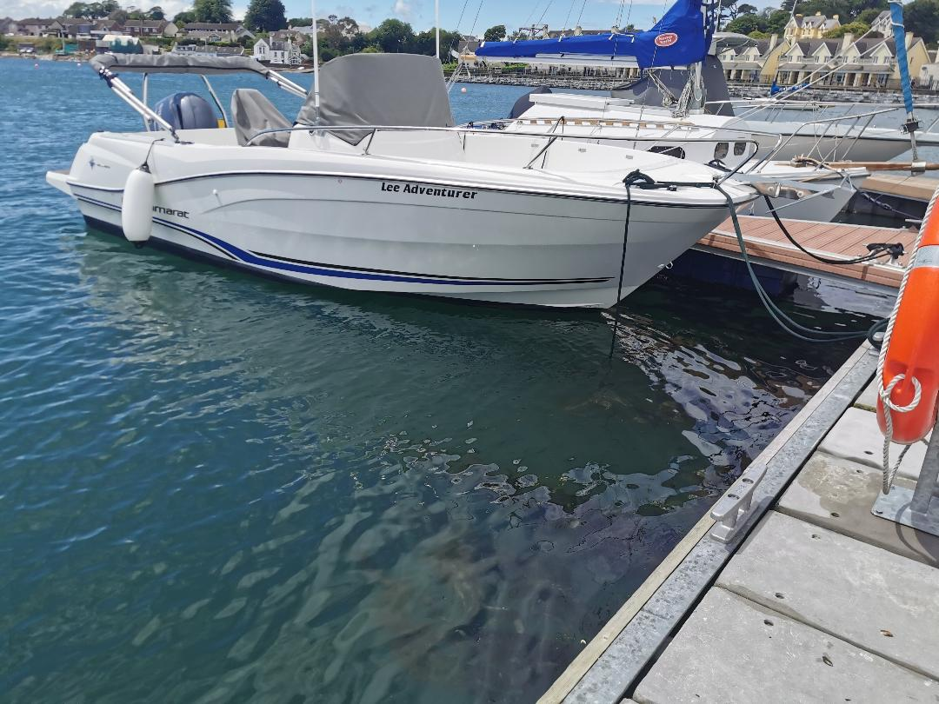
Lee Adventurer tied up at the Cobh Marine
SSTRAI have held many meetings throughout the year and our delegates represented the federation at events throughout the country.
During 2023, SSTRAI delegates held three positions on the Angling Council of Ireland, Martin Mc Enroe as Vice Chairman and Chairman I as Treasurer & Safety Officer, and Jonathan Rice as Hon Secretary. I am also a member of the Coach Tutor Team. Since the AGM Andrew Morgan has now taken on the role of Treasurer ACI and I am working as the Administrator, Vetting, H&S and Coach Co-ordinator. John O Brien is also working now with the ACI coach tutor team and it is great to have him onboard.
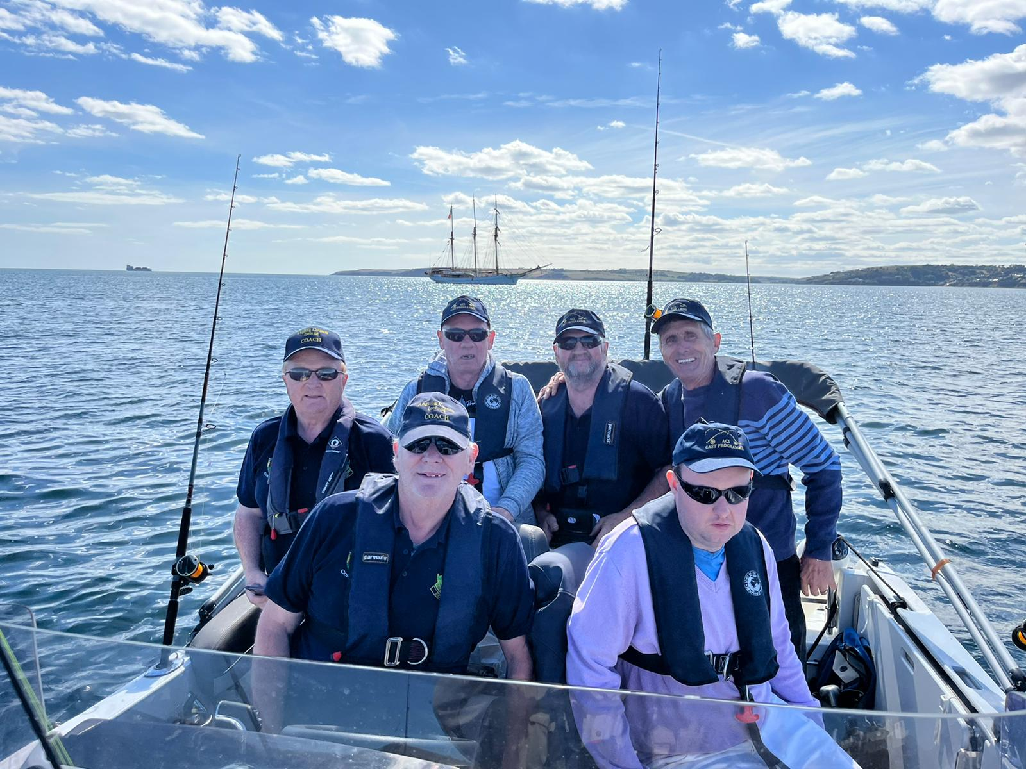
Members of the Organisation of National Ex-service Personnel who have now formed a new club affiliated to SSTRAI enjoyed a few days out in the harbour fishing in superb weather last season.
We have worked hard on behalf of SSTRAI and have made a very positive contribution to the success of the ACI. As ACI National Childrens Officer I am aware some clubs have yet to complete the Safeguarding Audit, this is most important. ACI itself has passed the Audit however, without full club compliance we will not be sure of where we stand in terms of full compliance, It only takes a few minutes to complete the survey.
We have worked with our colleagues in the ACI and have set up the Angling Consultative Council Ireland under the Department of Environment, Climate and Communications. We have attended meetings over the past year and are meeting again next Tuesday week in Dublin. We have worked through a detailed works programme dealing with national angling issues. SSTRAI through the ACI continue to be represented on the committee of Comhairle Na Tuaithe (Rural Recreation Section) and the National Water Forum. This provides us with great opportunities for direct contact and to participate in the decision-making processes that impact on our sport.
NASCO NGO meetings have been attended by Paddy and Martin in Scotland. Face to face meeting will be the norm again for 2023. SSTRAI has been invited to meet for the Year of the Salmon conference in Canada in October and Bob and Jonathan were nominated for this.
SSTRAI continues to support Salmon Watch Ireland, Bob Seward is a Board member and we continue through SWIRL to work on the protection of wild Atlantic salmon. Currently an Injunction on proceedings are underway at the High Court re Shot Head Bantry Bay. SSTRAI has made financial contributions to SWIRL in support of the great work being undertaken.
Martin Mc Enroe continues to serve as a member of the National Water Forum. Weekly updates are provided on the ongoing work of the forum and SSTRAI has direct input to meetings. Martin has pushed the Invasive Species Agenda over the past few years and a lot of progress has been made in terms of awareness among the forum members. Martin and I have worked with Invasive Species Ireland in the development of brochures and promotional material to raise awareness nationally. Martin is now on another group working with Invasive Species Ireland.
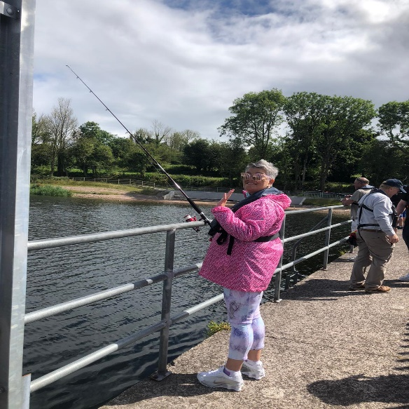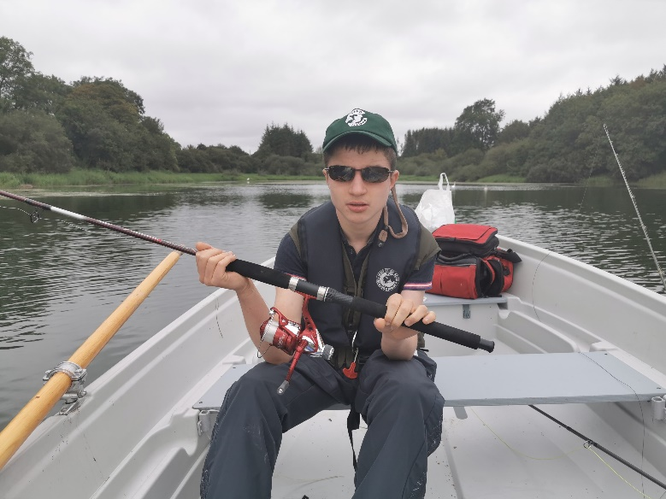
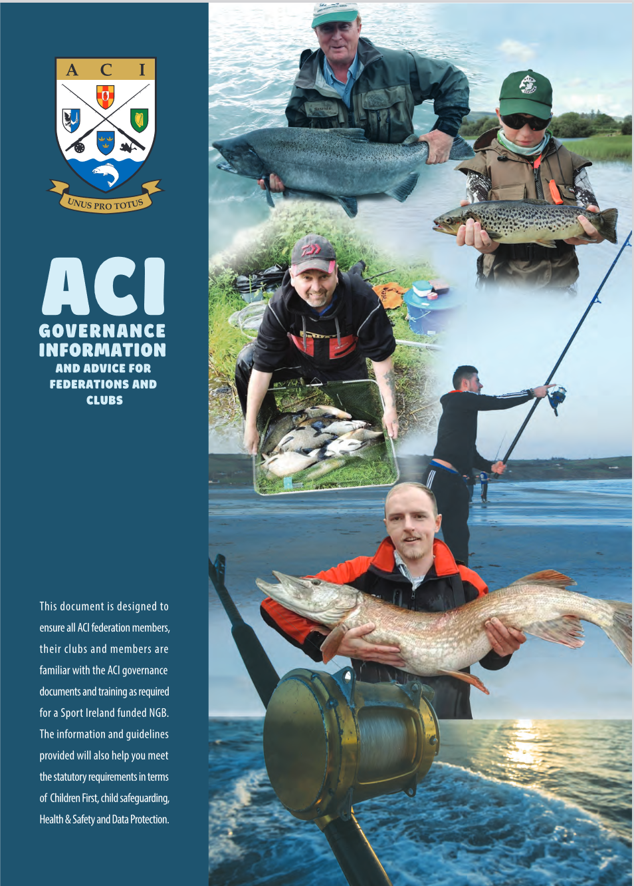
I have a number of the welcome packs for new clubs. This book was sponsored by Inland Fisheries Ireland and we thank them again for their kind support
This document provides much of the governance information required by clubs to be compliant with regulations and Sport Ireland requirements in terms of angling Coaching.

Angling For All – Angling for Youth Development Ireland & Angling Cast Programme
The ACI is the lead organisation in the roll out and delivery of AFYDI in Ireland. SSTRAI coaches have been at the forefront of this project and we will continue to train and help supply Angling Hubs with equipment during 2023. We got financial support for 5 groups in SSTRAI for our Cork Hub totalling €20,000 for 2023. This includes €3,500 for fuel for the boats, this was through a Sport Ireland initiative and is very welcome. This will provide many hours of angling for the Hub and we invite SSTRAI members to join us for some fishing outings this year. Martin Mc Enroe is working on a new midlands hub to be based in Athlone. May I take this opportunity to encourage all SSTRAI clubs to participate in AFYDI and the CAST programmes. While it is a lot of work the rewards are great for all involved, particular the disability groups. The Women in Sport Groups last year were amazing, we were blown away by the interest and we must capitalise on that this season.
We have also managed to purchase a new 10Hp engine with a grant from the Sports Capital grant scheme for the Wheelyboat, this will give great range in rivers or sea day trips.
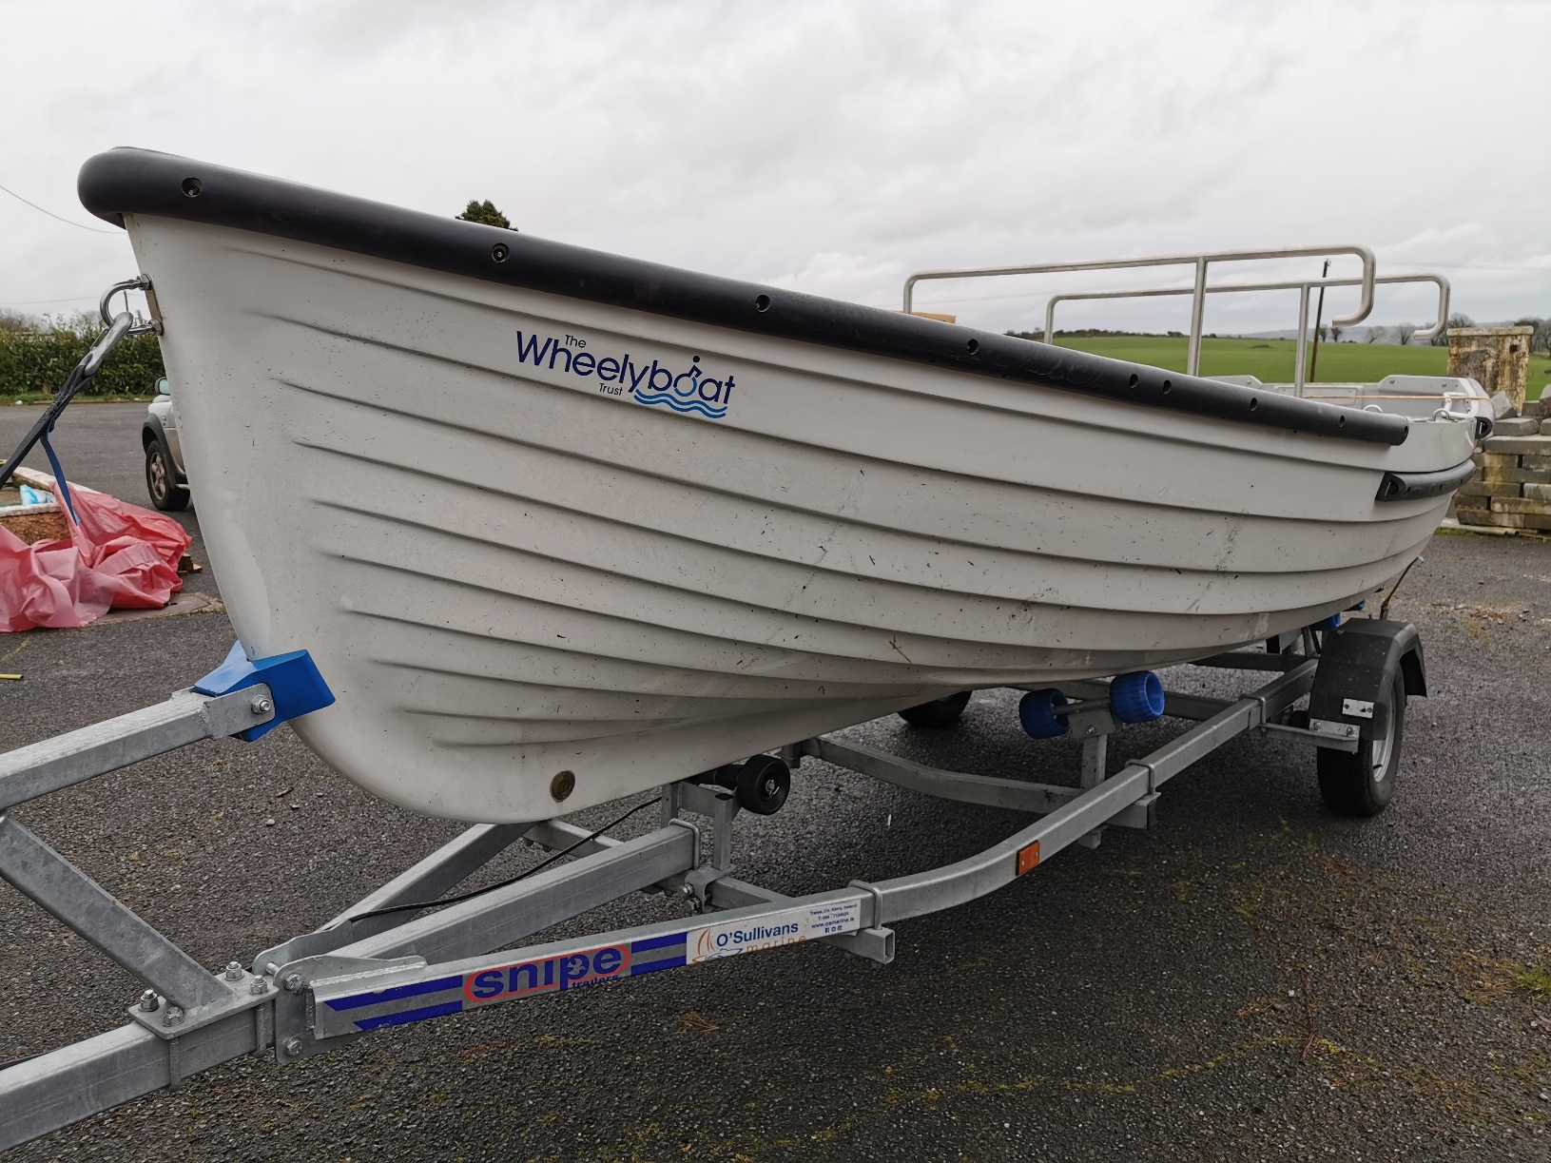

Salmon & Sea Trout Recreational Anglers Ireland

Sport Ireland Dormant Account NGB Community & Disability Sports Inclusion Fund
The ACI Sports Inclusion programme is long established. The Angling for All programme provides angling opportunities for all anglers including those with disabilities. We work with individuals or groups to cater for those with special needs, intellectual or physical disabilities of all forms weather mild, moderate, or severe. We invite those new to angling to participate in taster days to try our sport and participate in a range of angling events. During 2022 we continued to work with our now well-established groups and 4 of them have now formed angling clubs. Headway in Ballincollig, and Headway in Carrigrohane. The Rainbow Club for Children with Autism and The Organisation of National Ex-service personnel. We have also not set up a number of new groups for 2023 including 3 traveller groups, Fermoy, Mallow and Charleville, The CYDS Hut Group Cork City, and 2 groups from COPE Foundation 1 from Scoil Bernadette Transition Year students with intellectual disabilities, and COPE adult Services group. This certainly proves these programmes work. We do need more coaches to give a bit of time to help, particularly on Tuesdays and Thursdays. So if any of you out there can help please do let me know.
Sharon Sheedy, Bob and Claire Morgan at Sports HQ
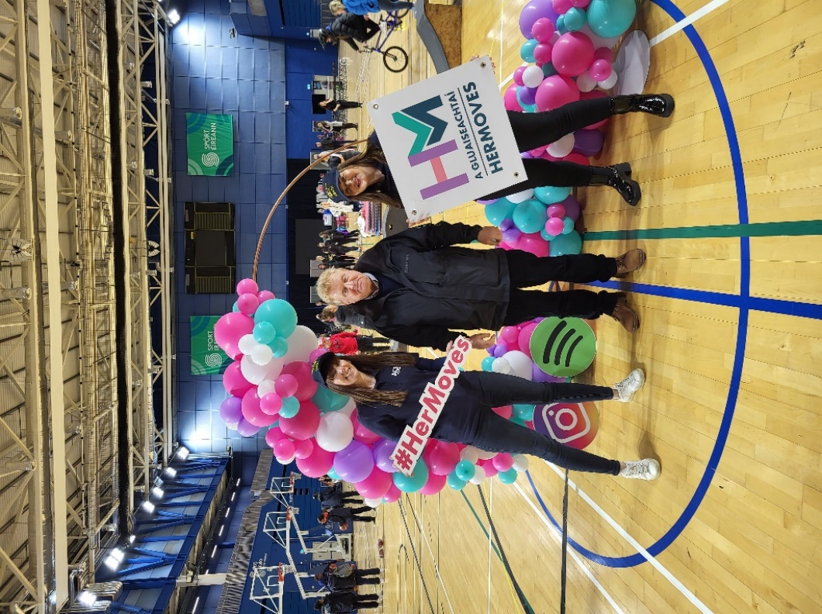
The new Sport Ireland “Hermoves” campaign has begun, our coaches Claire and Sharon attended the launch at Sports HQ and are now ready to get going for 2023.

I am sure this will be very popular again this year particularly the boat angling. We started at 09.30 am and finished at 10.30 pm at night, we had continuous new groups all day long.
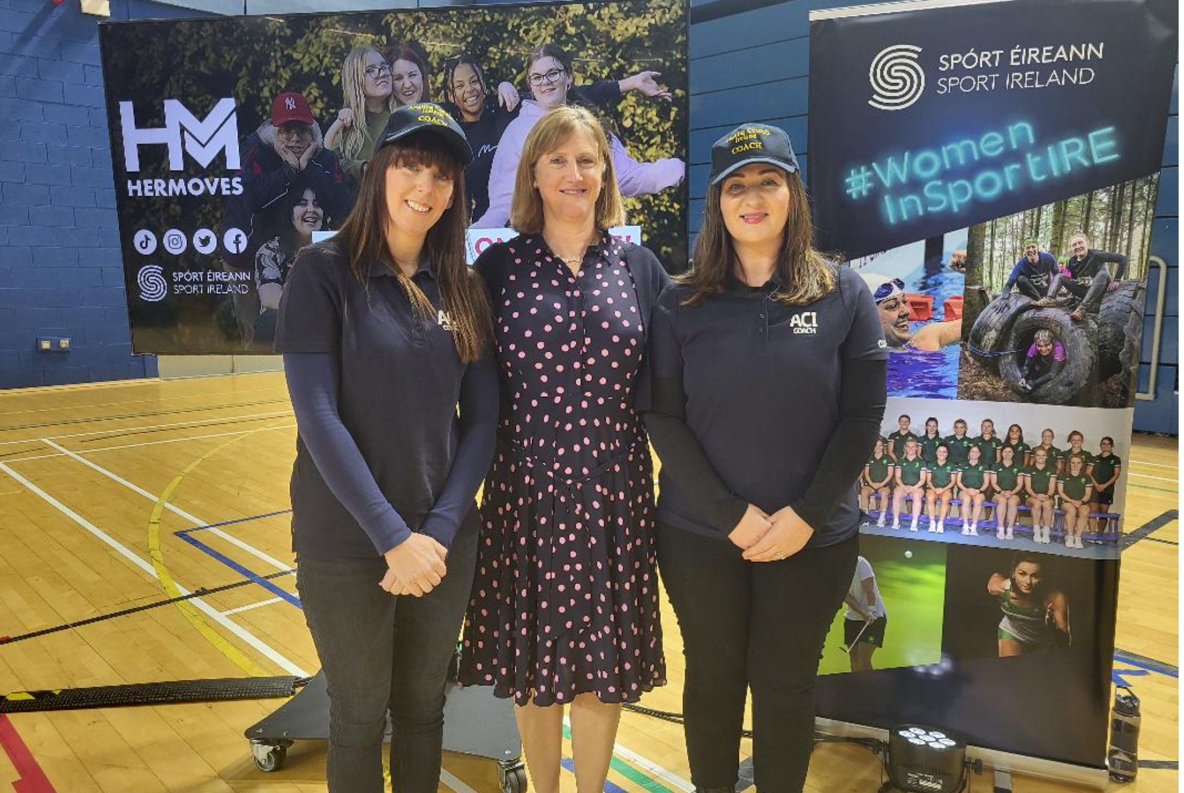
Sharon and Claire with Dr Una Maye CEO of Sport Ireland at the launch of “Hermoves” campaign, they done great work on the day.
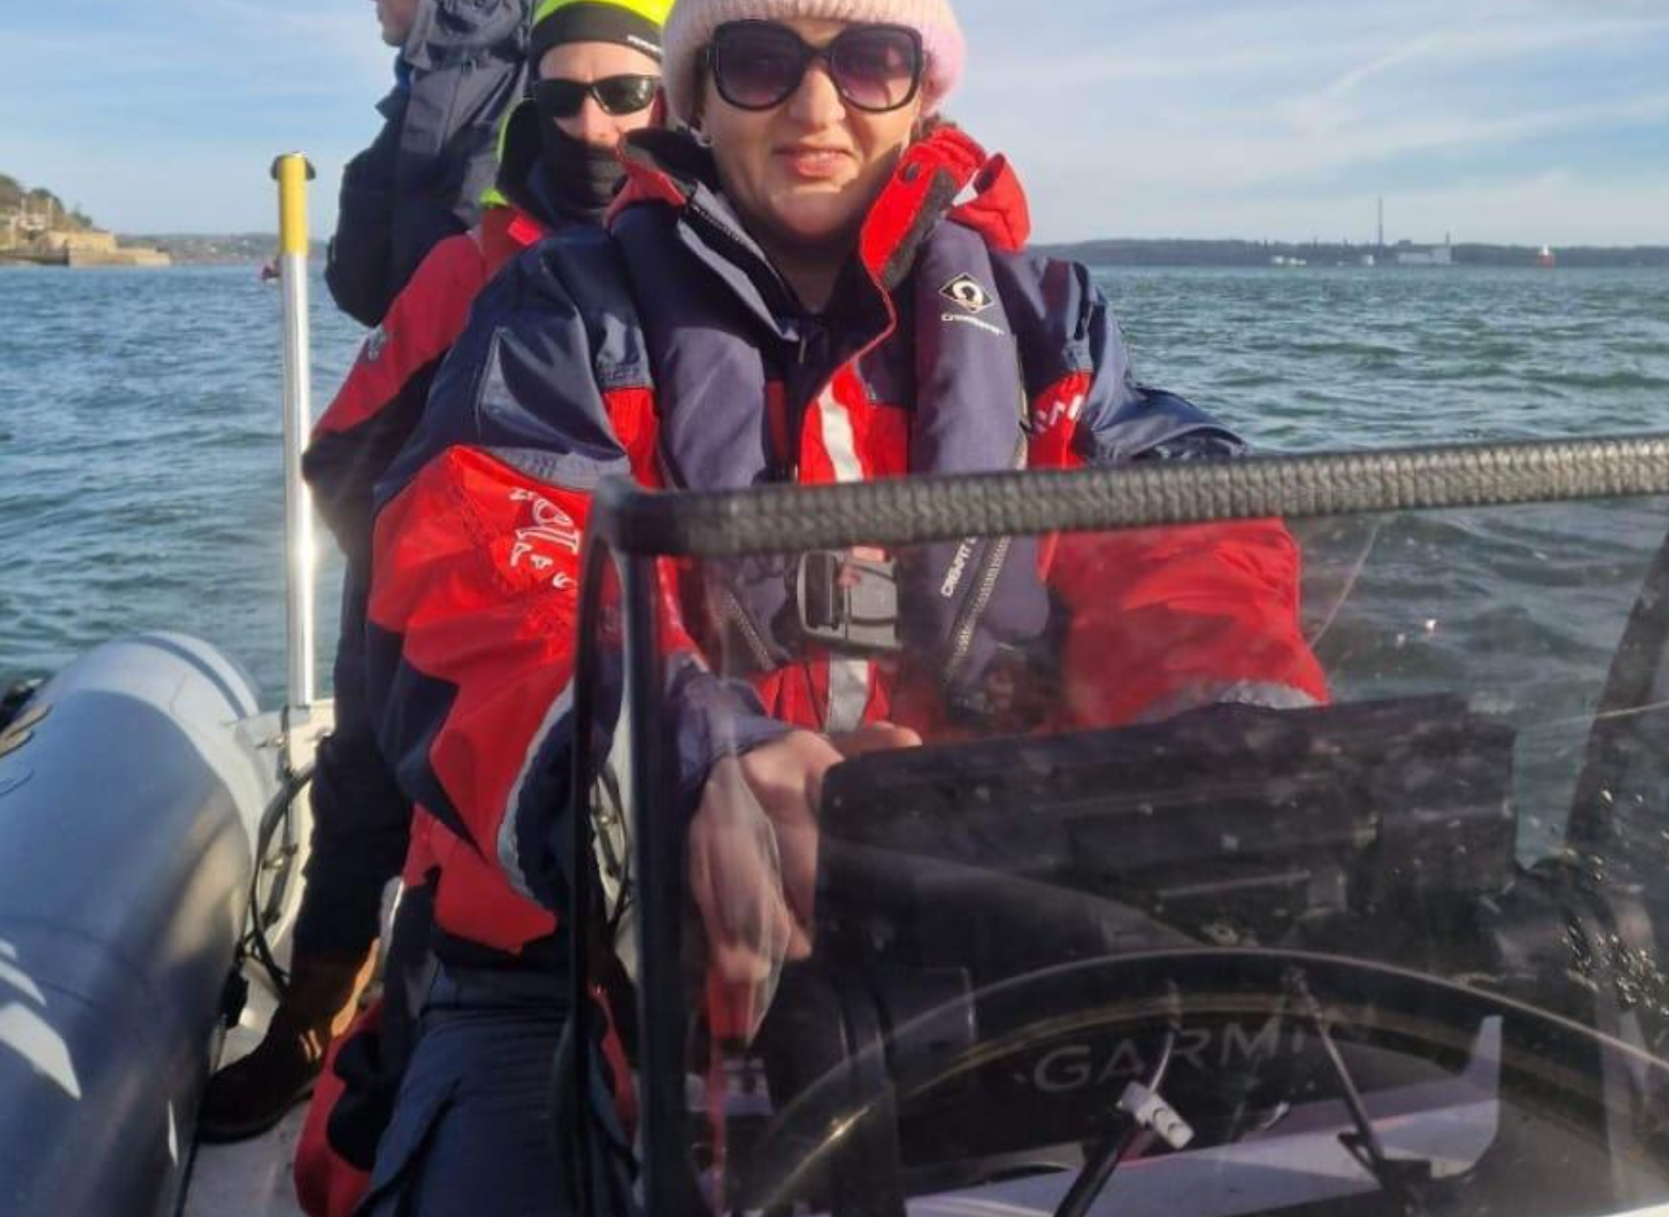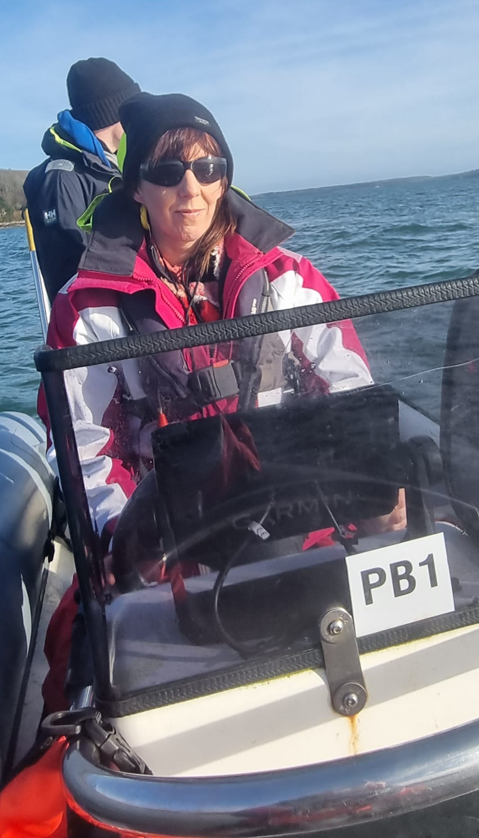
Claire and Sharon have been trained up now on ISA Powerboat Level 1 and 2 with Eddie English training school in Cobh.
Andrew and John have also completed their VHF training course. The cost of the training was covered through the Dormant A/C fund account without which it would be very difficult for SSTRAI to have volunteers trained.
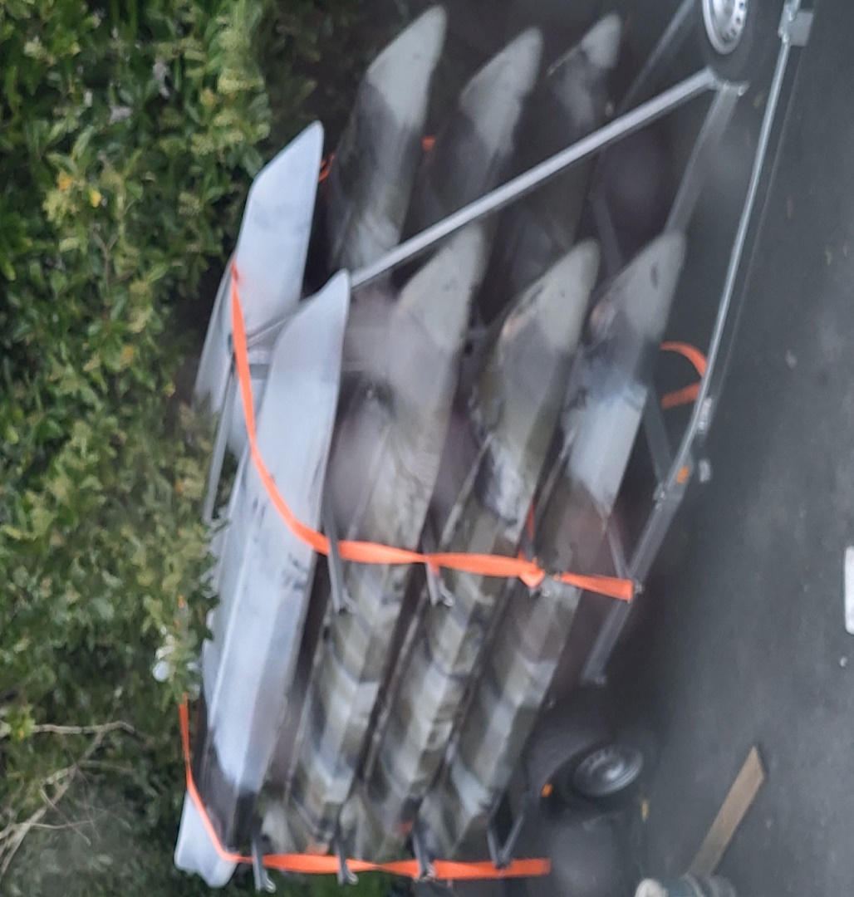
The SSTRAI Glanmire and District Salmon & Trout Angling club are nearly ready to go with the Kayak angling. We just need a few more training sessions, we finally have the trailer so once we have the tiedowns are sorted we will be on the water, hopefully the weather will pick up and the temperature warms a little.
Governance, Sport Ireland is constantly working on improving governance within the NGB’s
During 2022/23 I was offered a place by Sport Ireland on a HETAC Level 9 Professional Cert in Governance being delivered by the Institute of Public Administration through the National University of Ireland. This was a great opportunity to study governance in detail. I have always been working on different elements of governance for SSTRAI and ACI and I was delighted that Sport Ireland covered the substantial cost of the course. This again shows Sport Ireland’s commitment to help NGB’s develop.
I believe there will be a place offered again next year and I would highly recommend the course
Lee Explorer when she arrived into Dublin Port and Docks. Celtic Shipping brought her in from the Netherlands and saved a major towing journey for us.
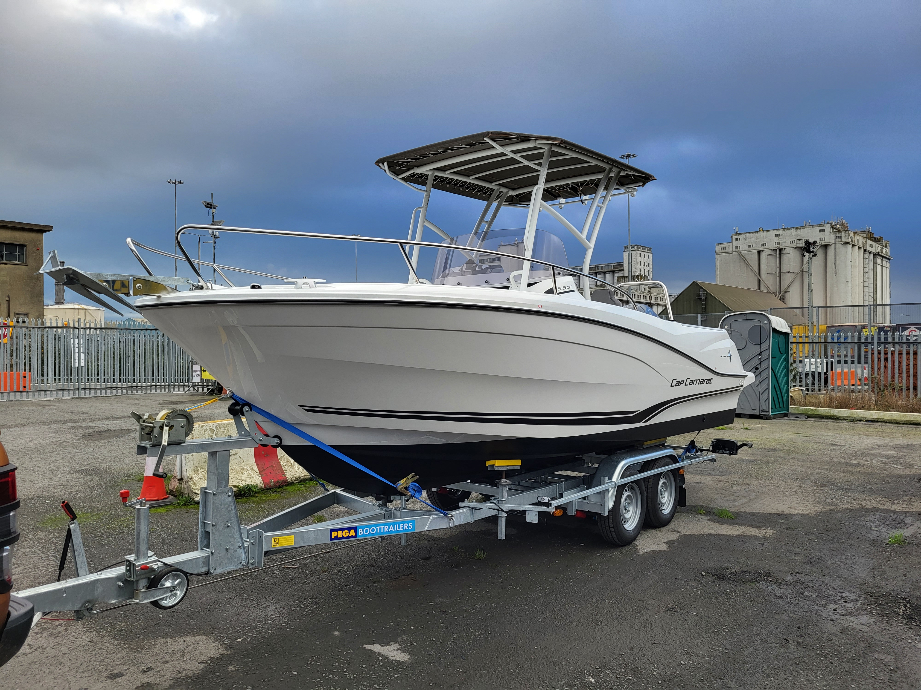
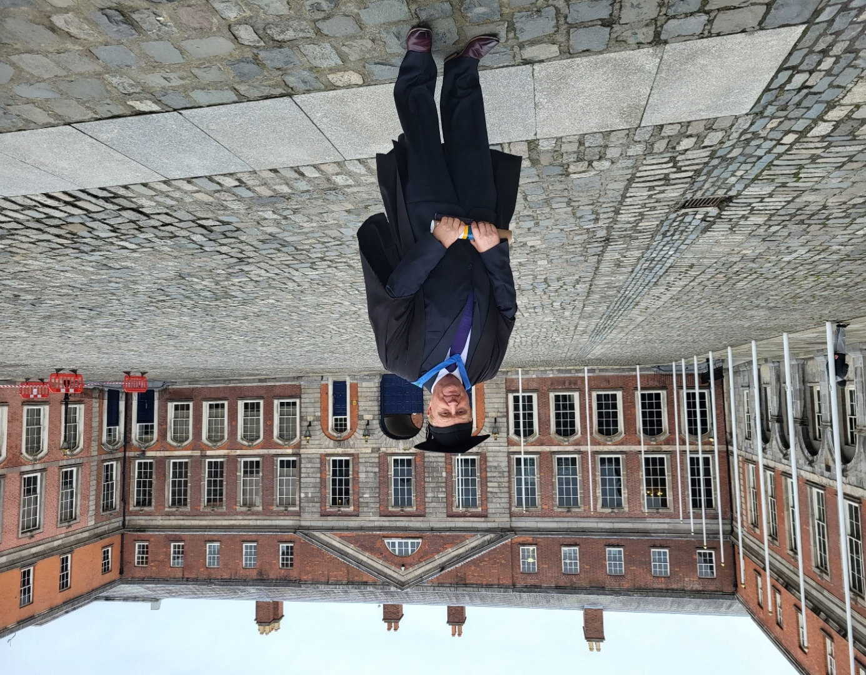
Bob at the IPA NUI Level 9 Governance Graduation Ceremony at Dublin Castle
ONE Angling Club Members completed a Suicide Awareness Safe Talk training course. Photo by Bob
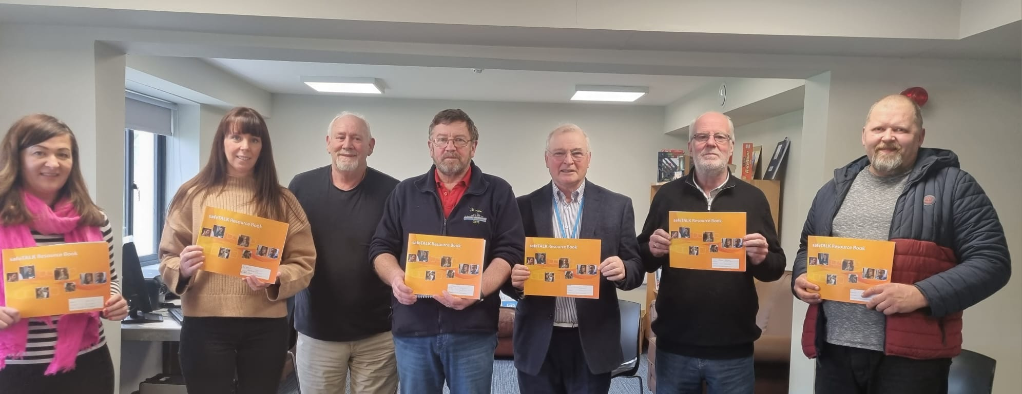

ONE Angling Club members completed a Mental Health First Aid training course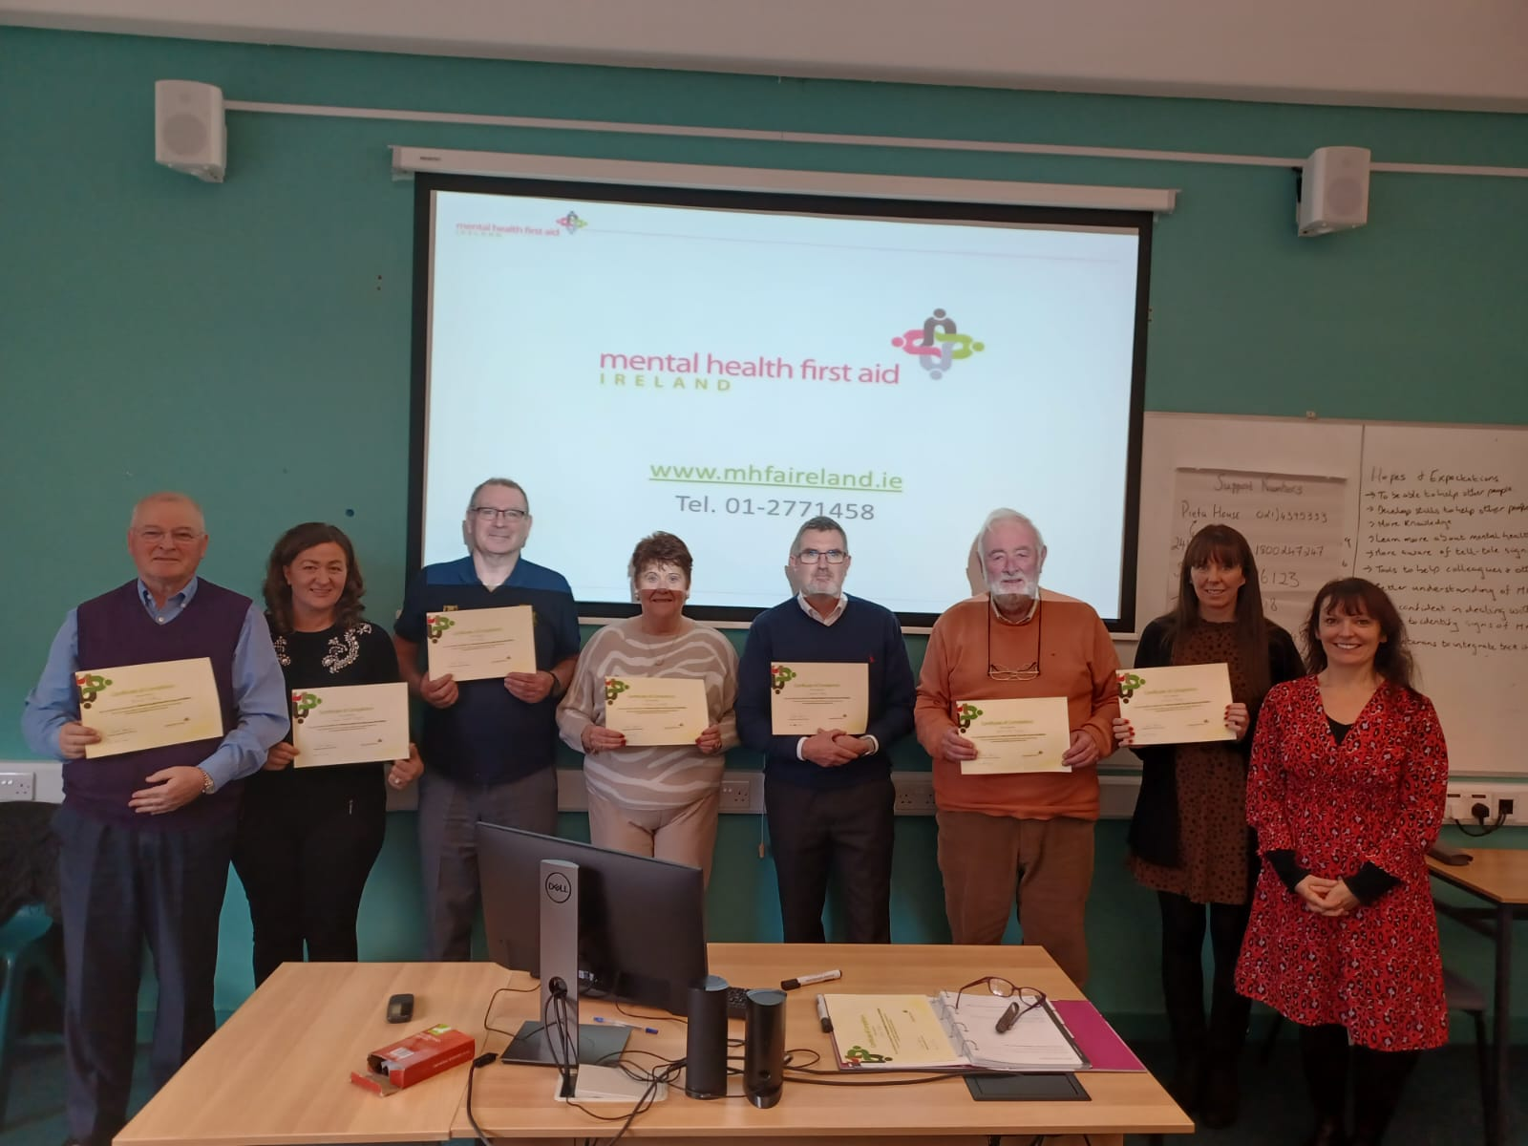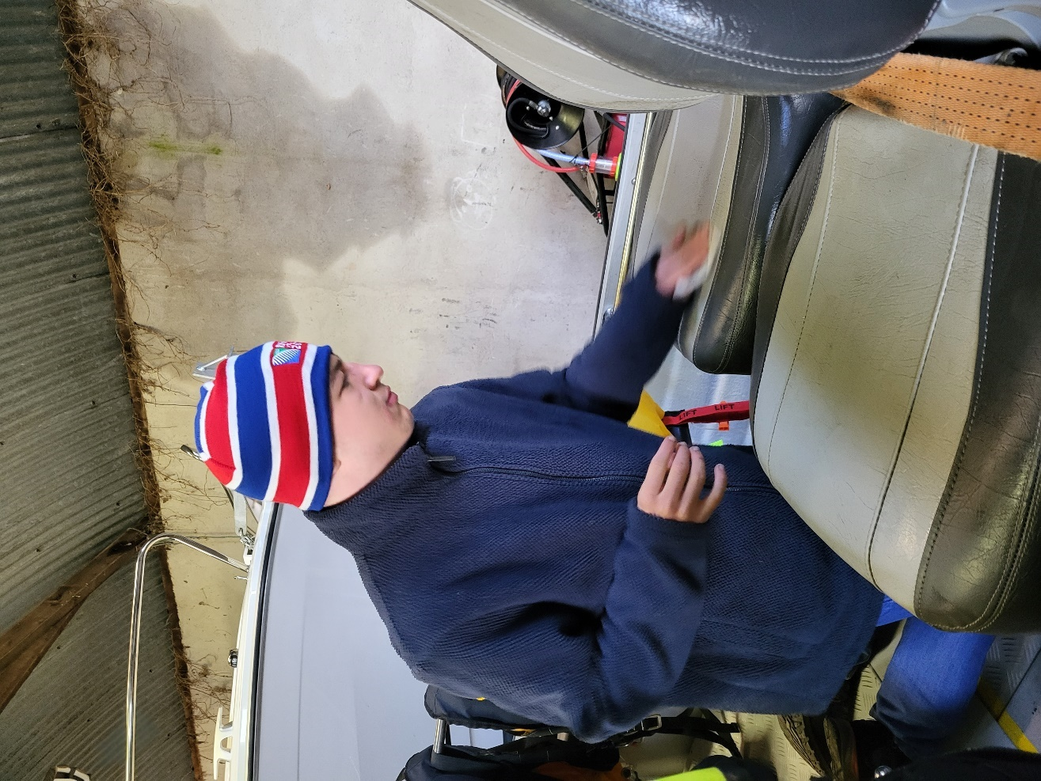
Craig from the Rainbow Angling Club
Enjoys working on the boats helping to keep them clean and tidy, he’s been a great help at the boat shed over many weekends.
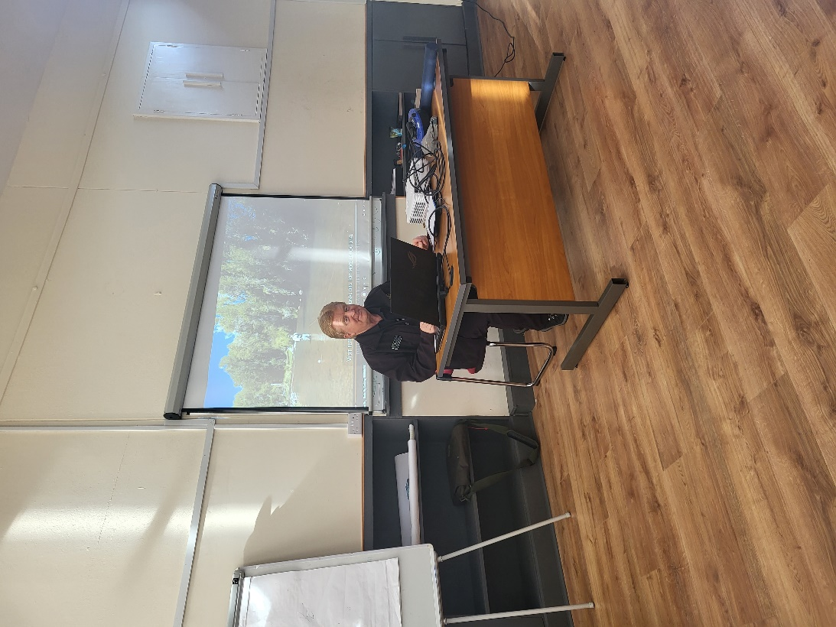
Bob delivering casting course theory to the flycasting course in Rathcormac, the course went very well and we were delighted to have been assisted by Inland Fisheries Ireland last year to help set this course up.
This will benefit both SSTRAI and ACI coaches who wish to become fly casting instructors at an introductory level. It is a foundation course to help anglers improve their casting skills so that they may be better placed to help novice anglers on their journey in fly fishing. 3 courses are planned for 2023. Already we have 6 members signing up to the Game Angling Instructors Association.

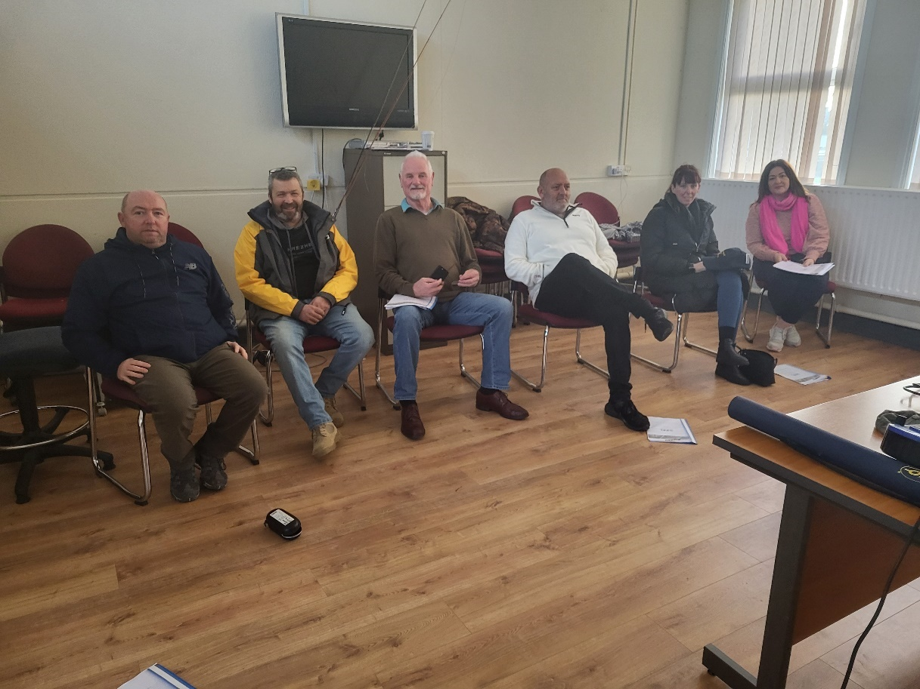
Headway (Acquired Brain Injury) groups
Introduction.
This programme funded through the Sport Ireland Dormant Account fund enables the ACI and its member federations to introduce, coach and train novice anglers in a wide range of angling skills, beginning with safety near on or near the water. We ensure plenty of fun elements for the young novice anglers and do our best to get them actively fishing as soon as possible. We then concentrate on helping them learn the necessary skills for them to become competent anglers. We use the ACI Angling Cast Programme which is a 6-stage certification programme and depending on the group we will work with them at a pace that is right for them. Our coaches are flexible, and we know we must be, also we understand that for many with disabilities their lives are very structured, and they have particular routines so we do what we can to facilitate this for each group and where practicable we will work with very small groups to help them along the angling pathway.
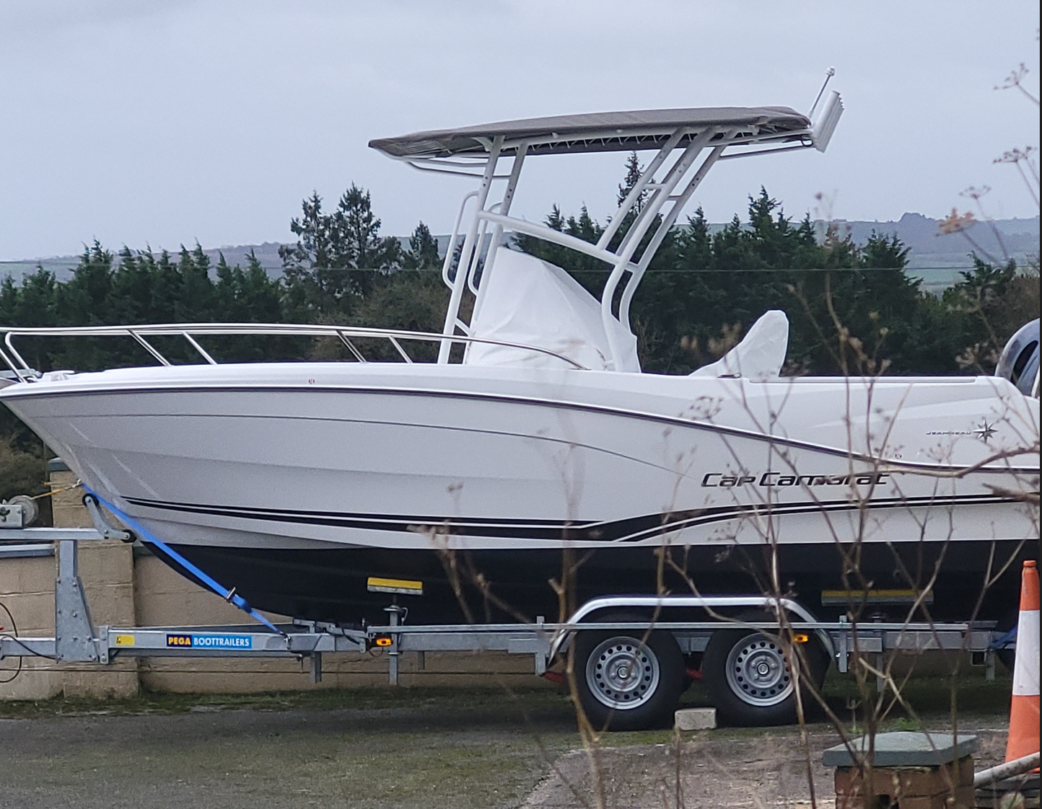
Lee Explorer getting ready for the launch 2023, all we have left to do is tie up the rigging, put on the name and fill the tank.
We have based a lot of this programme in Cork this year as we now have a reservoir stocked with fish and a good base to work from. We have been fortunate to secure a long lease with Irish Water and Cork County Council have supported us with this project. Inland Fisheries Ireland have also assisted with the venue development, and we have received funding from the Sports Capital Grants that has funded 50% of cost of a disability accessible angling boat for the venue and Cork Area.
This has allowed us to provide Cork with an Angling HUB through the Glanmire & District Salmon & Trout Anglers / SSTRAI that is well stocked and well equipped to work with many groups and for us to provide coaching to those that want to start fishing under a controlled and safe environment. Our coaches are delighted to give back to the novice anglers of all ages. In addition, we have access to some excellent salmon fishing on the river Blackwater in Cork and Waterford Ballyduff area.
Our colleagues in the IFSA are working with many groups around the country delivering the CAST programme and working both ashore and afloat introducing novices to angling and helping those who have completed level 3 to move on to levels 4-6.
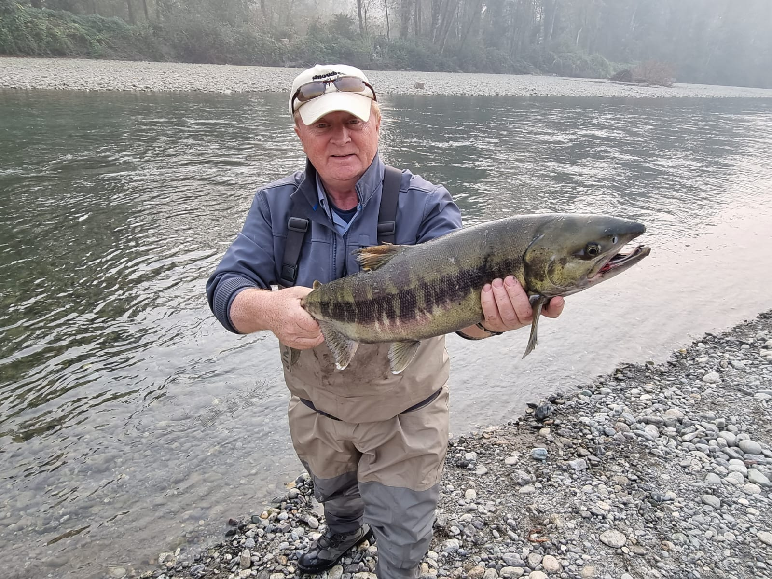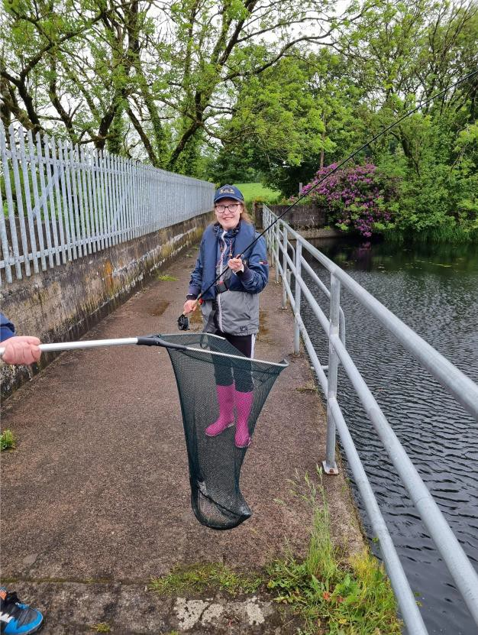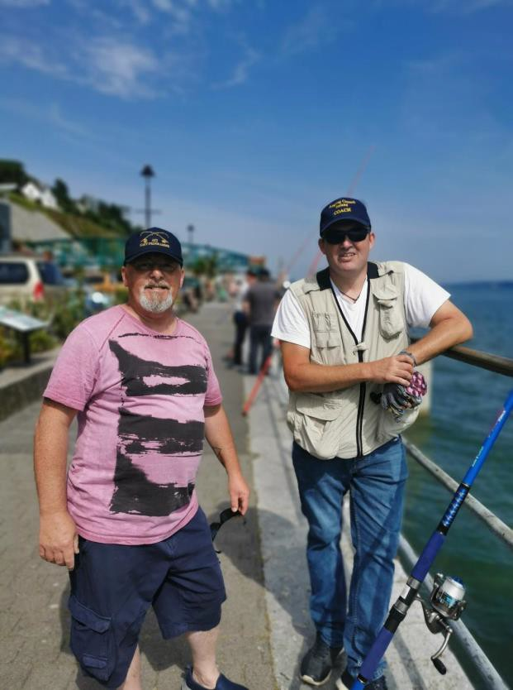

Just a small sample of fish from the Vedder River in BC
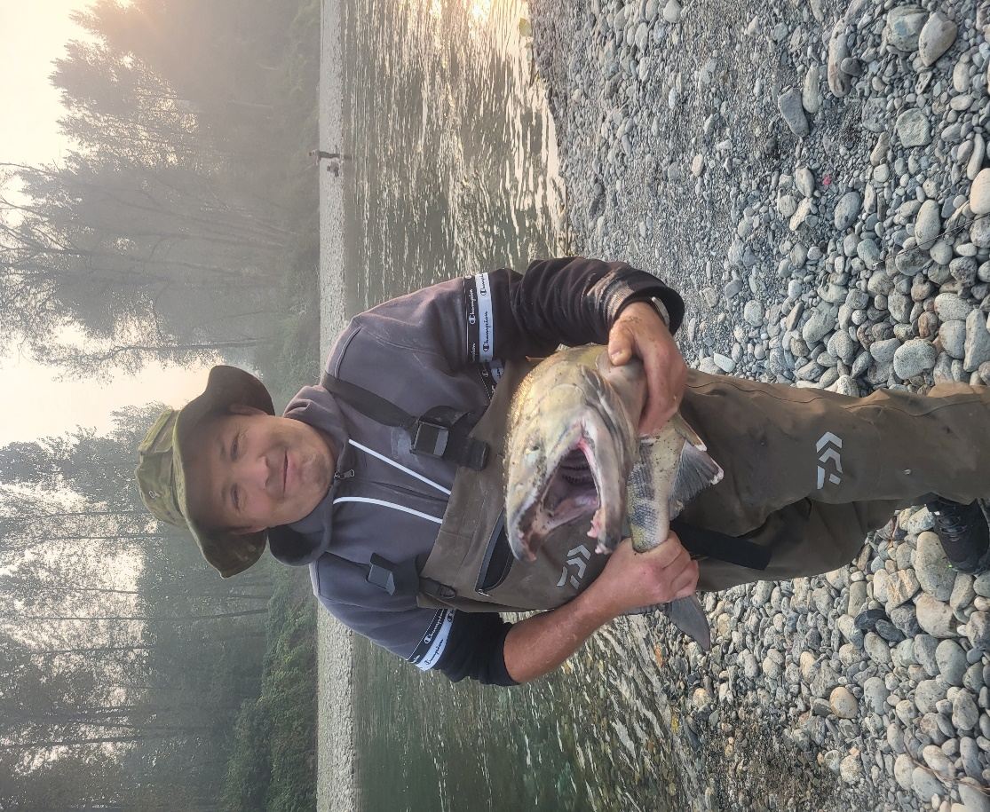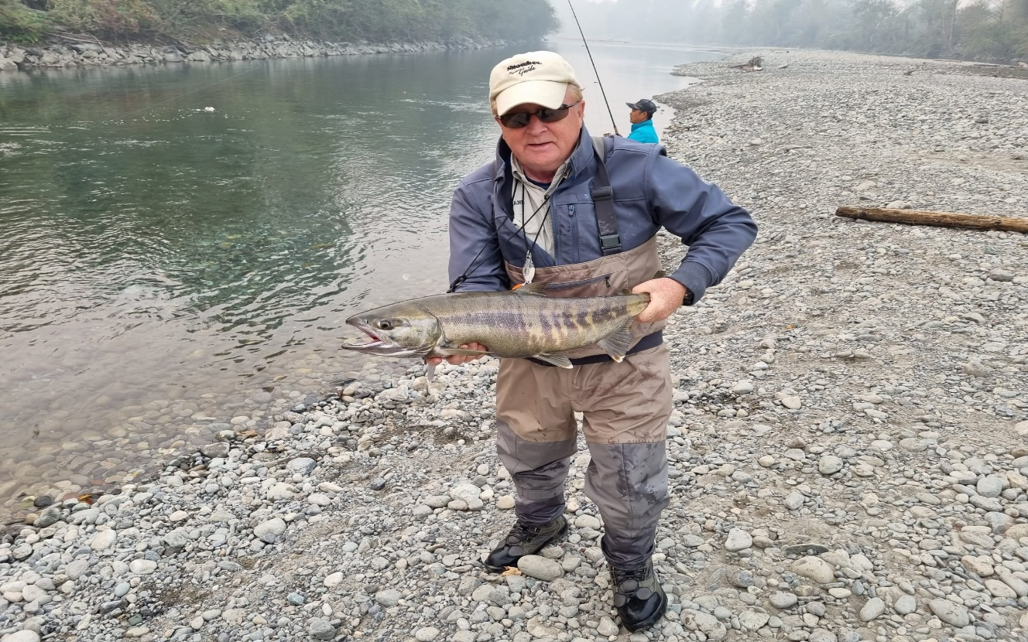
3 TESTIMONIAL COPE 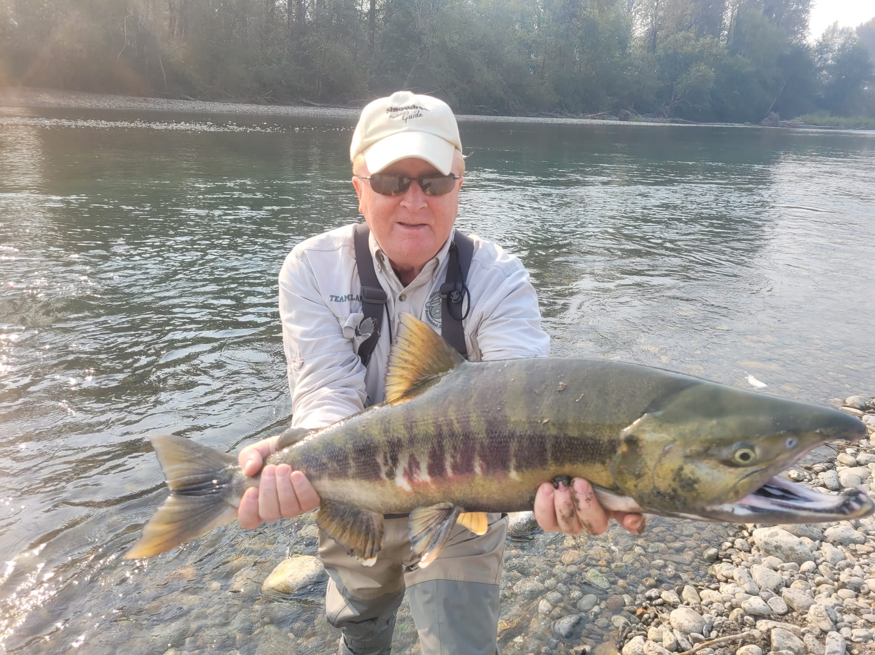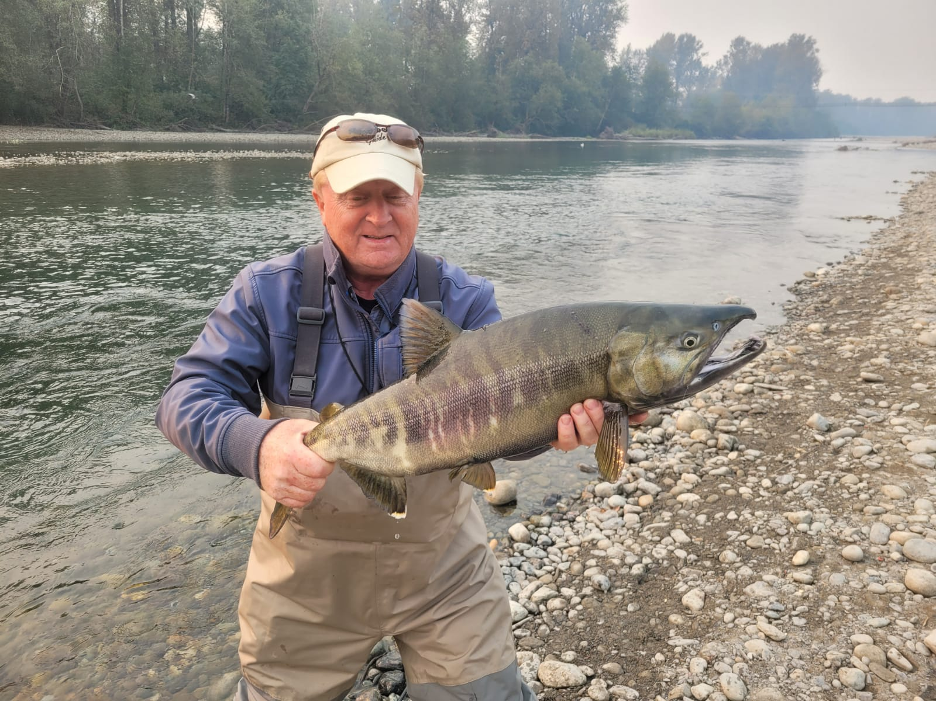

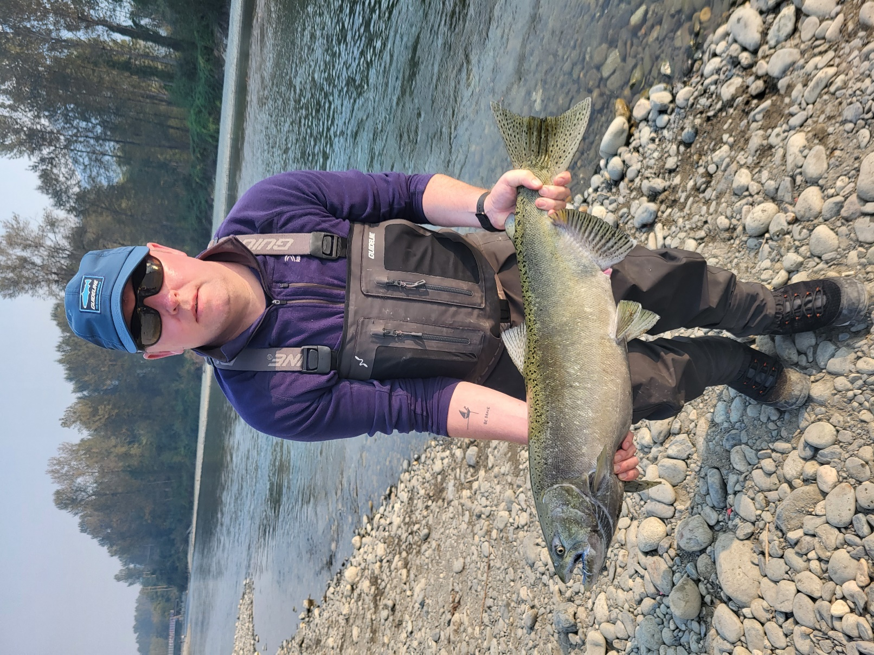
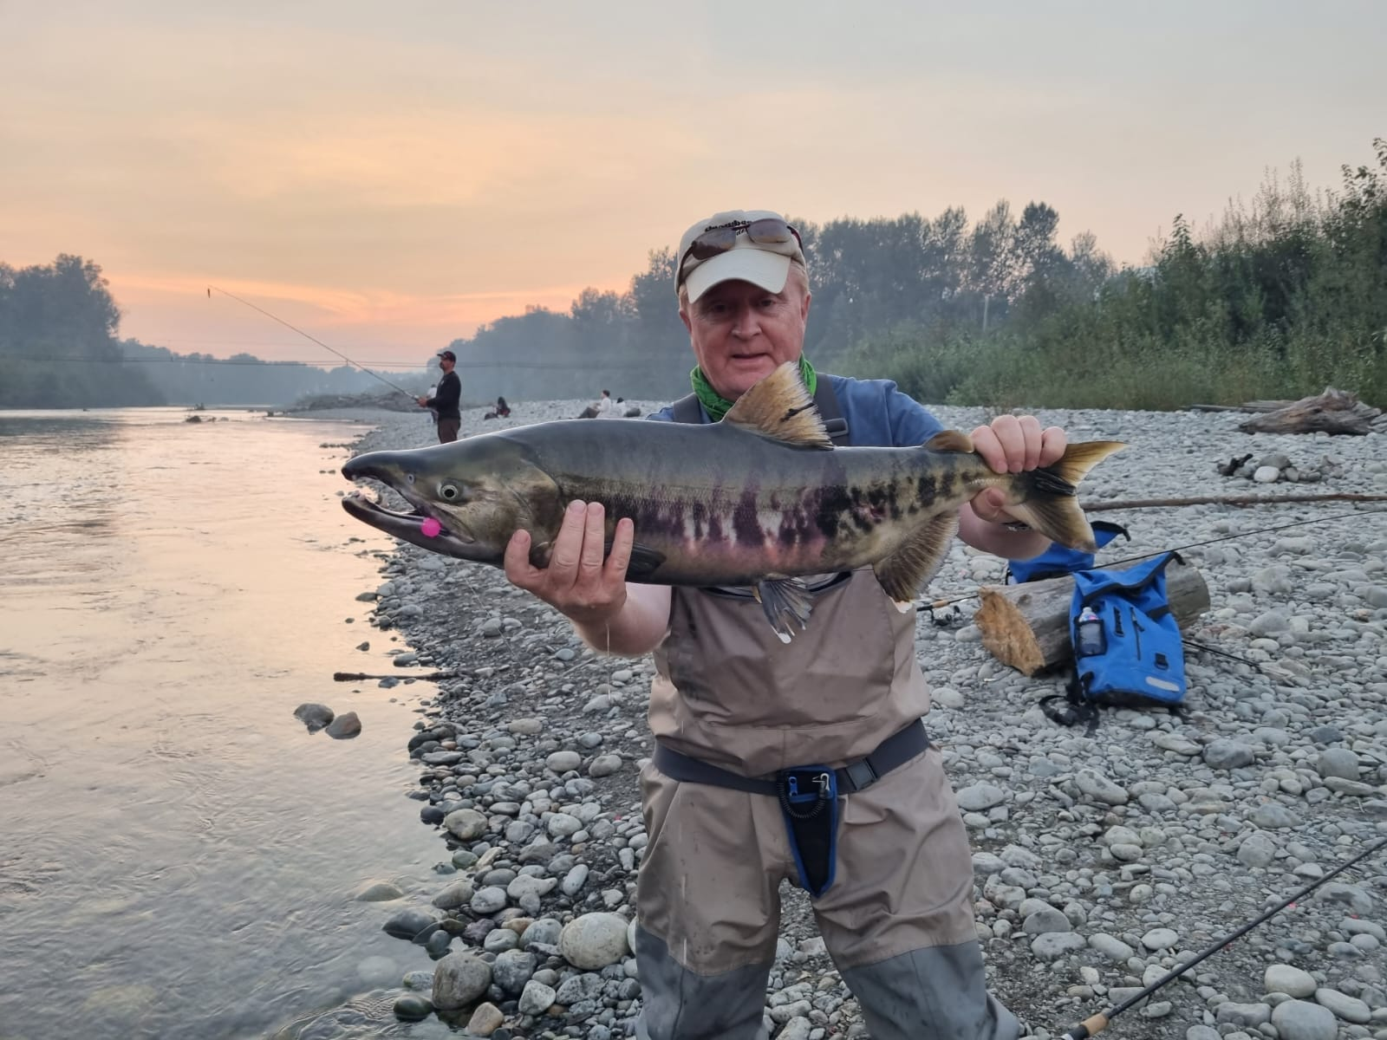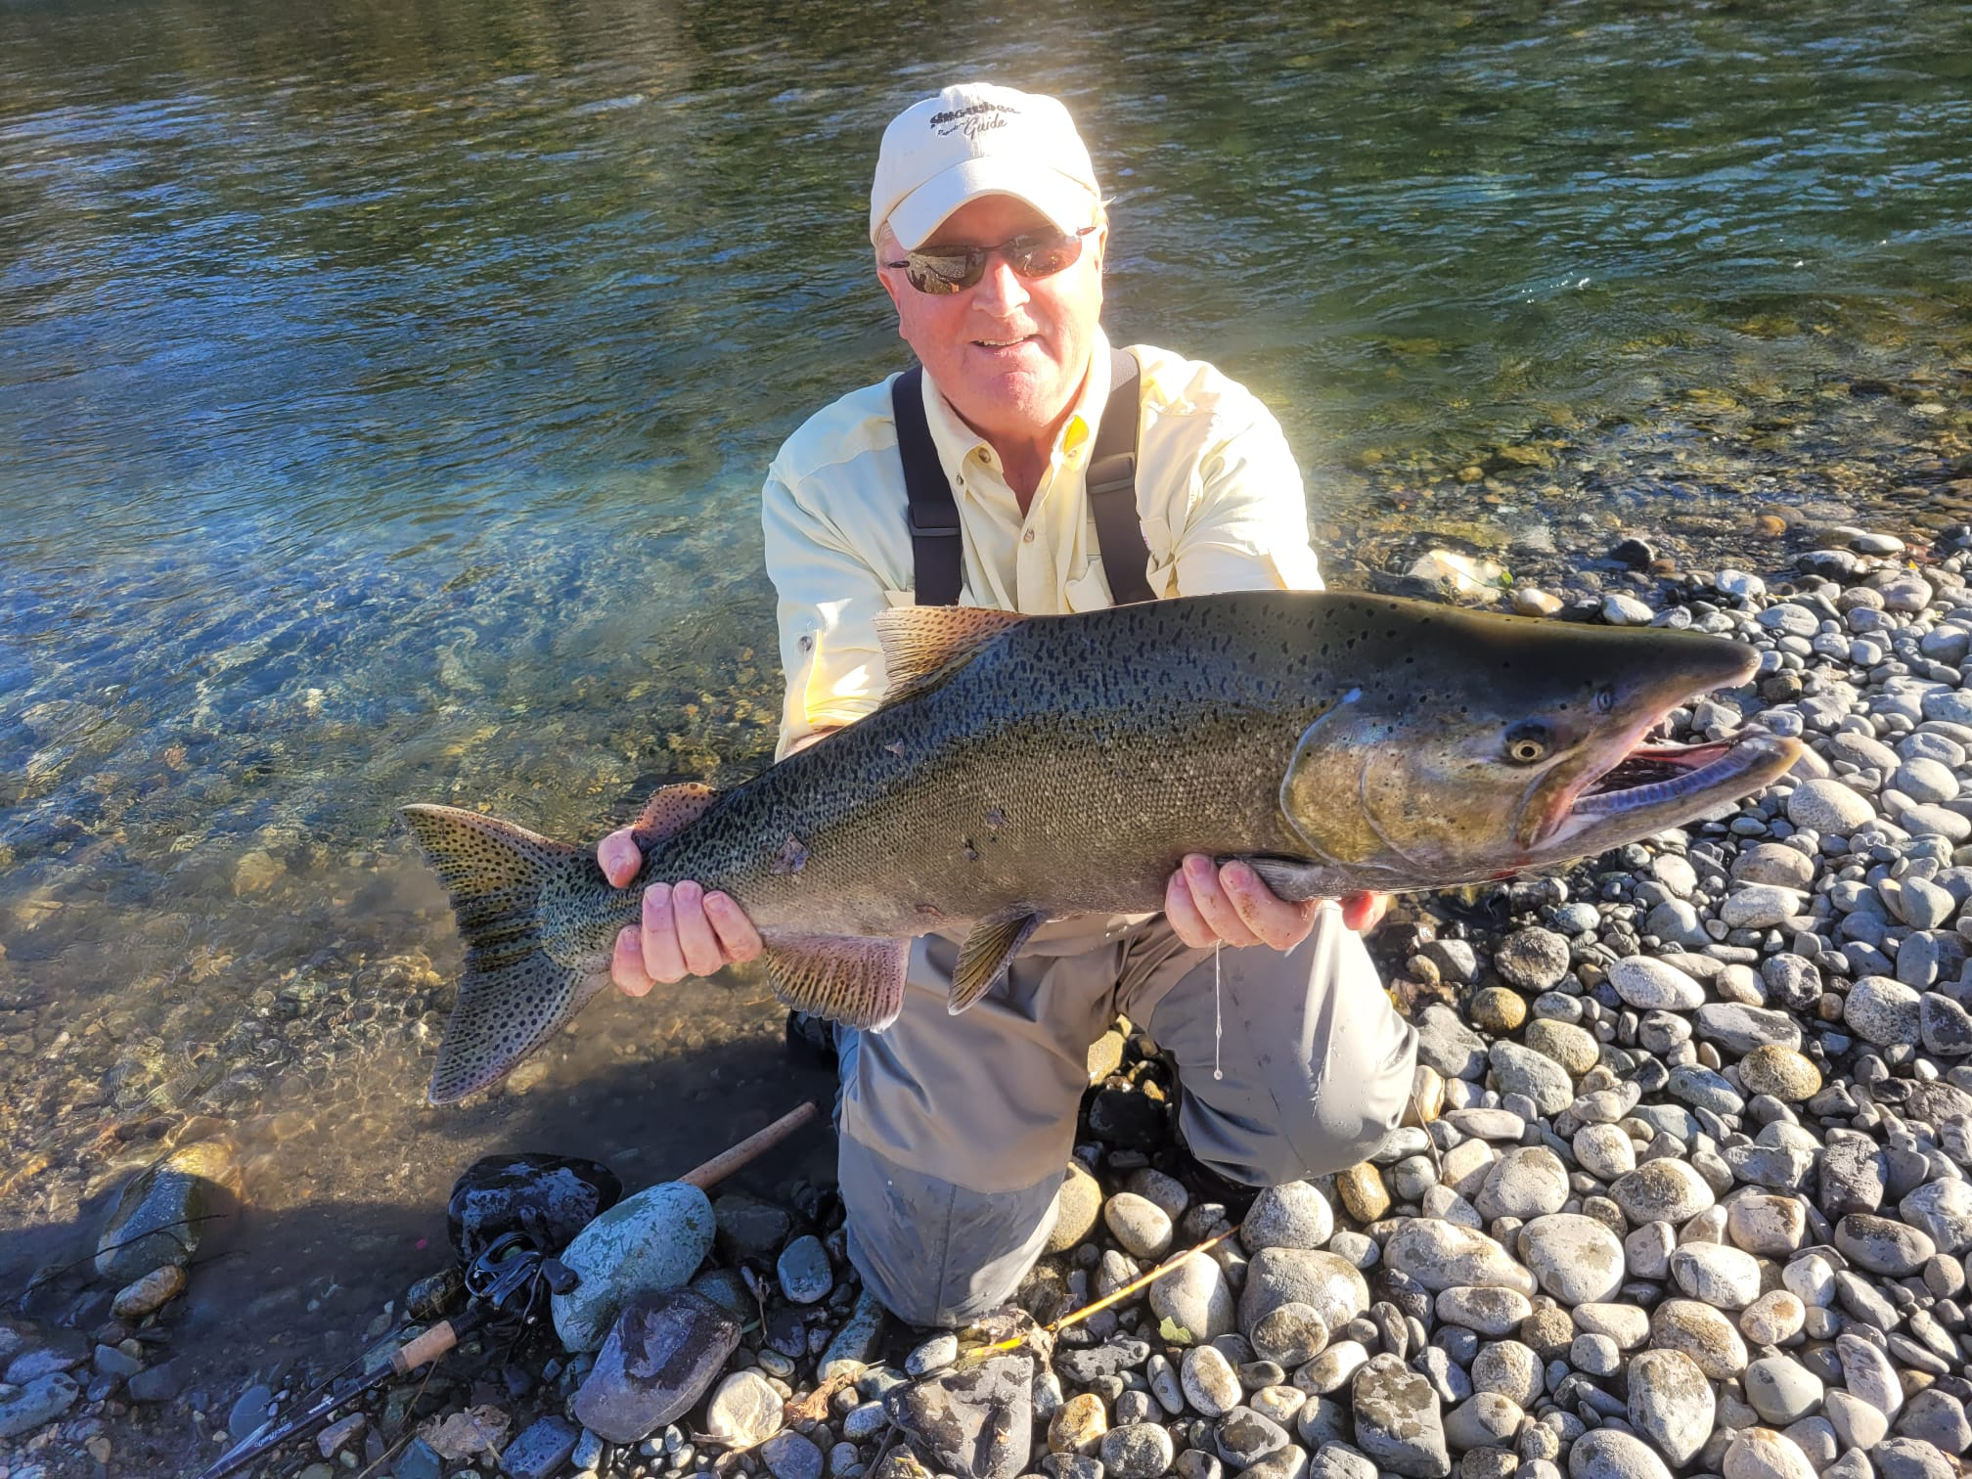
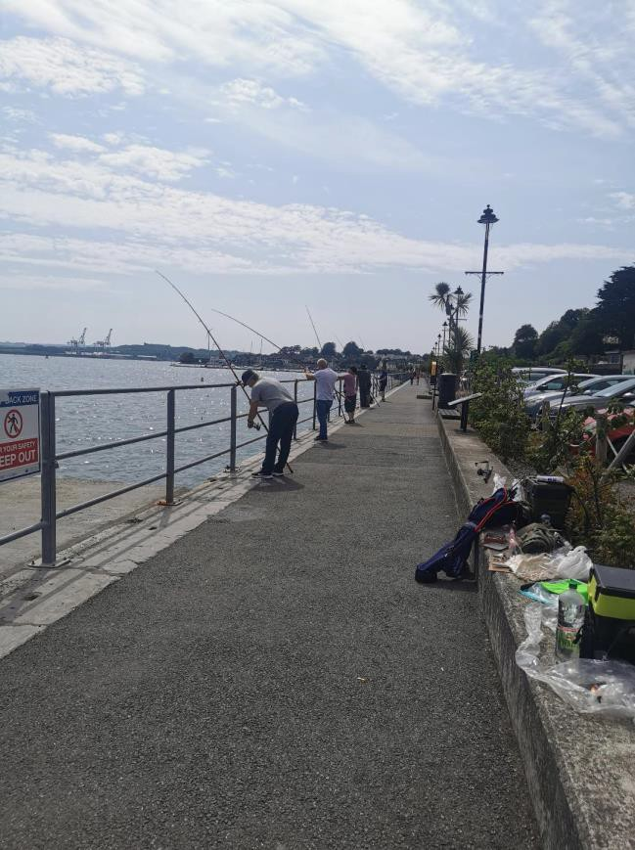
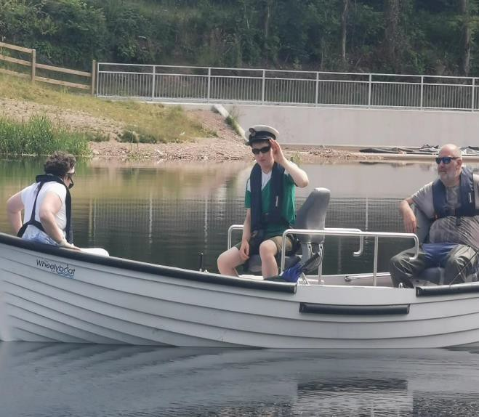
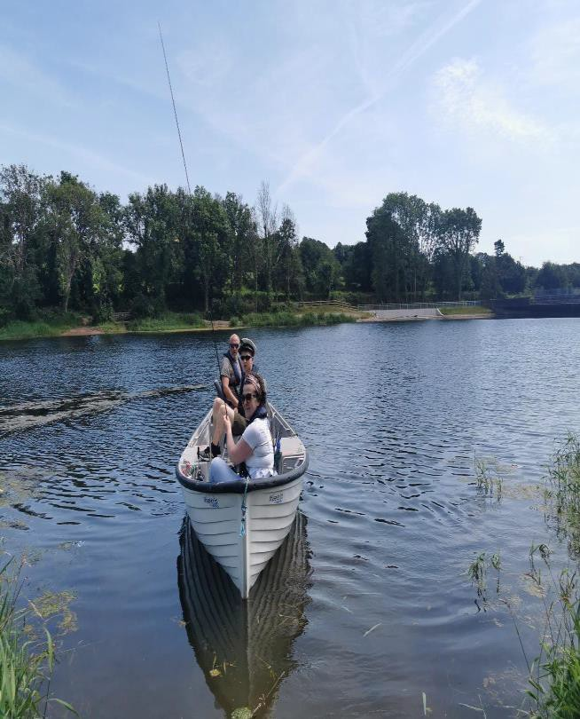
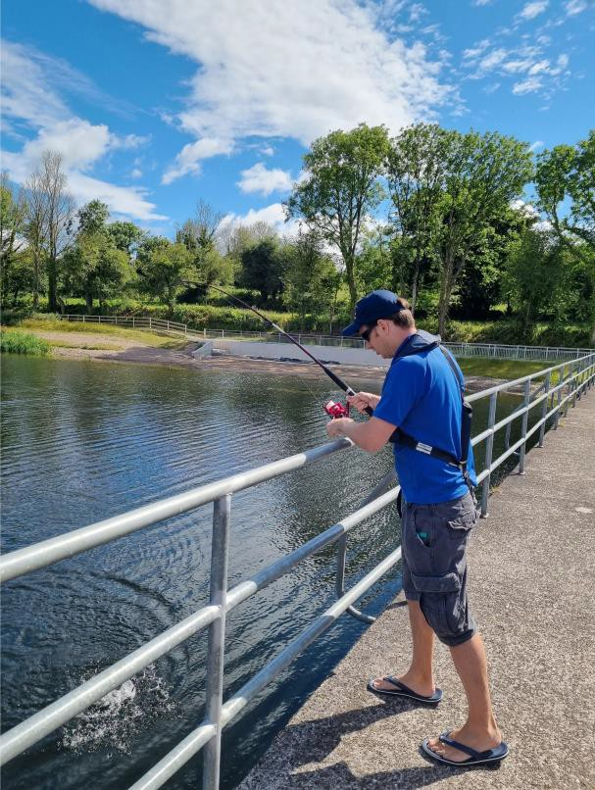

Headway Ballincollig Cork
The angling cast programme has provided Headway clients with the opportunity for some to develop new skills and
others to reacquaint themselves with skills they hadn’t the opportunity to use in a long time.
Participating on this programme gives our clients with a relaxing atmosphere to strengthen neurological structures often damaged due to their brain Injury such as mental, emotional, and physical areas. This group also offers our clients the opportunity to develop a hobby and social outlet that is transferable to their own communities and improving quality of life.
Jackie McCann
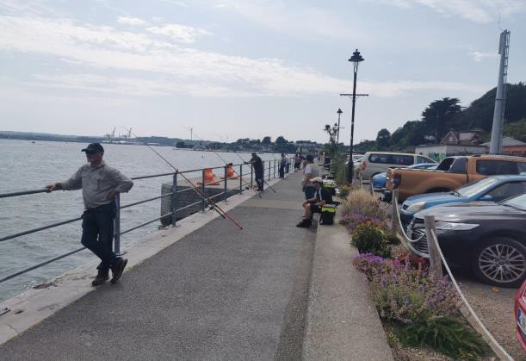
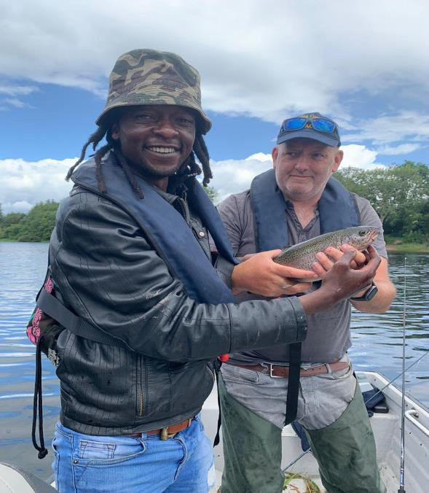
l

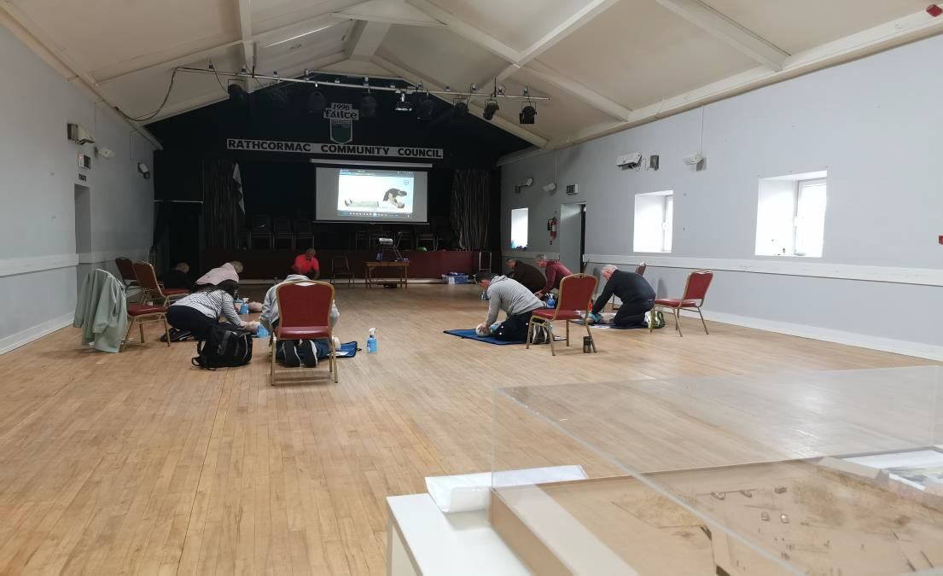
ACI Coaches undergoing the ACI First Aid defibrillator training during the course at Rathcormac. Course delivered by John O Brien Paramedic First Aid Instructor and ACI Coach Developer under training
We have completed 3 introductory level coaching courses, Coaching people with disabilities, Health & Safety, Safe Wading and Water Rescue workshops and First Aid for Angling. We have 14 additional volunteers from the Rainbow Club for children with autism under training in preparation for a coaching course in September. The Rainbow club membership has now increased to 500 children, we are working with 87 of the older Rainbow club members to start with and carers / coaches in total 103 in small groups and all new coaches will be working with our experienced coaches / coach developers well into the future. This will be developed further with younger children and their families for next year.
The ACI Community and Inclusion Programme is working well. We are confident we will at least meet our target numbers and expect to well exceed them by end of year. Since we are back delivering, we have seen new groups forming up in Tipperary, Kilsheelan where there is a great interest from the young and older novice anglers. We have events organised for August. We have a number of new groups for September with Cork Sports Partnership, Organisation of National Ex-service Personnel ONE, Addiction recovery and over 55 sheltered housing groups, in addition to our main groups.

SSTRAI executive members meet six times during the year for committee business. The meetings have been very productive and have kept us on track. In addition to the committee meetings 2021 there were several working group, delegate and Sub-group meetings dealing with various issues such as the New Strategic Plan 2022 to 2025,
- Habitat restoration,
- River development projects,
- Coaching meetings
- ACI meetings
- Inland Fisheries Ireland meetings, New Fisheries Legislation, Salmon & Sea trout Conservation Projects.
- Angling for Youth Development (Irl.)
- Coach Professional Skills Training (First Aid) (Child Welfare Training) (Coaching People with Disabilities CPD) (Health & Safety, Safe Wading and River Rescue.)
- Game Angling Instructors Association (GAIA), Training days on single handed.
- Coaching people with disabilities training.
- Angling Consultative Council Ireland Meetings with DECC

SSTRAI will this year revamp the website and include specific sections on salmon aquaculture and I encourage members to keep themselves informed by regularly visiting the website.
SSTRAI is assisting clubs and working with Inland Fisheries Ireland to get approved projects around the country that will assist in the protection and stock recovery process.
The Salmon & Sea Trout Recreational Anglers Ireland (SSTRAI) seriously oppose any further developments of salmon farming because of the extreme high risks involved. The risks are even higher when organic fish farming is planned as only a maximum of two sea lice treatments is allowed, anything above that will result in losing the organic status label. In support of job creation, we in SSTRAI support the Irish tourism industry and we are doing our part in protecting and developing our natural resources.

The ACI is registered with Sport Ireland and Sport Ireland Coaching as the NGB for Angling in Ireland. The ACI is also registered with NASCO as an NGO group. The ACI is also prescribed in fisheries legislation as the recognised national governing body for angling. Over the past number of years, the ACI has built up good relations with Comhairle na Tuaithe and participated in discussions on access to the countryside, access to waters etc. and helped to develop good communications and cooperation between the parties involved. The ACI has run several training courses for coaches and delivered many training programmes for groups with assistance from the local sports partnerships

SSTRAI is a long-standing member of ACI and have helped to develop it over the past 18 years. SSTRAI fully supports the Angling Council of Ireland and the work that it does for its members.

New National Inland Fisheries Forum
SSTRAI will be attending the new National Inland Fisheries Forum for 2023 and beyond.

Insurance 2023.
SSTRAI has set up an excellent Irish insurance package for our federation and clubs. We have secured great deals on Public Liability and Personal Accident cover for our members. We have PL to €6.5 million, the use of boats is covered, and includes a provision for international events. We have also arranged cover on request for Employers Liability, details of work must be submitted for quotation.
I take this opportunity to thank all those who have helped during the past year, early signs of salmon are showing some improvement on last year and I wish you all tight lines for 2023.
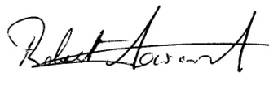
Bob Seward
Hon Secretary
Salmon & Sea Trout Recreational Anglers of Ireland
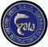GAIC Member
Advanced Marine & Countryside Game Angling Guide
Licensed ACI L3 Angling Coach Developer, Mentor & Assessor.
Snowbee Registered Guide and Instructor
Member Irish Charter Skippers Association (ICSA)

SSTRAI wishes to acknowledge the support received from the following,
Angling Council Ireland 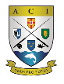www.anglingcouncil.ie
Sport Ireland 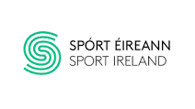 Sport Ireland Coaching 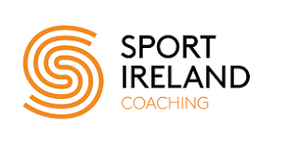
Dormant Account Funding 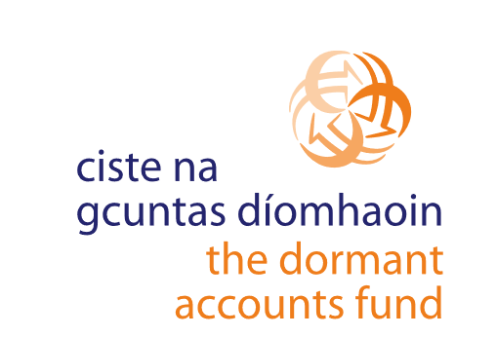
National Lottery Funding
SSTRAI has been a recipient of national lottery funding through the Sports Capital Grants Scheme.
