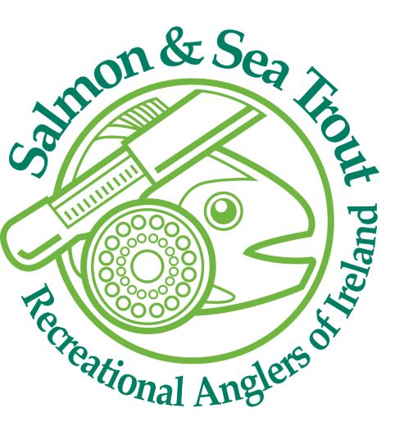

**SSTRAI Affiliation & Membership Renewal 2024**

The Salmon & Sea Trout Recreational Anglers of Ireland is an all-Ireland federation of affiliated recreational game angling clubs.

Our aim is to

• represent recreational angling clubs in all aspects of the sport and to work towards an abundance of salmon and trout stocks.

• To promote environmentally friendly habitat restoration in all districts.

• To provide up to date relevant information on national and international matters concerning salmon and trout.

• To promote the recreational sport of angling throughout Ireland

www.sstrai.ie

www.anglingcouncil.ie

  

Members of Irish Federation of Sport

Members of Angling Consultative Council Ireland

Members Salmon Watch Ireland Ltd



**SSTRAI Club Membership Application / Renewal 2024**

Club Name: ____________________________________ Phone number _____________________

Secretaries Name: _______________________________ E-mail Address _________________________

Please print

Address: _______________________________________________________

Club Children’s Officer Name:___________________ Phone Number _____________________

E-mail Address ______________________________

Please print

**Insurance requirements 2023: We have Public Liability cover to €6.5 million as this is now the limit required by state agencies such as Inland Fisheries Ireland, Leader Company’s, Sports Capital Grants and County Councils for development projects and leases etc. Public / Products Liability cost €4.00 per member. Personal accident cover which is optional costs €3.00 per member. Please note to avail of personal accident cover all club members must be covered on the club personal accident policy.**

Membership details; these are required for two purposes, firstly insurance and secondly for the Irish Sports Council annual return of membership to show participation in angling sport.

**NB** **Please note an up to date register of membership must be maintained by all affiliated clubs.** The figures required below are from 2022 and should be available from the clubs 2022 register of members. Where clubs expect an increase or decrease in membership please allow for this in the table below. Should additional membership cover be required please inform SSTRAI treasurer and s/he will make arrangements for the additional cover as necessary.

.

|  |  |  |
| --- | --- | --- |
| Total number of  Members  A ( ) | Maximum number of Day Tickets sold in any one day  B ( ) (if relevant) | Total A+B  __________ |
|  | **Note:** Where day tickets/ permits are issued by clubs, please indicate the maximum number of day tickets issued in any one day. This number **must not** be exceeded. |  |

**The above information in mandatory to obtain cover.**

Insurance premiums costs have increased nationally in recent years. SSTRAI has maintained premiums as low as possible through good risk management policies and procedures, Club Safety Statements, and Child Safeguarding Policies, Safeguarding 1, 2 and 3 training together with structured coaching and training programmes. SSTRAI does reserve the right to amend charges in line with insurance premium increases or decreases.

Total for Public/ Products Liability and Personal Accident is €7.00 per member i.e. A+B above _____@ €7 = €_____

Note: The Personal Accident cover **is optional** however it is highly recommended, if your club does not require

Personal Accident cover then the Public Liability is Total A+B _____ @ €4.00 = € ________



**Angling Council Ireland Capitation Fee**

**Angling Council Ireland Capitation Fee:**

SSTRAI as members of the ACI are required to pay a capitation fee per adult member. This is required to assist the ACI in its administration, Child Safeguarding and Protection, development of angling coaching in association with the National Coaching Development Programme for Ireland, Angling for Youth Development AFYD (Irl.), ACI CAST Programme, National and International representation. SSTRAI has 3 representatives on the Angling Council of Ireland.

**Angling Council Ireland Register:** Please record the number of all members (Full / Associate). The capitation rate is €2.00 per adult member. i.e. total in Colum C x €2 and entered in the capitation fee section below.

|  |  |  |  |  |  |
| --- | --- | --- | --- | --- | --- |
| A  No of males O/18  _______ | B  No of females O/18  __________ | C  Total no of members O/18  ________ | D  Total number of males U/18  _________ | E  Total number of females U/18  _________ | F  Total number of U /18 members  ________ |

|  |  |  |  |  |  |  |  |  |
| --- | --- | --- | --- | --- | --- | --- | --- | --- |
| Affiliation Fee @ €110  €110 | Insurance  Total  ______ | | Capitation Fee @  €2.00 for each adult member  ______ | | Total  ______ | Signed on behalf of club  ______________ | For SSTRAI use: Received by; ……………  Date received  … ………..  Amount received €…………………..  Receipt &Insurance Policy issued date………………….. | |
| €110.00 | | €_______ | | €_________ | € _________ | | |  |

SSTRAI individual membership cards will be issued in bulk to club secretaries on receipt of payment. Cards will have insurance details on them. They can be used to produce evidence of insurance to land owners and for entry to ACI /SSTRAI events and competitions.

|  |
| --- |
| Number of angler members with a disability ( ) Please specify by disability if practicable  Physical _____ blind_____ deaf_______ Intellectual______ Wheelchair bound________  SSTRAI along with ACI and the Local Sports Partnerships aim to assist clubs with disabled anglers. The above information will assist with Sport Ireland funding applications and funding of operational plan programmes. |

Please complete and send with payment to SSTRAI treasurer C/o 25 Shanowen, Rathcormac, Co. Cork. E-mail bobseward08@yahoo.com Mobile 085 8436459.

**NB: Cheques to be made out to SALMON & SEA TROUT RECREATIONAL ANGLERS of IRELAND. Please do not use abbreviations as cheques will be rejected. Receipts will be issued to the notified email address.**