Salmon & Sea Trout Recreational Anglers Ireland

Angling Council Ireland NGB Community & Disability Sports Inclusion Programmes
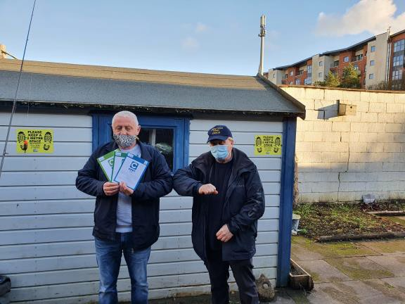
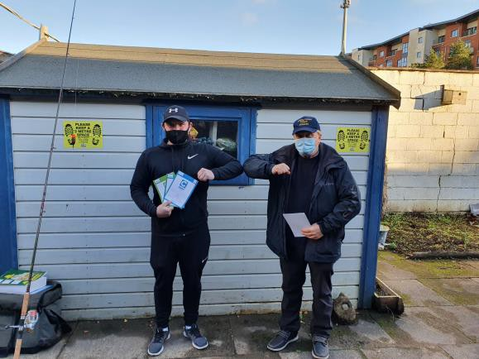
The ACI Sports Inclusion programme is long established. The Angling for All programme provides angling opportunities for all anglers including those with disabilities. We work with individuals or groups to cater for those with special needs, intellectual or physical disabilities of all forms weather mild, moderate, or severe. We invite those new to angling to participate in taster days to try our sport and participate in a range of angling events.

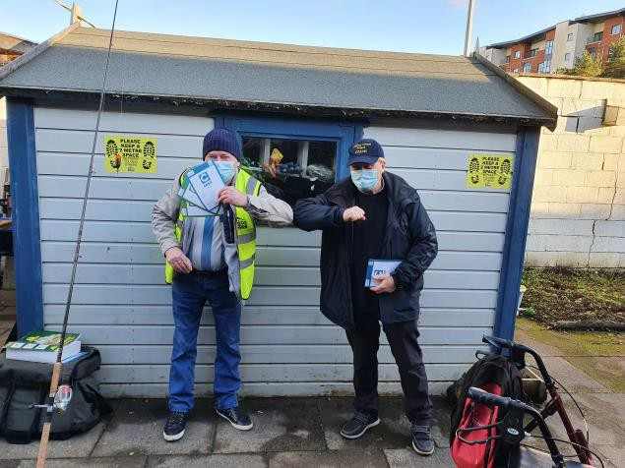
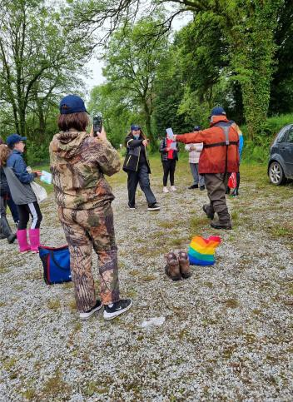
Presenting the CAST certificates at Headway COPE Scoil Bernadette students getting their CAST certs.

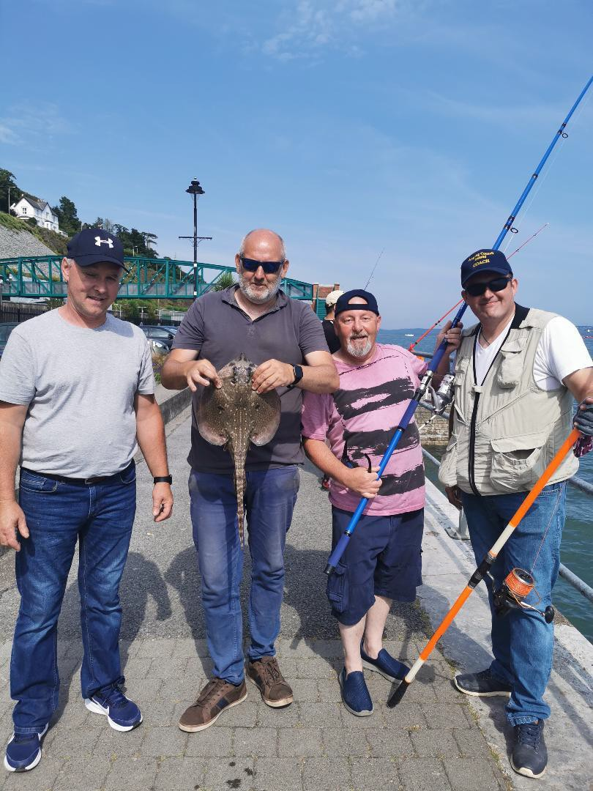
Headway (Acquired Brain Injury) group at Cobh

1 REVISION HISTORY

Revision History
Revision | Author | Notes
1.0 | ACI/SSTRAI/  IFSA | First Issue

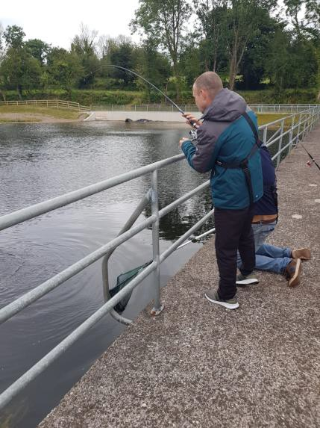
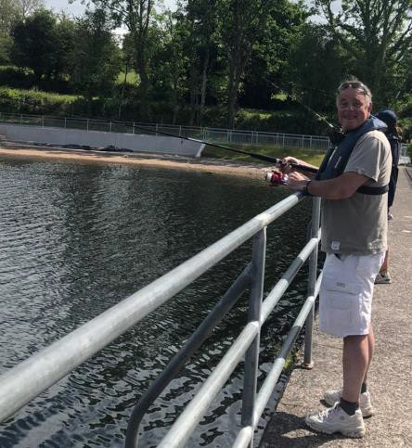
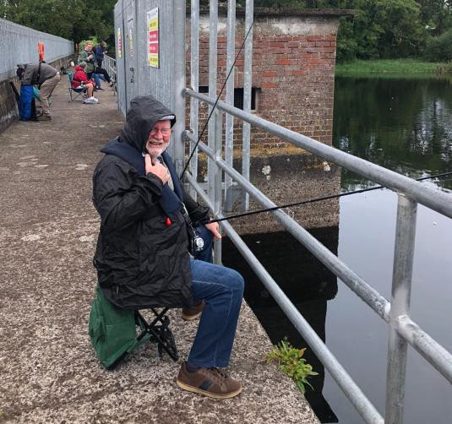

Page | 2

2 INTRODUCTION.

Introduction.

This programme funded through the Sport Ireland Dormant Account fund enables the ACI and its member federations to introduce, coach and train novice anglers in a wide range of angling skills, beginning with safety near on or near the water. We ensure plenty of fun elements for the young novice anglers and do our best to get them actively fishing as soon as possible. We then concentrate on helping them learn the necessary skills for them to become competent anglers. We use the ACI Angling Cast Programme which is a 6-stage certification programme and depending on the group we will work with them at a pace that is right for them. Our coaches are flexible, and we know we must be, also we understand that for many with disabilities their lives are very structured, and they have particular routines so we do what we can to facilitate this for each group and where practicable we will work with very small groups to help them along the angling pathway.

We have based a lot of this programme in Cork this year as we now have a reservoir stocked with fish and a good base to work from. We have been fortunate to secure a long lease with Irish Water and Cork County Council have supported us with this project. Inland Fisheries Ireland have also assisted with the venue development, and we have received funding from the Sports Capital Grants that has funded 50% of cost of a disability accessible angling boat for the venue and Cork Area.

This has allowed us to provide Cork with an Angling HUB through the Glanmire & District Salmon & Trout Anglers / SSTRAI that is well stocked and well equipped to work with many groups and for us to provide coaching to those that want to start fishing under a controlled and safe environment. Our coaches are delighted to give back to the novice anglers of all ages. In addition, we have access to some excellent salmon fishing on the river Blackwater in Cork and Waterford Ballyduff area.
Our colleagues in the IFSA are working with many groups around the country delivering the CAST programme and working both ashore and afloat introducing novices to angling and helping those who have completed level 3 to move on to levels 4-6.

Some pics of events held 2021
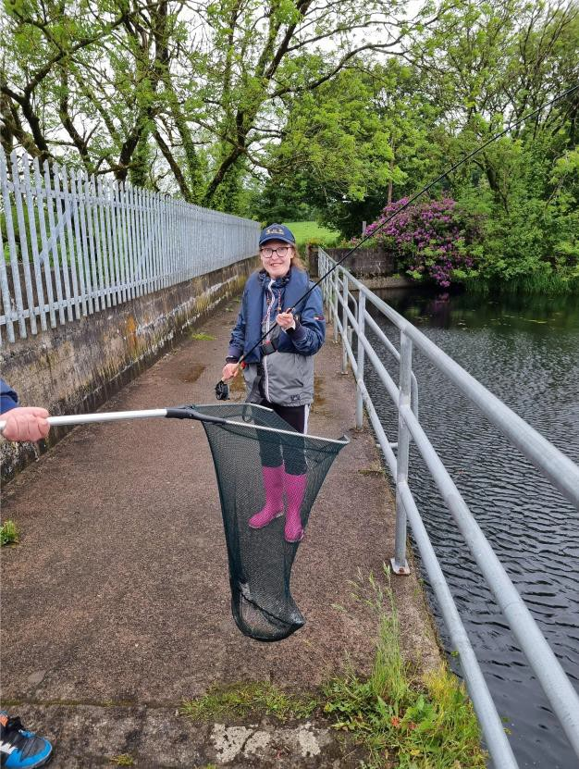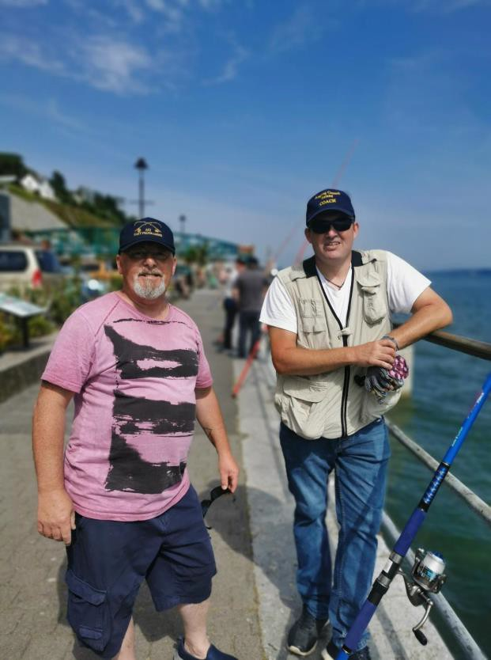

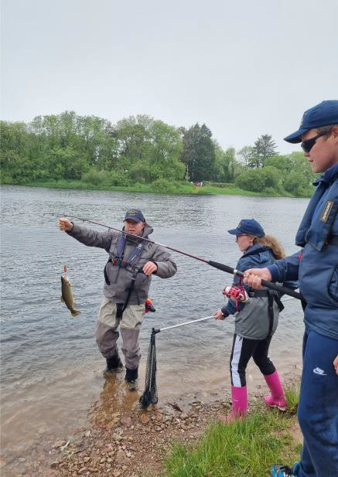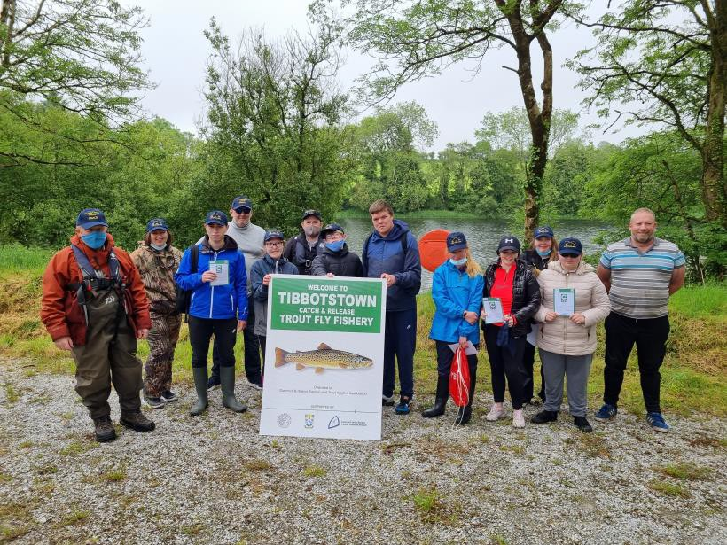

Groups from the COPE foundation Scoil Bernadette completed the ACI Cast Level 1 -3 and really enjoyed the craic, we had great fun also both at the school and on the reservoir. We worked on casting practice in the school tennis courts and completed introduction to water safety and the safety equipment, life jackets and throw ropes, safety glasses and angling caps. They all caught fish, landed fish, unhooked fish, and helped return fish safely to the water. We operate a catch and release policy at the reservoir and students and teachers enjoyed fly fishing and had some great catches, it was hard to get the fishing rods off the teachers not to mention the students at the end of the sessions. The principle said he would like to continue this programme with the transition students, and we look forward to continuing work with them.

From Headway Acquired Brain Injury Group members.

" I never thought I would be able to fish again since my stroke and my wonky hand, it felt good to be back" JB

" I find it hard to switch off and relax, I feel so relaxed when fishing I never knew it would make me feel so good." GM

"Marvellous, just marvellous" OOD

"Time flies and the instructors are so nice and helpful, I love it"

- Great fun, brings out the best in people
- Roles have changed for clients, 1 is now the driver and another the “sat nav”
- Having never fished before it was great to be given the opportunity to try a new hobby
- Breaking down barriers of communication and getting to know each other in a different setting outside of the centre
- Location is accessible to all
- Equipment was adapted to meet the individual needs of the clients i.e. right sided weakness
- Coaches are very supportive and they have a good understanding of the cognitive difficulties that we may have.

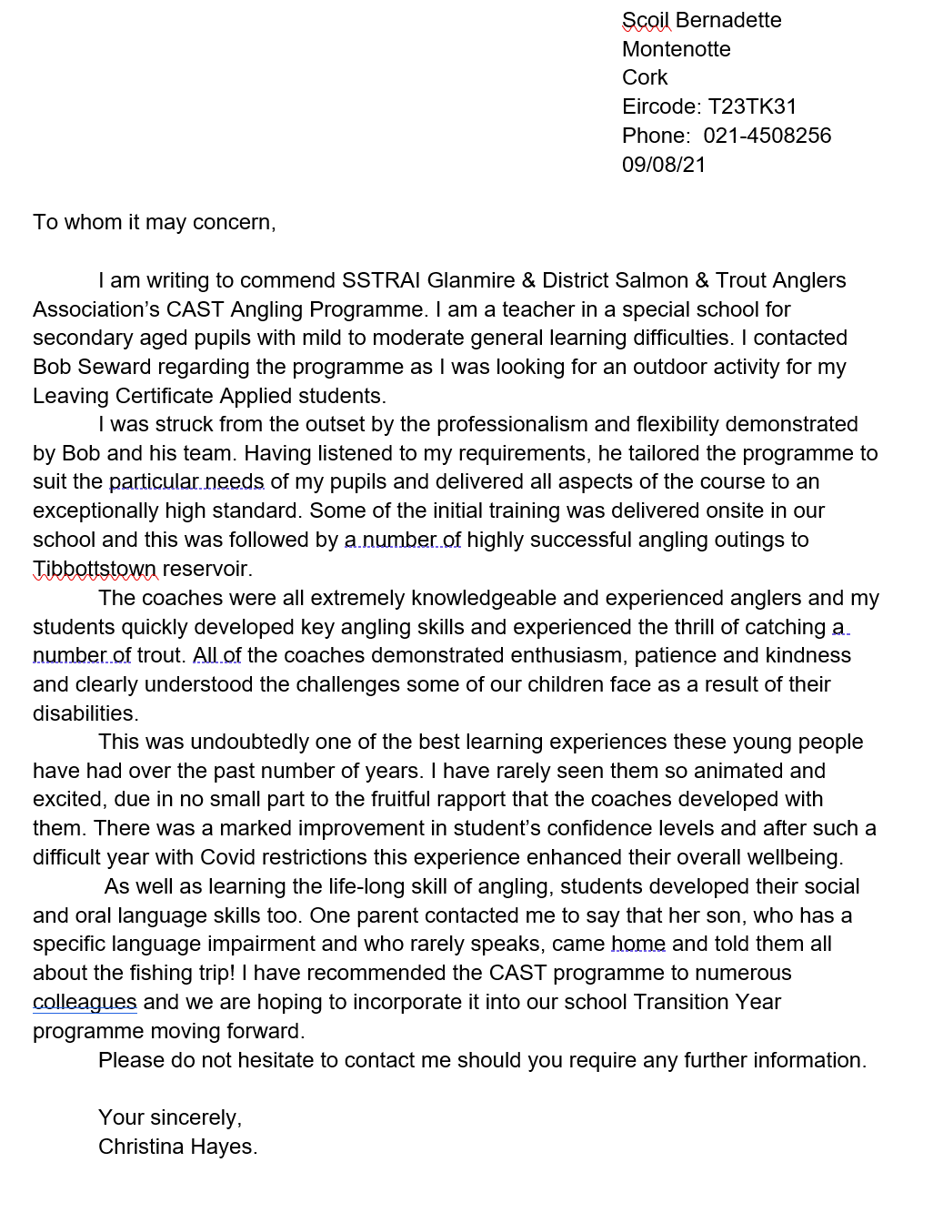
3 TESTIMONIAL COPE

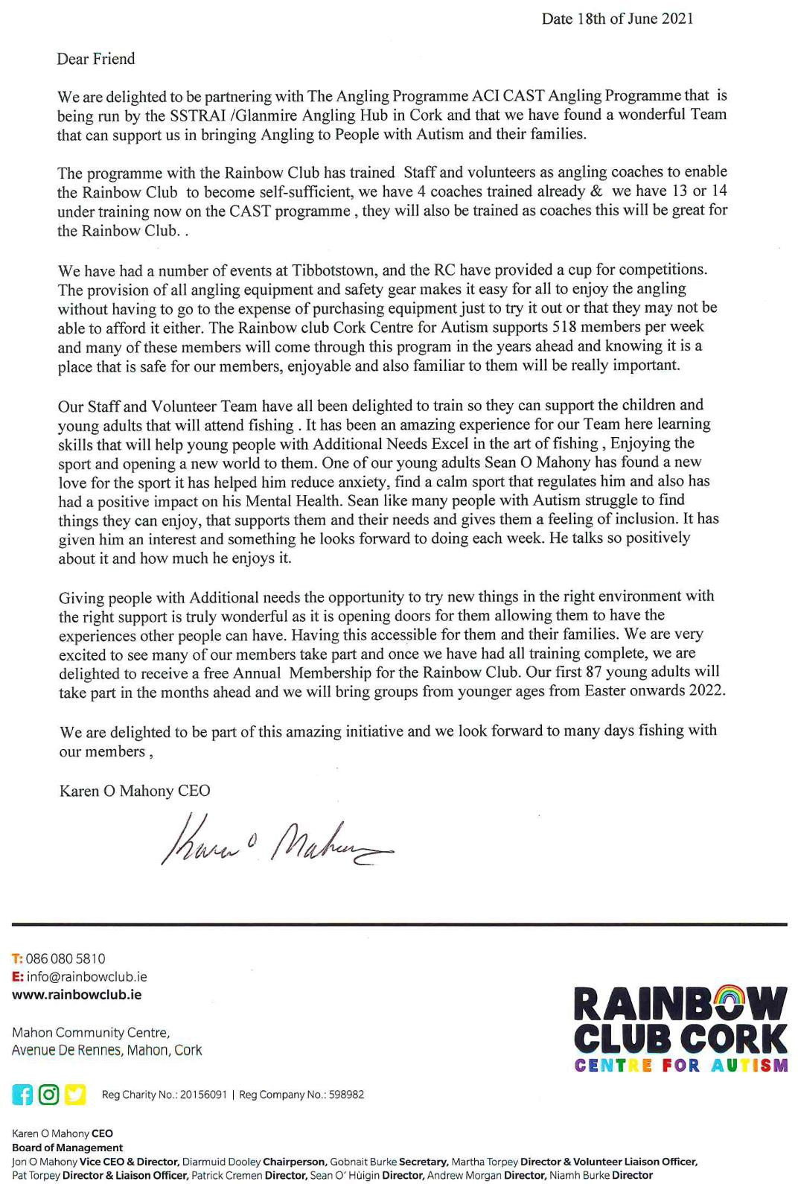

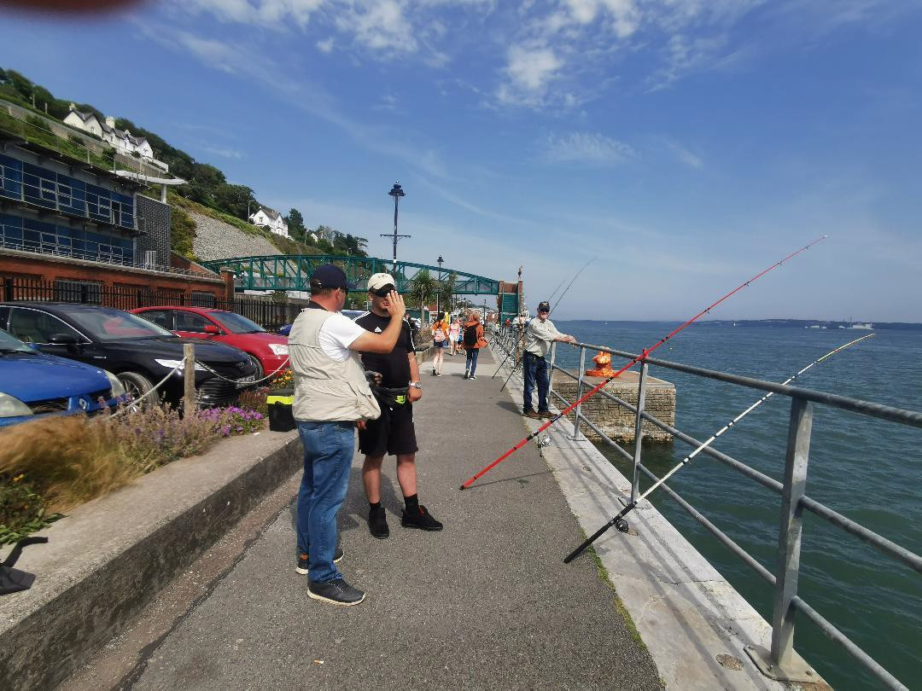
Deep water Quay Cobh, Denis here in black an example to us all, spends most of his day in a wheelchair, he said he never stood for so long out of the wheelchair without pain, 2hrs 20min until he fished with us at Cobh deep water quay.

Headway Ballincollig Cork
The angling cast programme has provided Headway clients with the opportunity for some to develop new skills and
others to reacquaint themselves with skills they hadn’t the opportunity to use in a long time.
Participating on this programme gives our clients with a relaxing atmosphere to strengthen neurological structures often damaged due to their brain Injury such as mental, emotional, and physical areas. This group also offers our clients the opportunity to develop a hobby and social outlet that is transferable to their own communities and improving quality of life.
Jackie McCann

3.1 AREAS OF OPERATION

Some photographs and comments from events below.

- River Blackwater Salmon and Trout Angling Cork and Waterford
- Tibbotstown Reservoir Brown and Rainbow trout Fishing
- Cork, Clare, Kerry, Wexford Sea Angling Shore
- River Lee Tidal Waters Angling
- Beach Angling Waterville
- Coach Training online, Waterford, Cork Harbour and in Rathcormac.
- Sea Angling Boat, Donegal, Cork, and Wicklow.

Youth Sea Angling with IFSA in Co Clare
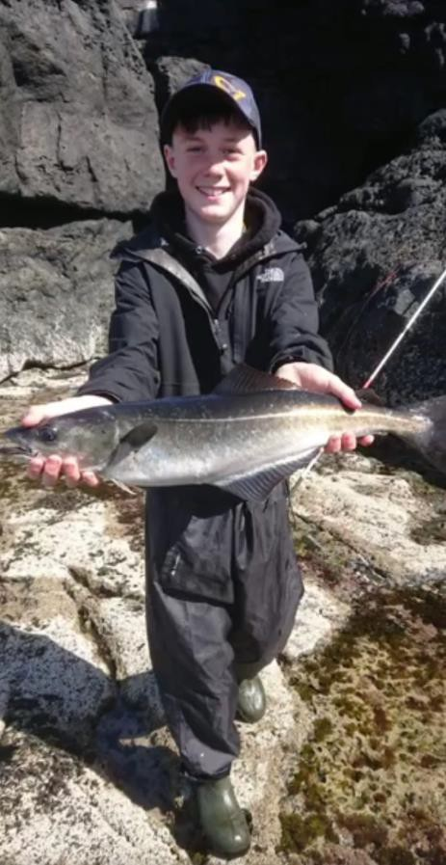
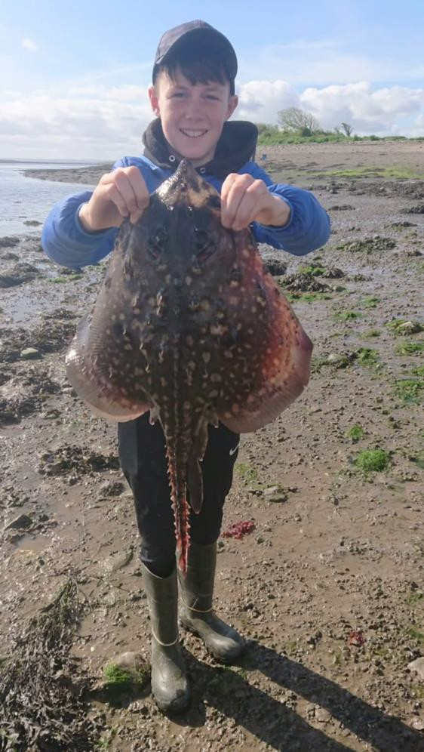

Our IFSA sea anglers are delighted to be back with outdoor angling adventure events on beaches, and shorelines and boats around the country. Encouraging people back out has not been too difficult, a fish of the month initiative was well received by the novice and experienced anglers alike. The CAST programme is now embedded in our angling coaching and we are working with lots of groups in communities around the country.

Dormant A/C support through Sport Ireland for community and inclusion programmes enables the delivery of so much more to groups, the provision of equipment and training enables good coaching sessions in safe environments which is so important to all those involved. It also helps reduce the cost making it much more accessible for all. Angling is a cradle to grave sport and it provides wonderful outdoor adventure opportunities for all ages and all abilities, male, female or other.

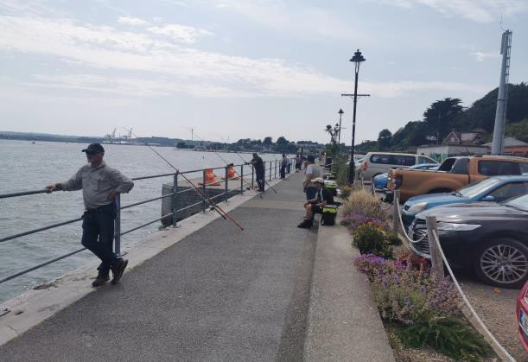
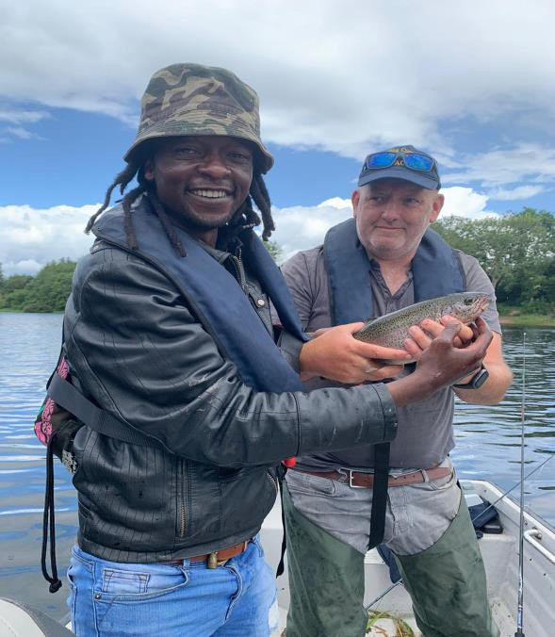
ANGLING PICS

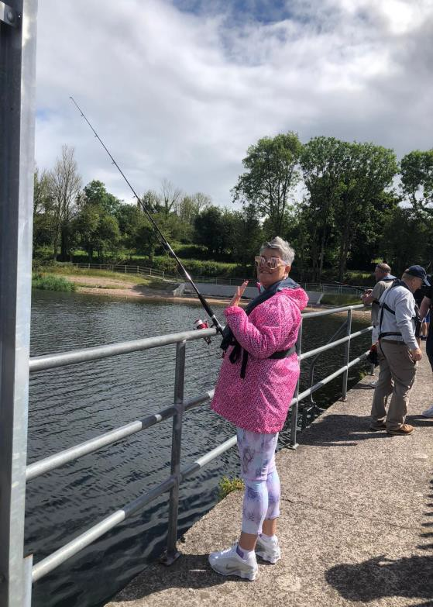

First time fishing and first ever fish a rainbow trout, had a great day with Andrew on the lake boat.

Shore casting rods in use at Cobh. This venue is ideal for disability groups with secure railings and adjacent to the railway station, good carparking and multiple seating areas for those that need it. Coaches keep a watchful eye and assist where necessary during all activities. This venue has been used numerous times for our events. The venue is suitable during summer and winter, it is well lit and close to amenities. We are also working with our IFSA colleagues for the boat angling elements, particularly for the competitive groups.

We now have a stock of angling equipment for Sea shore and boat, Game and Pike / Perch angling for multiple groups.
Headway Cork have acquired their own equipment through the ACI / SSTRAI with some support from Cork Sports Partnership. We can facilitate multiple user groups at the same time. It is hoped to introduce the group to boat sea angling later this year. We are working on obtaining 2 small 22ft craft with capacity of 5 on each for Cork City and harbour fishing next year.

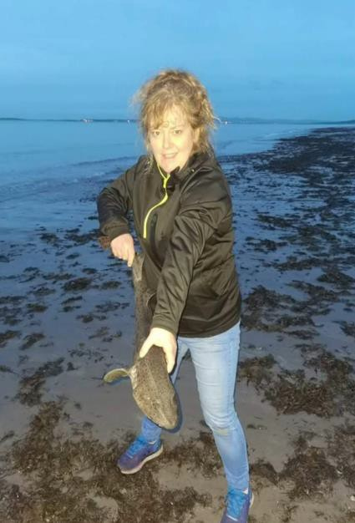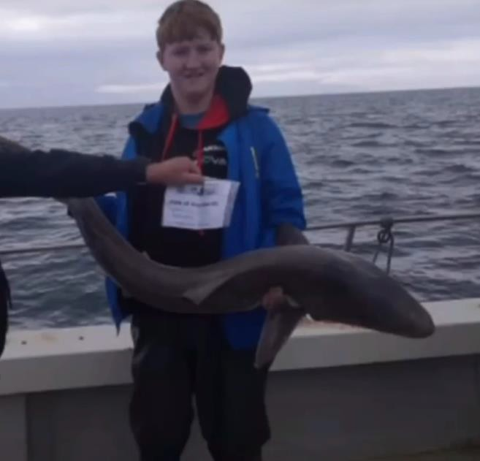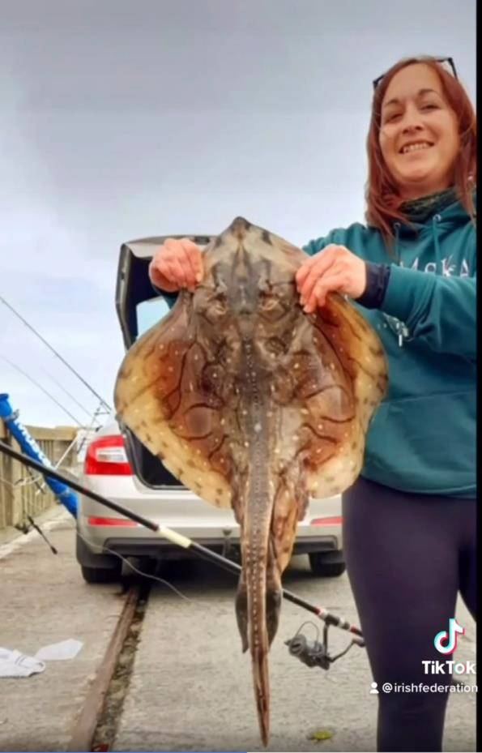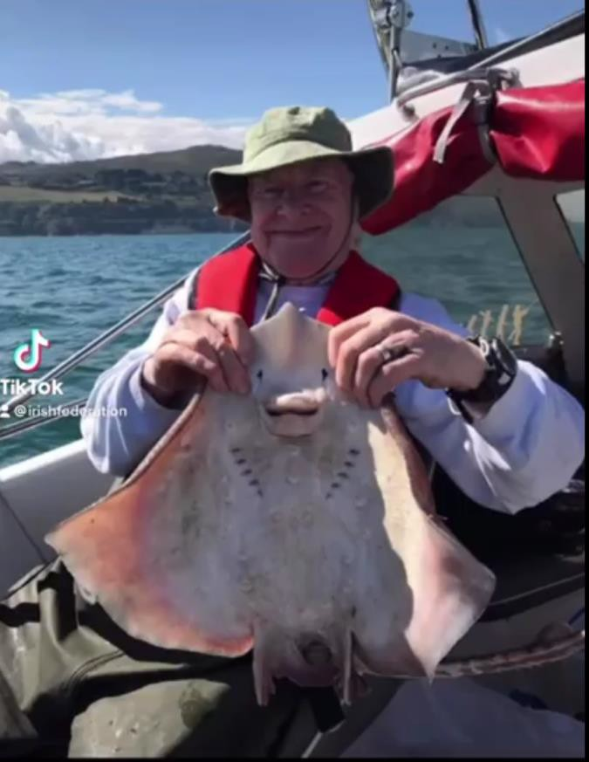
IFSA Ladies in action at Fenit Pier Co. Kerry Bull Huss, Shark and Rays in July

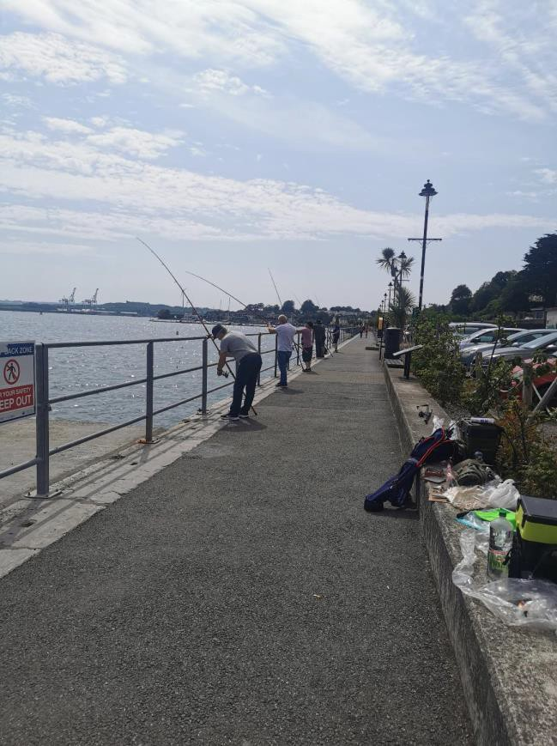
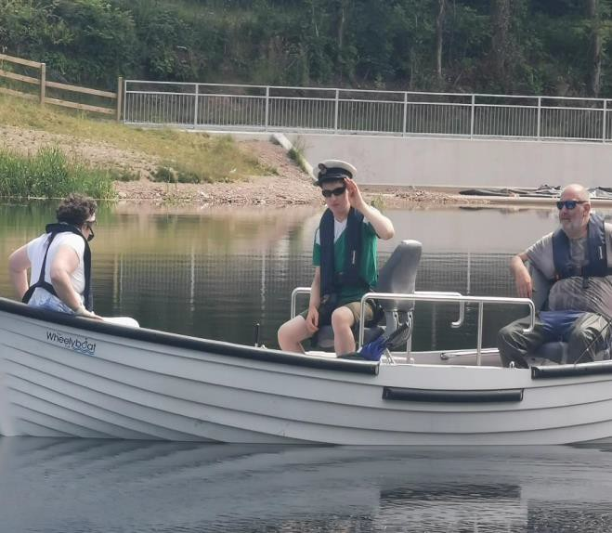
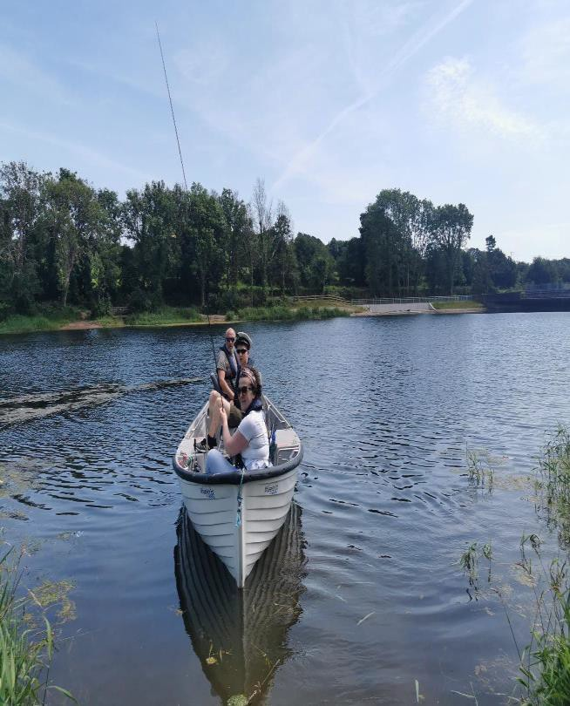
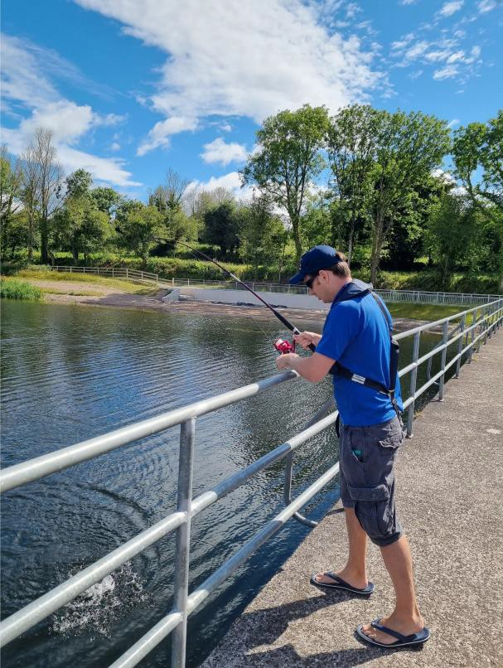

Great to see everyone concentrating on the casting and fishing and not on their disability. Everyone had a great day. All bait, rigs and equipment provided by ACI/SSTRAI. Anglers just need to turn up with an open mind and enjoy the experience.

Wheelyboat at Tibbotstown “Captain Craig” giving the orders, he caught 2 nice brown trout, Rainbow Club coaches Claire and Andrew assisting. The Wheelyboat was part funded by Sports Capital Grant, Cork Sports Partnership and the Club.
Cork Sports Partnership staff member Cathal Geraghty hooked into a nice rainbow trout at the taster day for Cork Youth Leaders. The aim of these taster days is to show youth leaders from around Cork what angling has to offer their respective groups. Plenty of action and they also experienced coaches working with a disability group afterwards.

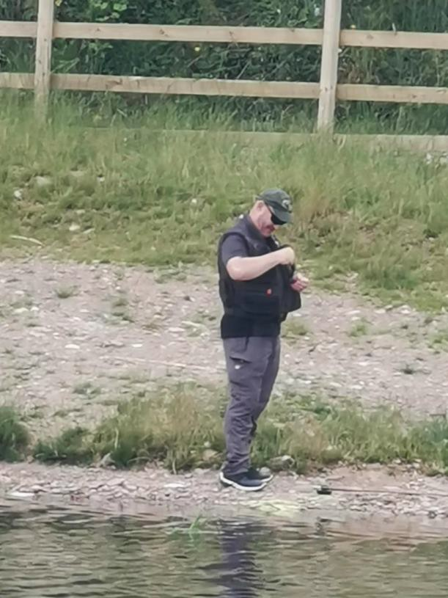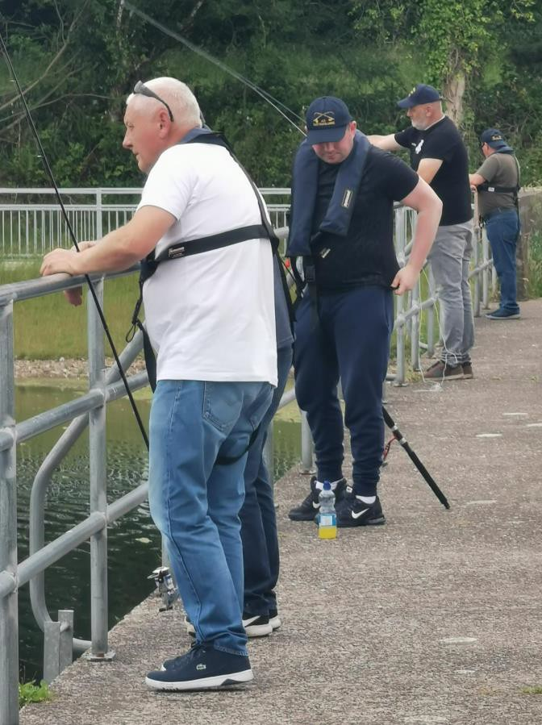

Headway client selecting the right fly Enjoying the sunshine and practicing the fly casting
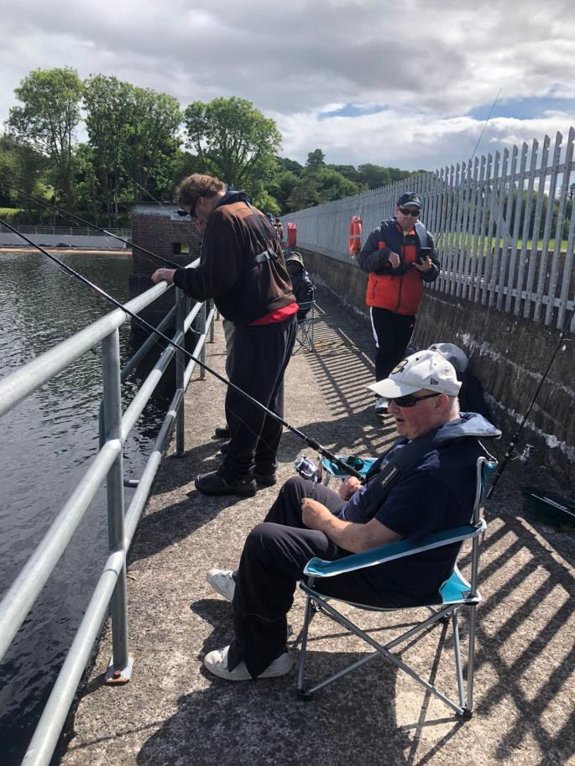

Sitting back, relaxing and enjoying the experience, no pressure, a wonderful group to fish with.

We normally take turns on the boats, particularly for those who feel comfortable on the water and who may find casting difficult due to their disability. We can troll the lures and they enjoy this.

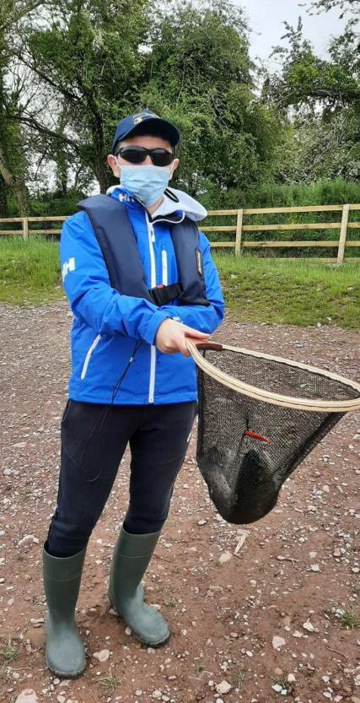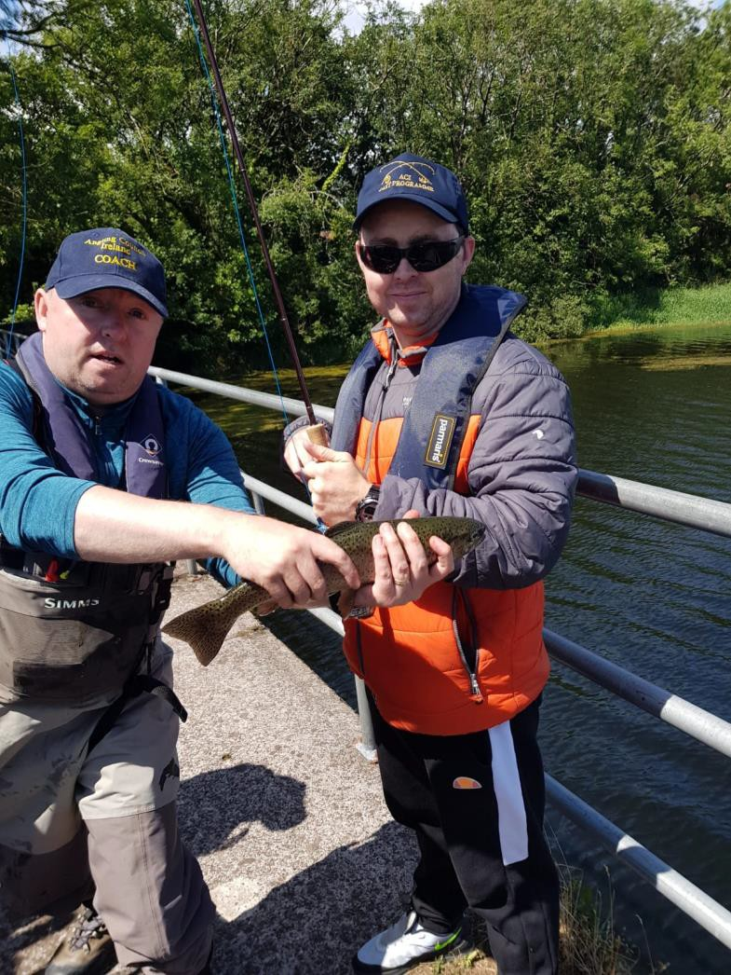

Landing his first ever fish at Tibbotstown, and what a fish.
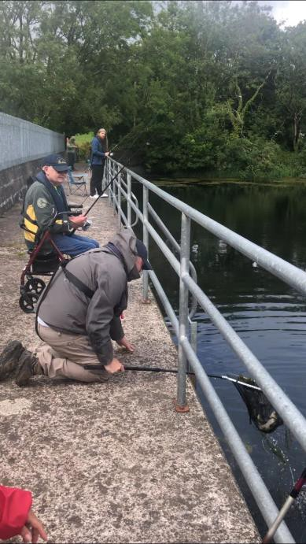

Walter’s determination won out in the end with a fabulous 3lb brown trout. He well deserved it with all the casting and sorting out the tangles he would not let his disability get in the way of having some good days out with the lads, he has great spirit and is always good for a laugh.

Jonathan our coach is kept busy at every event working hard to help everyone get on the fish.

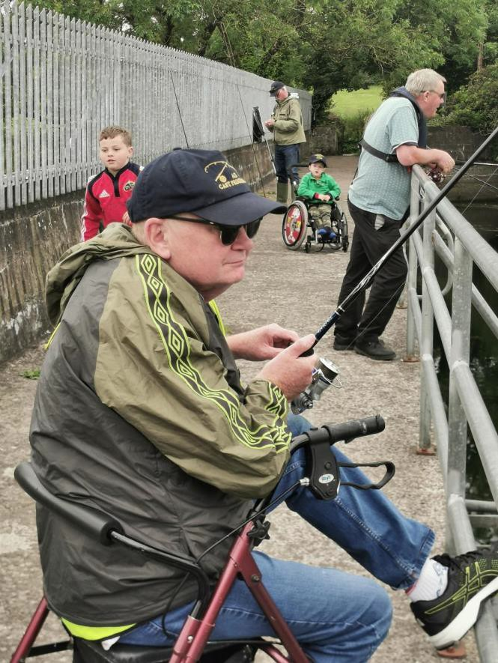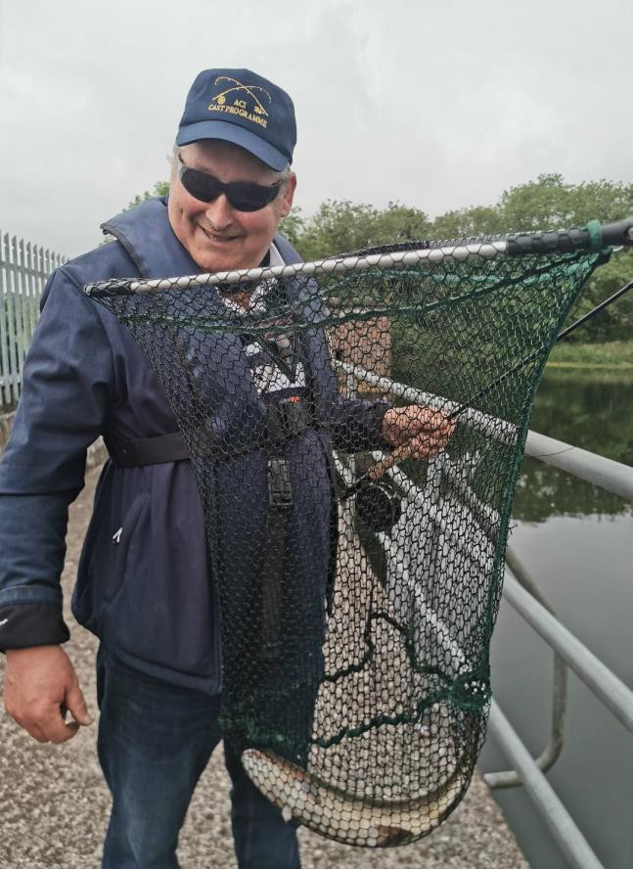

Smiles all round, Headway group members, a quality brown trout on the fly, note our junior members enjoy helping out and coaching.

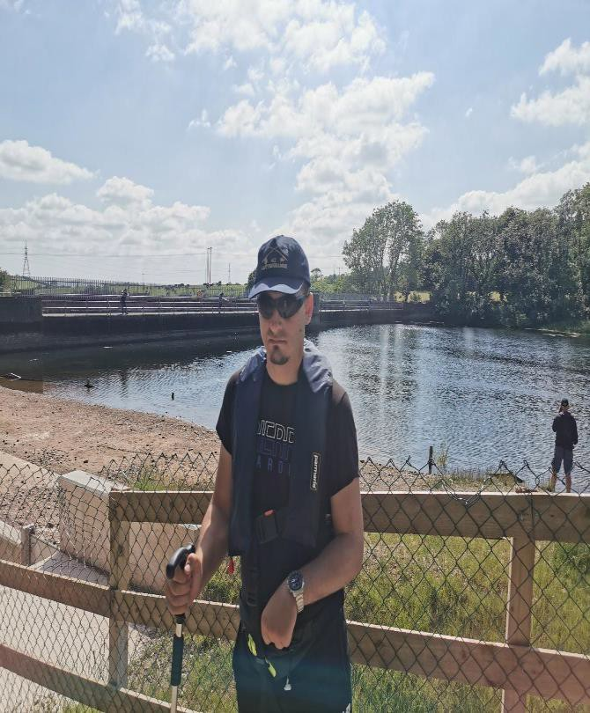
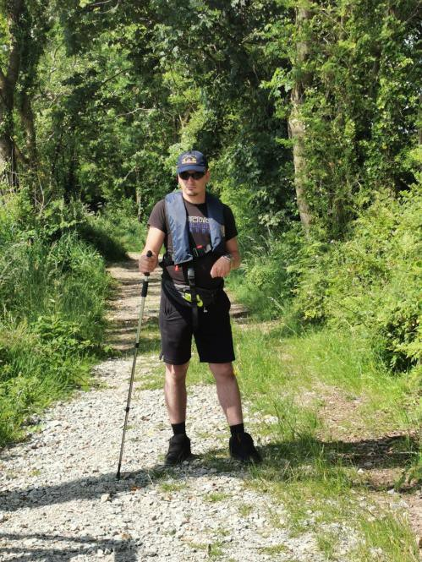 l

Denis from Headway acquired brain injury group 1 took a break from the fishing and his wheelchair at the start of the dam wall for a walk to the woods, he is amazing. He keeps pushing himself to improve his mobility and he enjoys getting out.

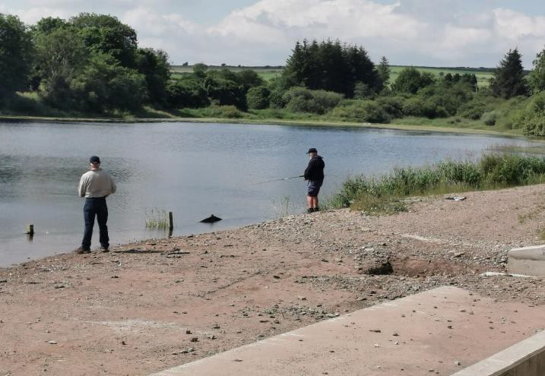

Being out in the fresh air and participating in an adventure sport does a lot of good for your mental health, just one of the comments we often get, another is just have a look around, everyone is laughing and smiling and enjoying themselves.
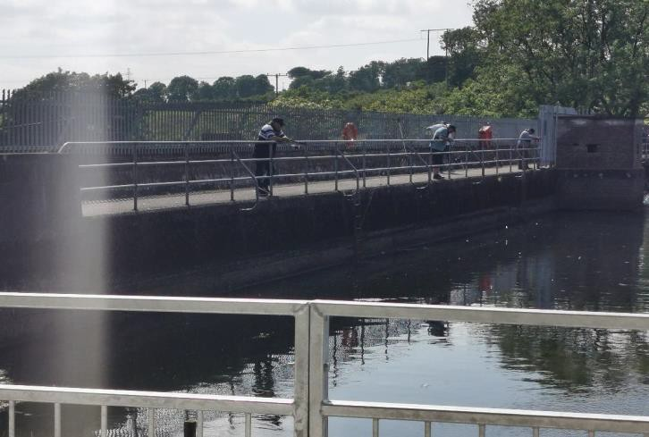
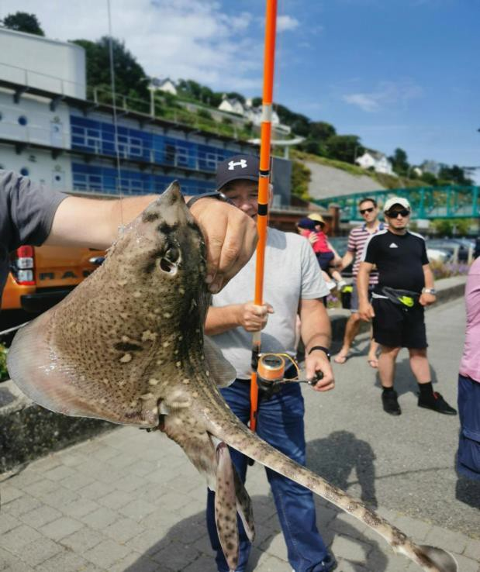
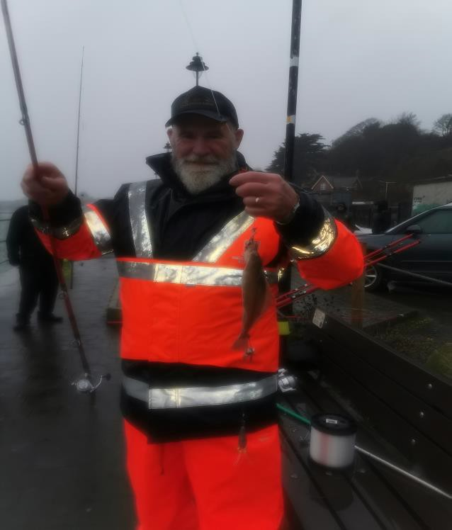

Concentrating on the rising trout, trying to determine what they are feeding on, real dedication what a team. In the warm weather it can be difficult to get the fish to take, nothing stops these guys from trying and enjoying it.

Below one of the ones that did not get away, all fish returned safely.

What a difference a day makes, summer and winter fishing with Headway in Cobh deep water quay.

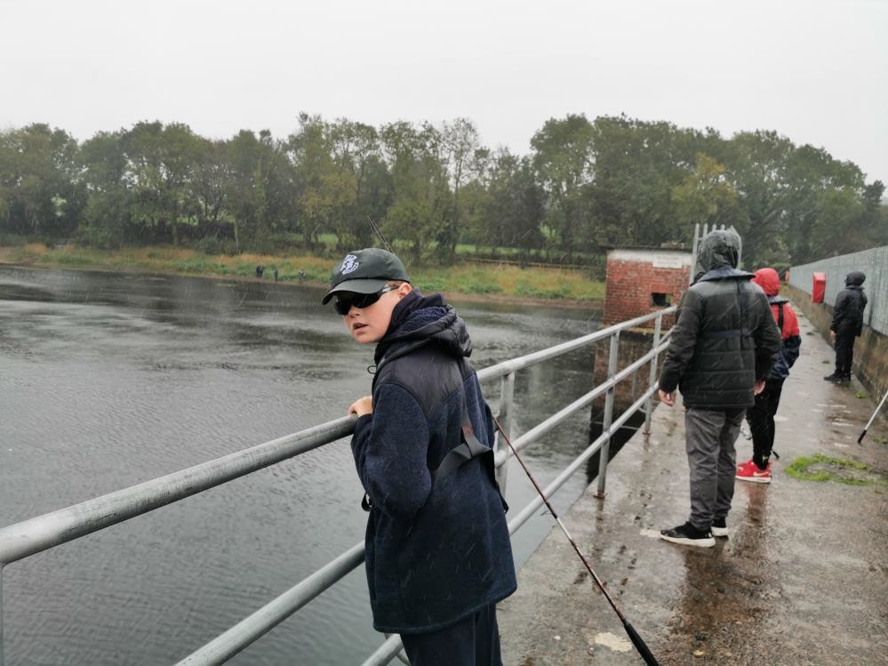
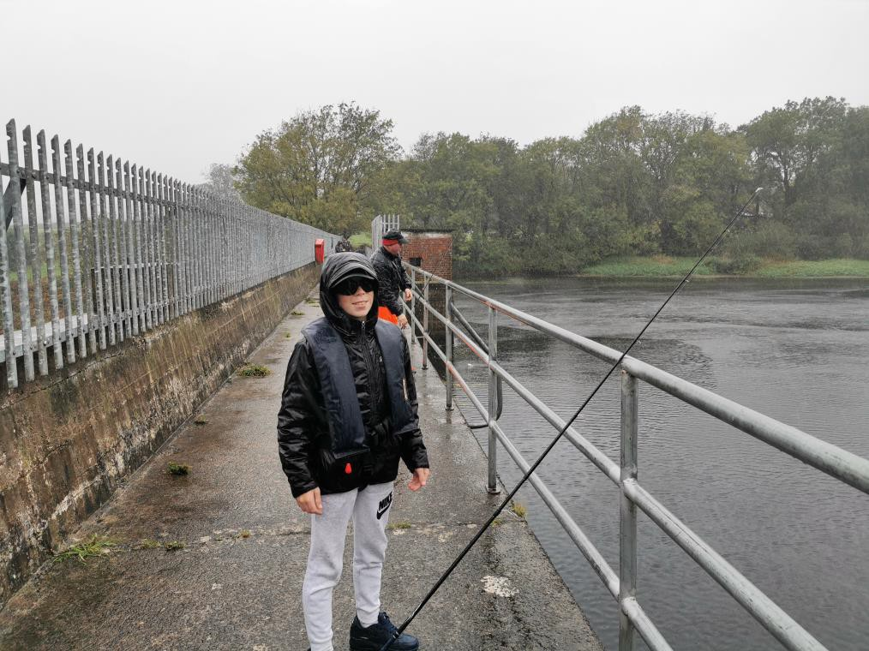

We had the pleasure of welcoming a youth group from Moyross in Limerick that we have worked with in the past. Despite the weather they really enjoyed the
fishing. Many repeat visits are planned for this great group, nothing puts them off the fishing and they enjoyed the coaching.

Many of the carers work on one to one basis with these young people, Garda Youth Diversion etc.
They were a pleasure to work with and so polite. We will have the boats ready for their next trip.

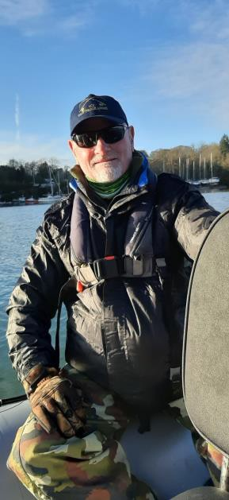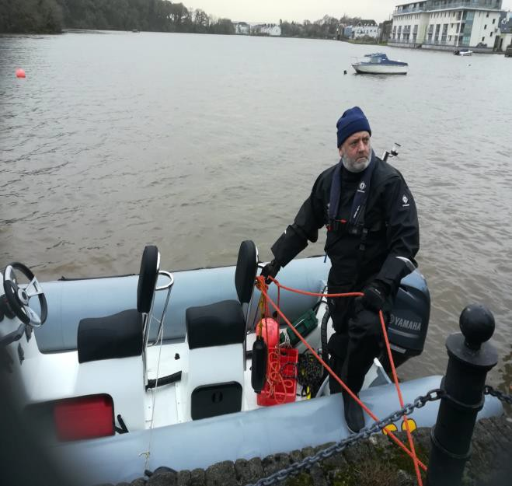

John O Brien and Andrew Morgan completed the powerboat level 2 training in Cork Harbour as part of the Coach CPD training and for safe operation of the wheelyboat.
Releasing a grilse on the Backwater during a fly fishing taster day at Kilbarry Cork and Flowerhill Waterford
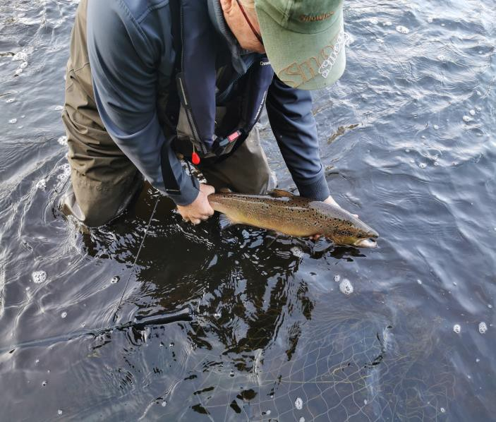
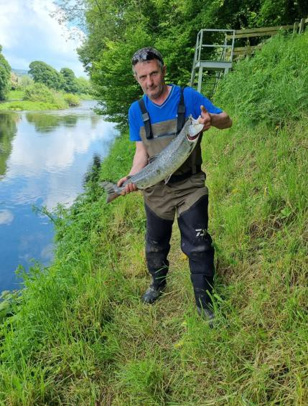

Coach Greg Farrell landed a nice fish also.

We are working with Cork Sports Partnership and have delivered taster sessions for Cork Youth Workers so they have some experience and may encourage their respective groups to come and fish with us from Sept to December. 9 groups have expressed and interest so far.
We are holding a second taster day at the end of August to accommodate more youth leaders. Cork Sports Partnership are liaising with the groups. Transportation is an issue for some groups, so we are testing out new fishing locations in Blackrock and on the river Lee.

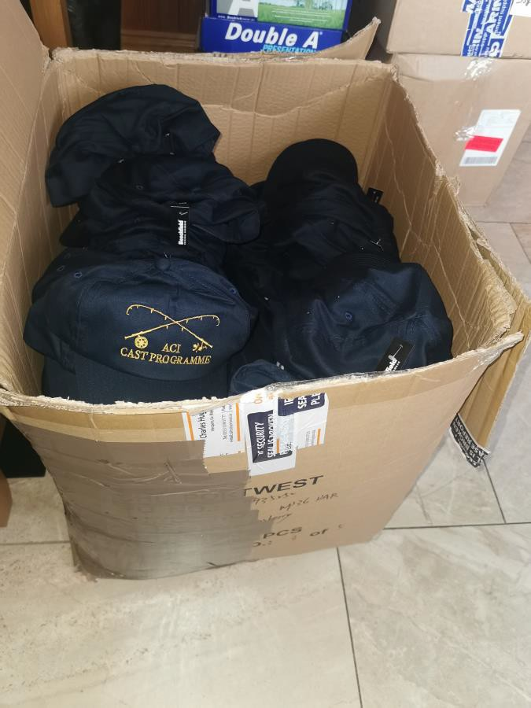

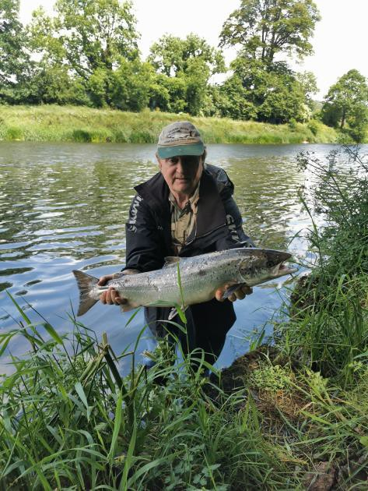

Nice salmon on the blackwater, caught during a coach training session at Kilbarry upper.
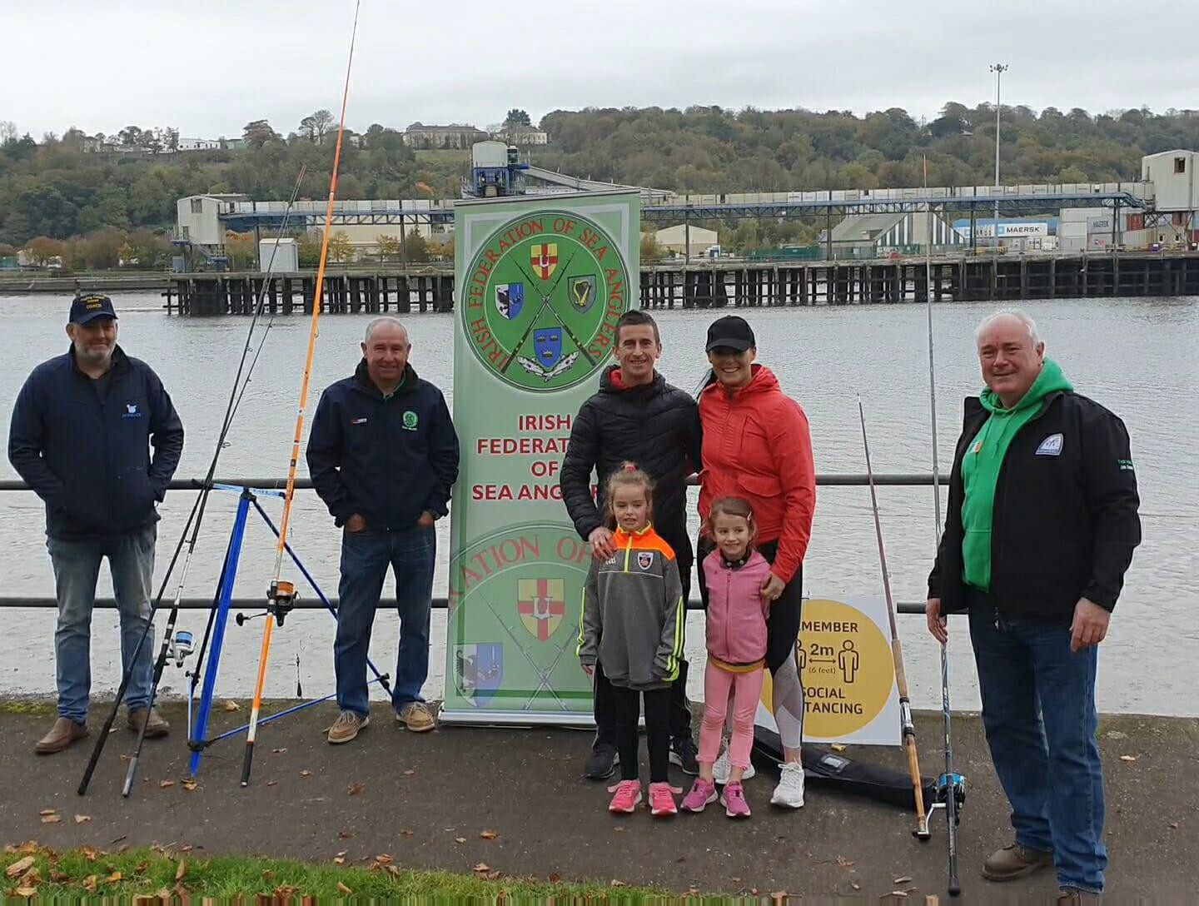

Estuary Fishing SSTRAI and IFSA, Rob Heffernan and his family joined in with us at the Marina Cork Taster day, we sea angling and fly fishing demonstrations and lots of practice rods for all to try out. We maintained good social distance and disinfection protocols.

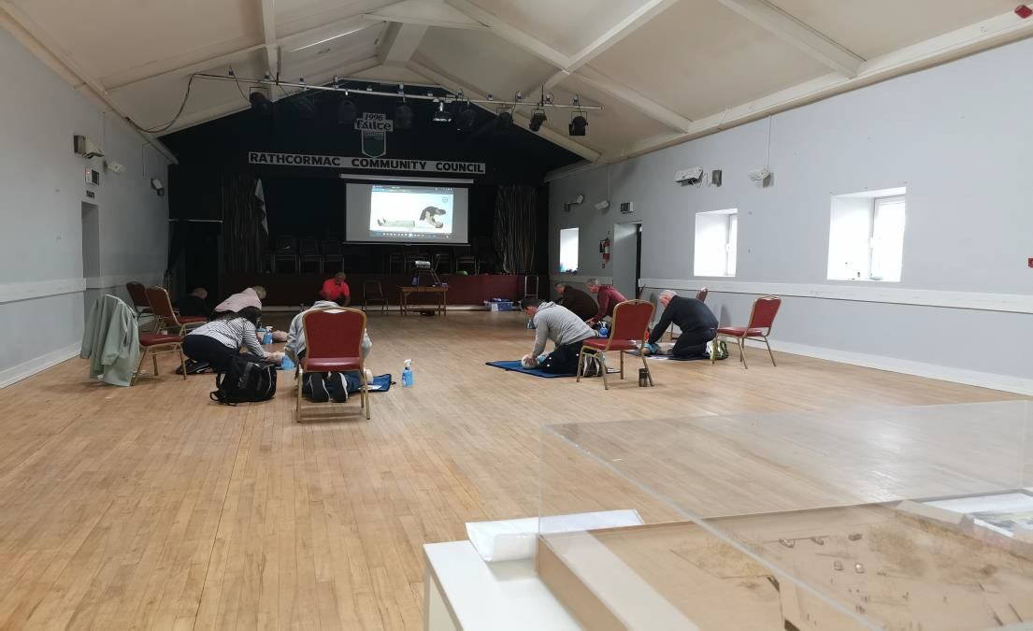

ACI Coaches undergoing the ACI First Aid defibrillator training during the course at Rathcormac 2021. Course delivered by John O Brien Paramedic First Aid Instructor and ACI Coach Developer under training
We have completed 3 introductory level coaching courses, Coaching people with disabilities, Health & Safety, Safe Wading and Water Rescue workshops and First Aid for Angling. We have 14 additional volunteers from the Rainbow Club for children with autism under training in preparation for a coaching course in September. The Rainbow club membership has now increased to 500 children, we are working with 87 of the older Rainbow club members to start with and carers / coaches in total 103 in small groups and all new coaches will be working with our experienced coaches / coach developers well into the future. This will be developed further with younger children and their families for next year.
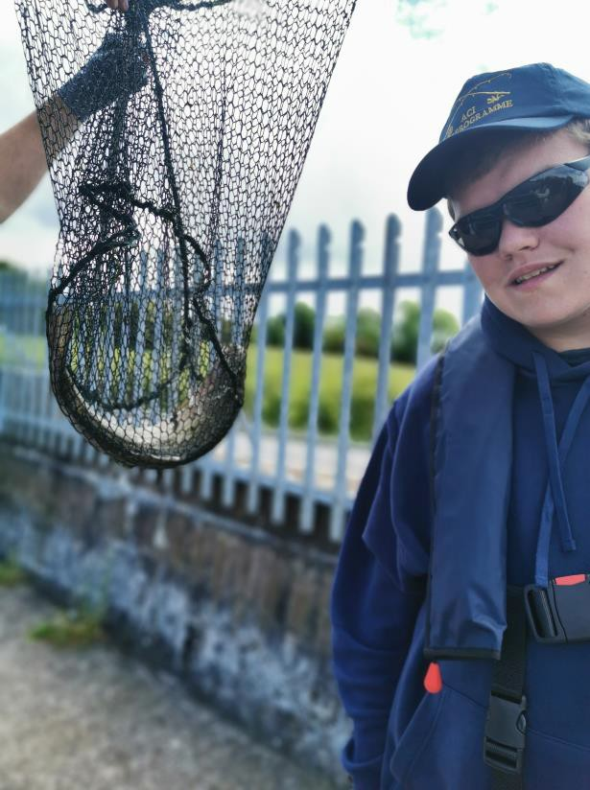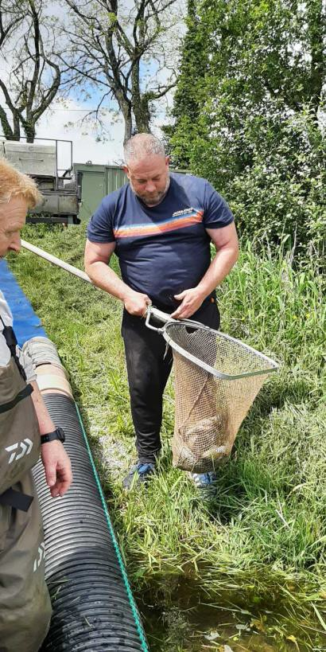

Coach Timothy Ahearn releasing trout into the reservoir as part of our stocking programme. 500 trout released at a cost of €2,500, we are aiming for a second stocking in September for the winter fishing for Rainbow trout.

Across

Cope Foundation Scoil Bernadette student, delighted after catching his first fish a nice rainbow trout.

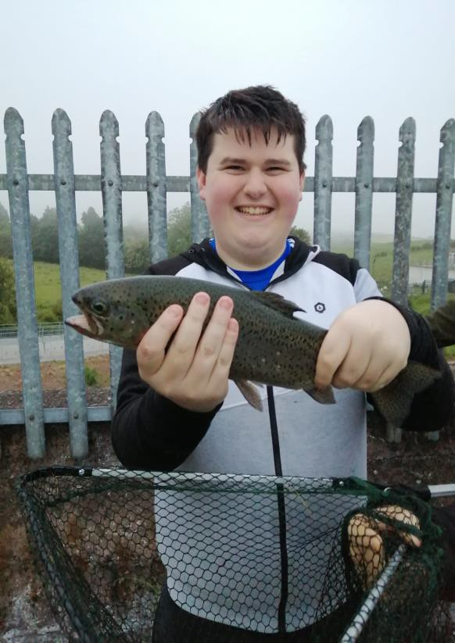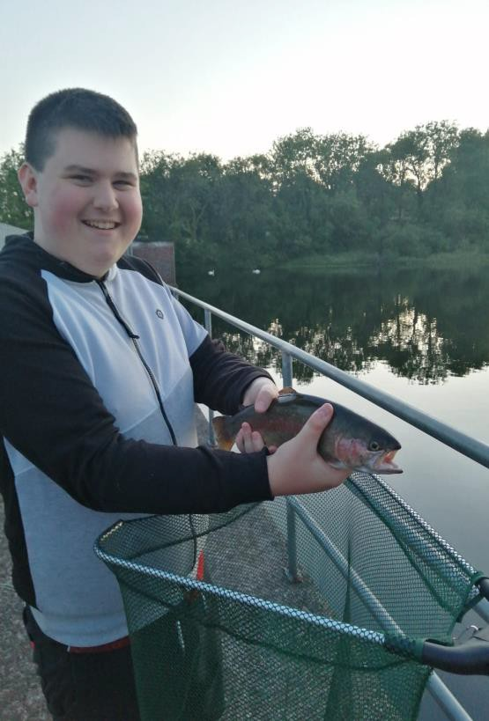
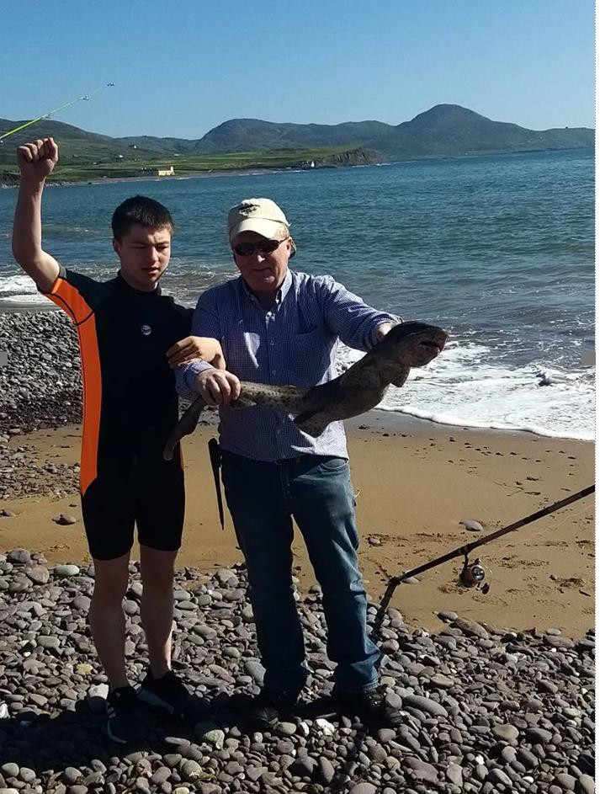
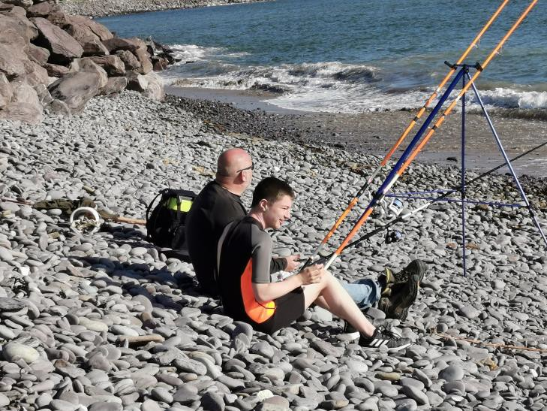

The smiles say it all, after a lot of practice casting, success at last with his first ever fish, then a second. Living with autism will not hold Sean back, he wants to become an ACI angling coach junior leader. We will help him all the way and he is working through the CAST Programme. Mum and Dad are so proud. Below Craig from the Rainbow club celebrating after catching a 10Lb Bull Huss (member of the shark family) from the beach in Waterville, he loves being at or on the water, he is not sure about handling some fish species though.

The ACI Community and Inclusion Programme is working well albeit a late start due to Covid 19 restrictions. We are confident we will at least meet our target numbers and expect to well exceed them by end of year. Since we are back delivering, we have seen new groups forming up in Tipperary, Kilsheelan where there is a great interest from the young and older novice anglers. We have events organised for August. We have a number of new groups for September with Cork Sports Partnership, Organisation of National Ex-service Personnel ONE, Addiction recovery and over 55 sheltered housing groups, in addition to our main groups.

The ACI through Sport Ireland and the Return to Sport Expert Group advice were granted opportunities as of the 7th of June to return to Angling Events on the basis that we adhere to the recommendations and COVID 19 Guidelines, (Procedures and documents). Each club /group was required to complete the relevant covid compliance documents and follow the procedures. The ACI delivered training to clubs and groups on the duties of Covid Compliance Officer and a Covid Designated Officer – both required to have completed the ACI Online Induction Course.

Each club/HUB/group were required to complete and return the relevant documents, forward the names of their Nominated Child Protection and Covid Officers to their Provincial Secretary and the National Secretary prior to commencing any competitions or events.

The roles of the Covid Compliance and Designated officers have been covered in the ACI Online Induction Course. It was essential that the Covid Compliance Officer ensured that the guidelines as updated were adhered to, that the Covid documentation was completed and legible and maintained as required. To date we have had no reported issues due to events organised under the Dormant A/C’s Community and Inclusion Programme, we worked with pods in the disability groups who were permitted to open and operate prior to June 7th.

The new Lee Adventurer was launched this year in June and we are now providing angling coaching in Cork Harbour, we have had some great sessions with children with autism, youth lady’s groups and adults most of whom caught their first fish ever, they all enjoyed the trips and angling.
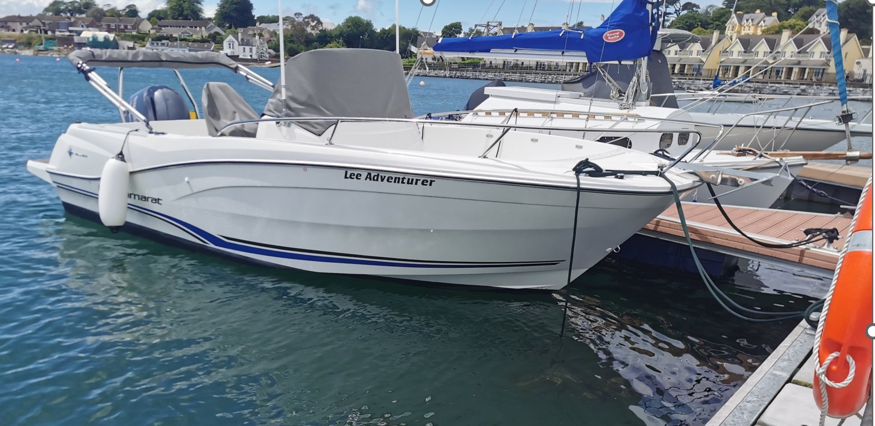
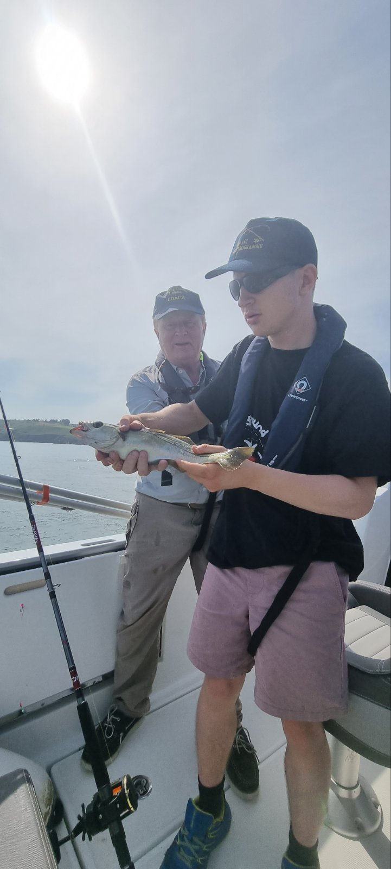 Craig O Shea with his first ever Pollack, he had a great day
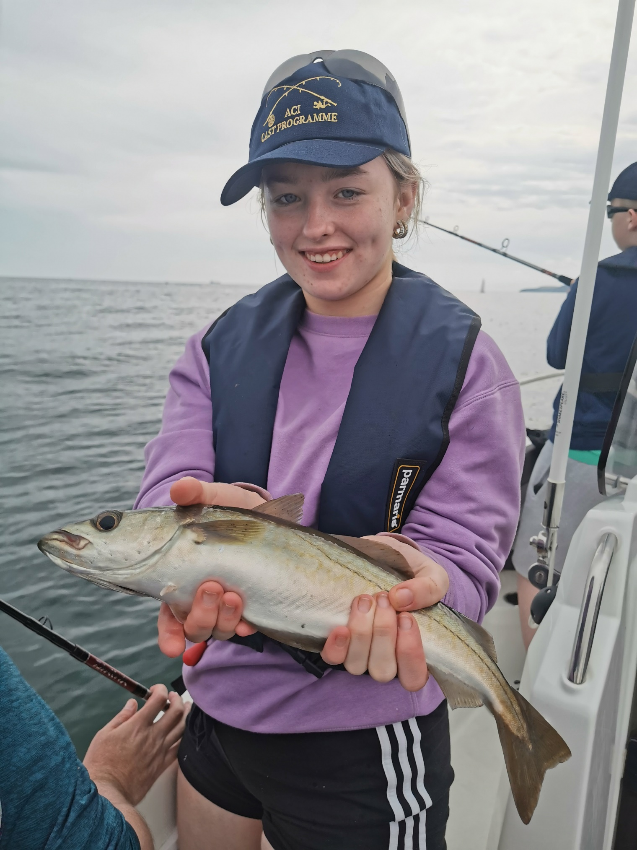

Great day out on Lee Adventurer, first ever fish, they had a great taster day and all signed up for the Women In Sport Angling Cast Programme 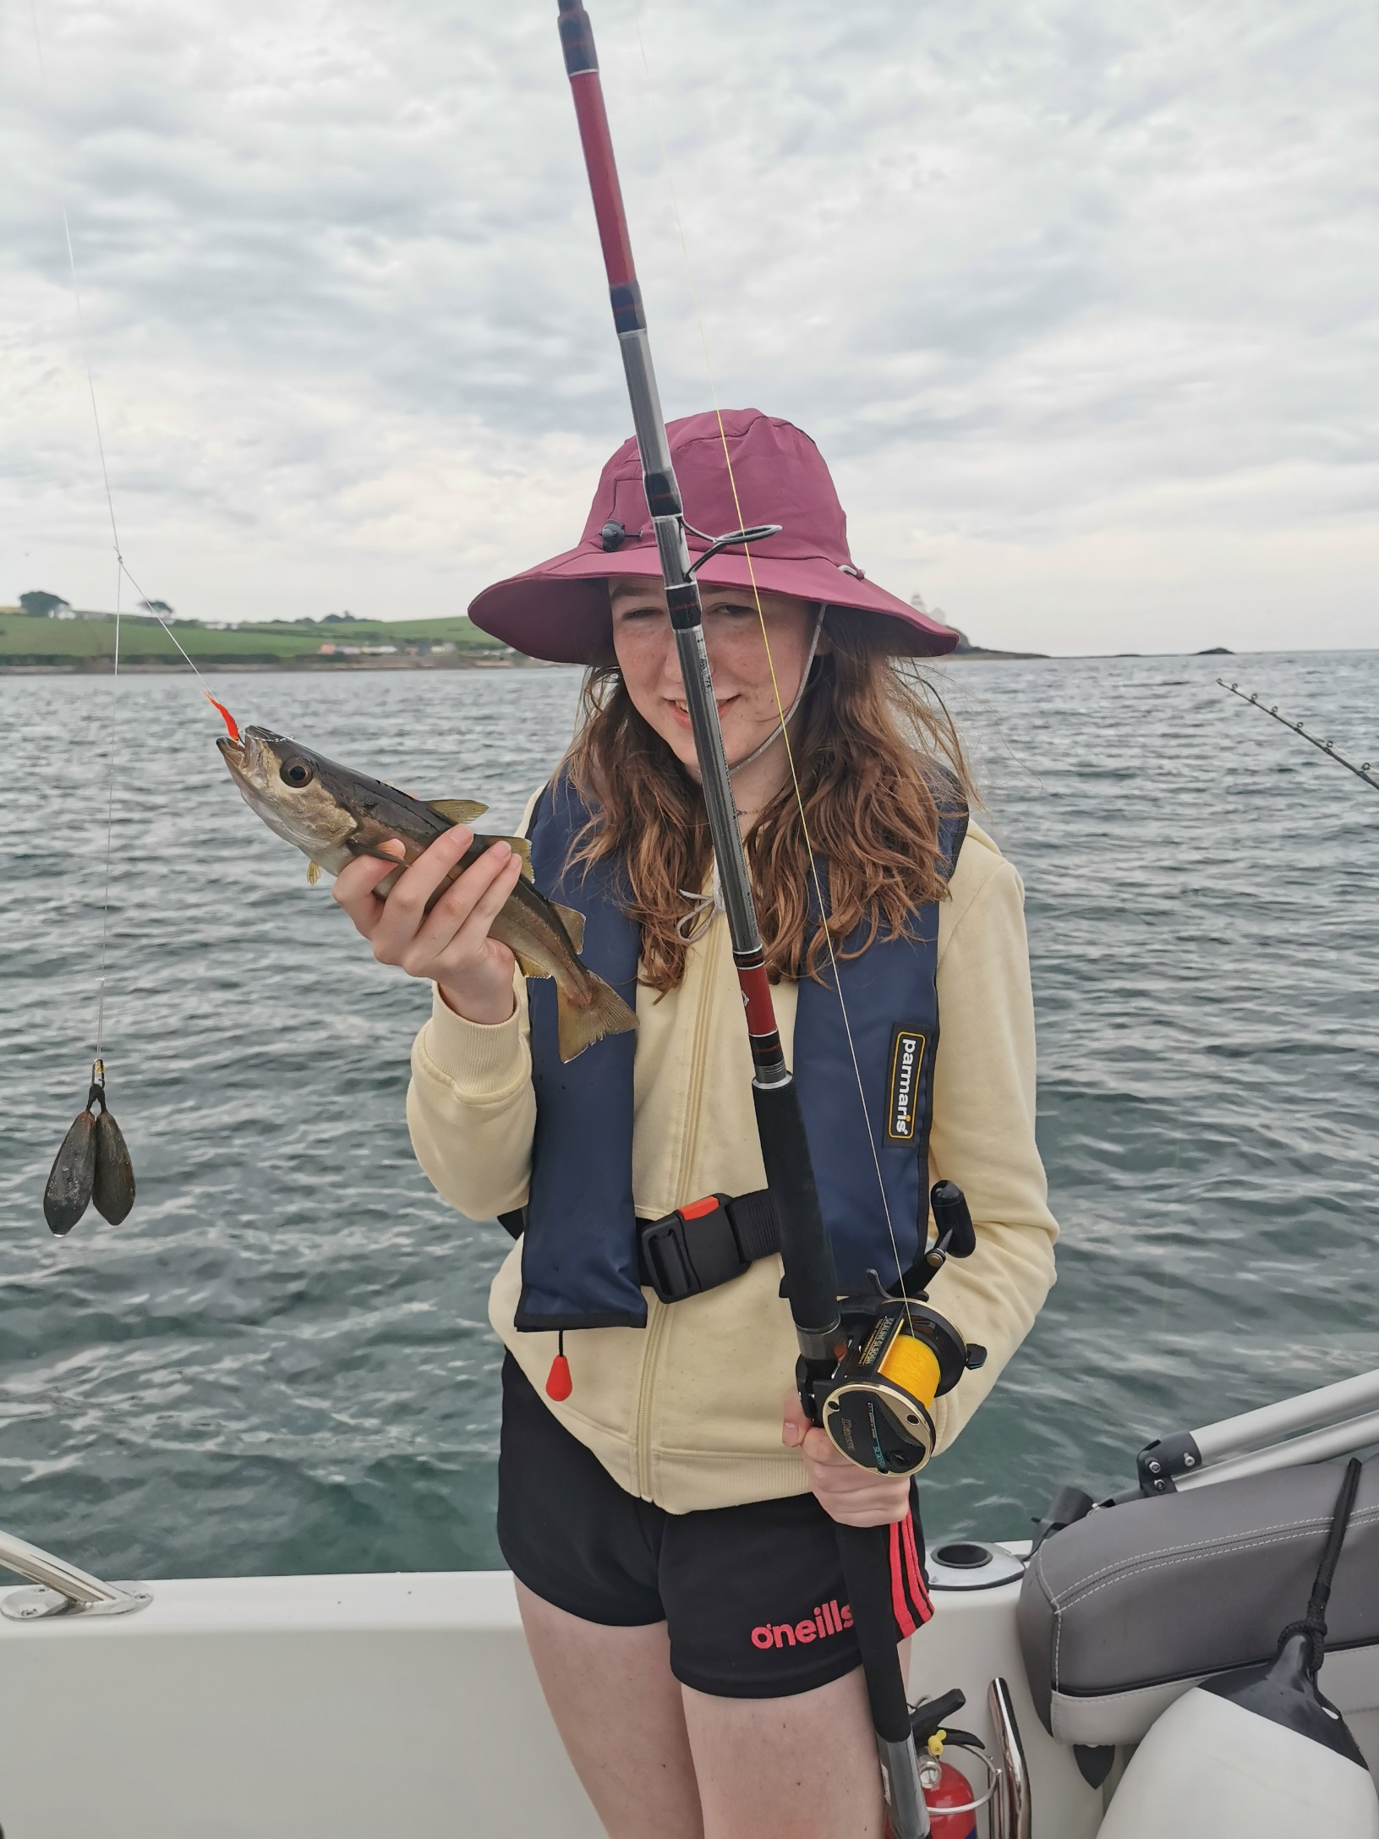
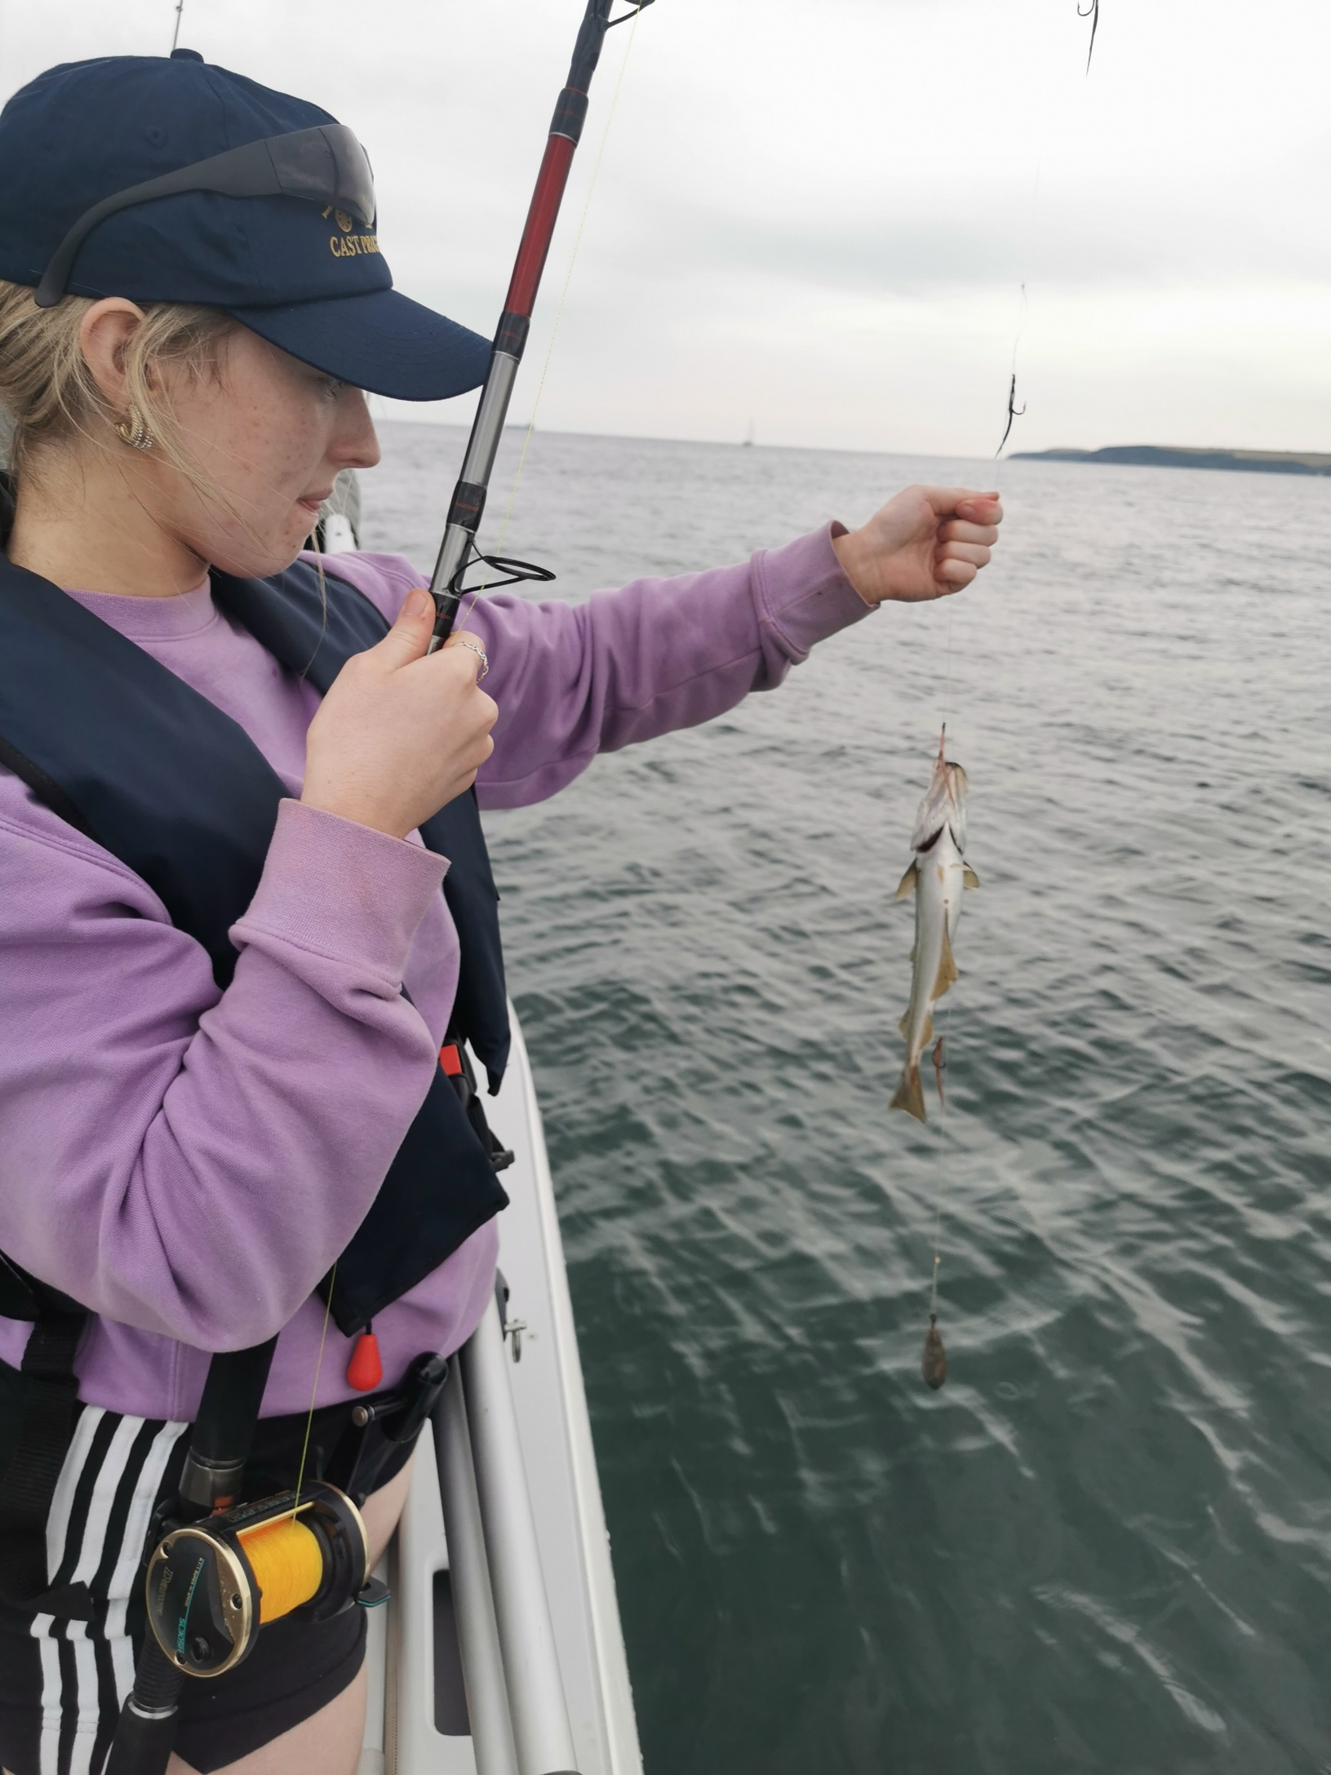

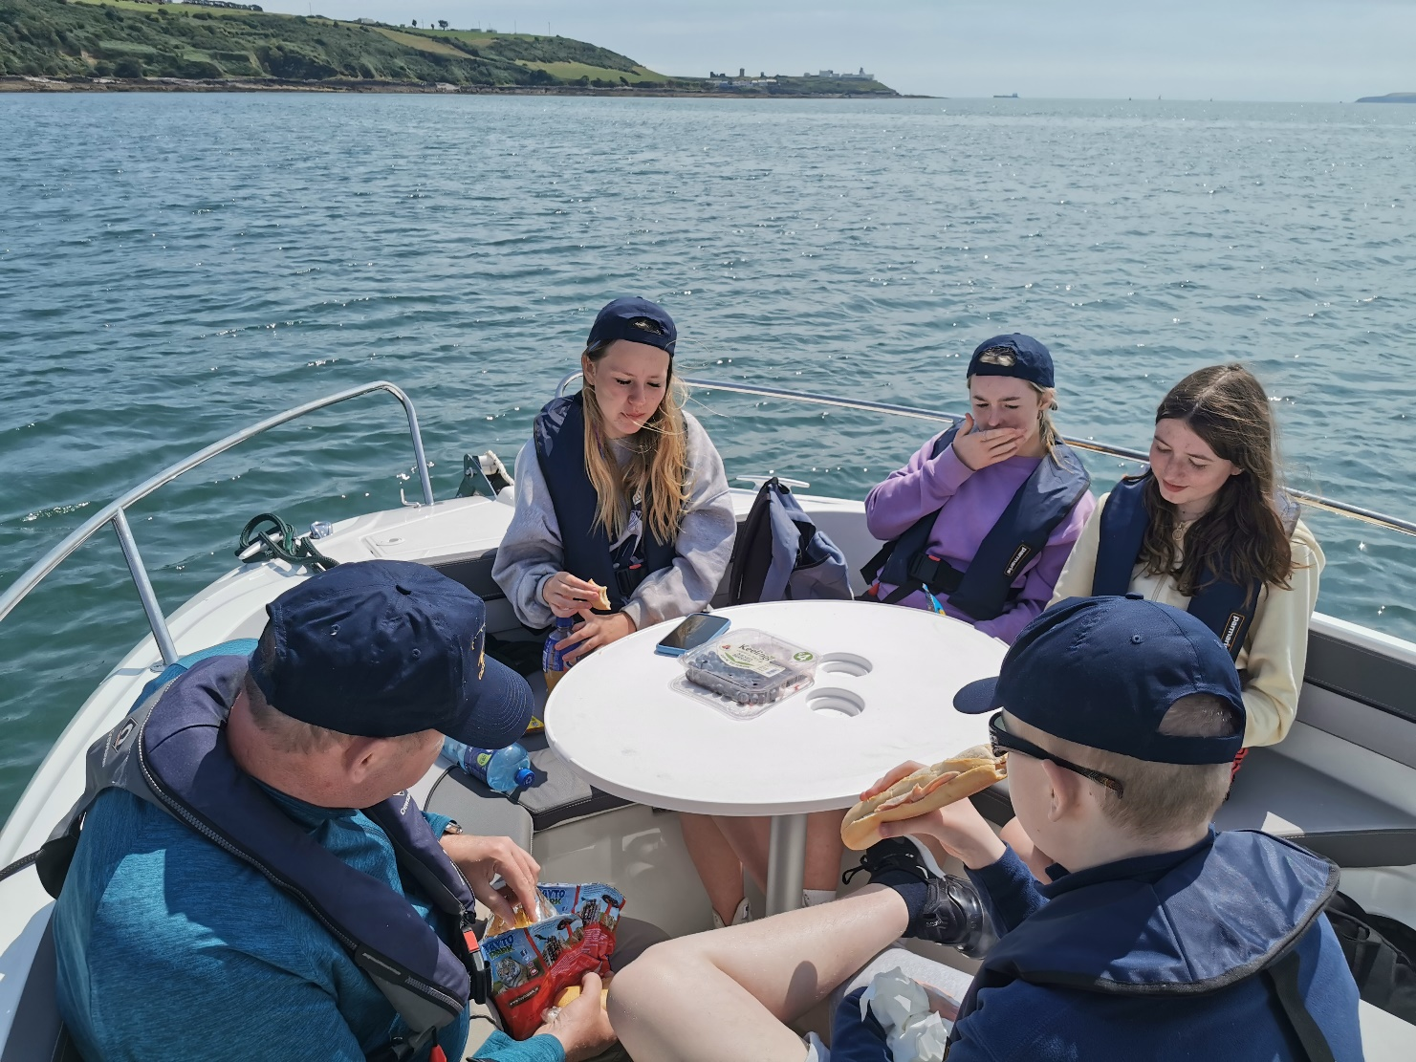

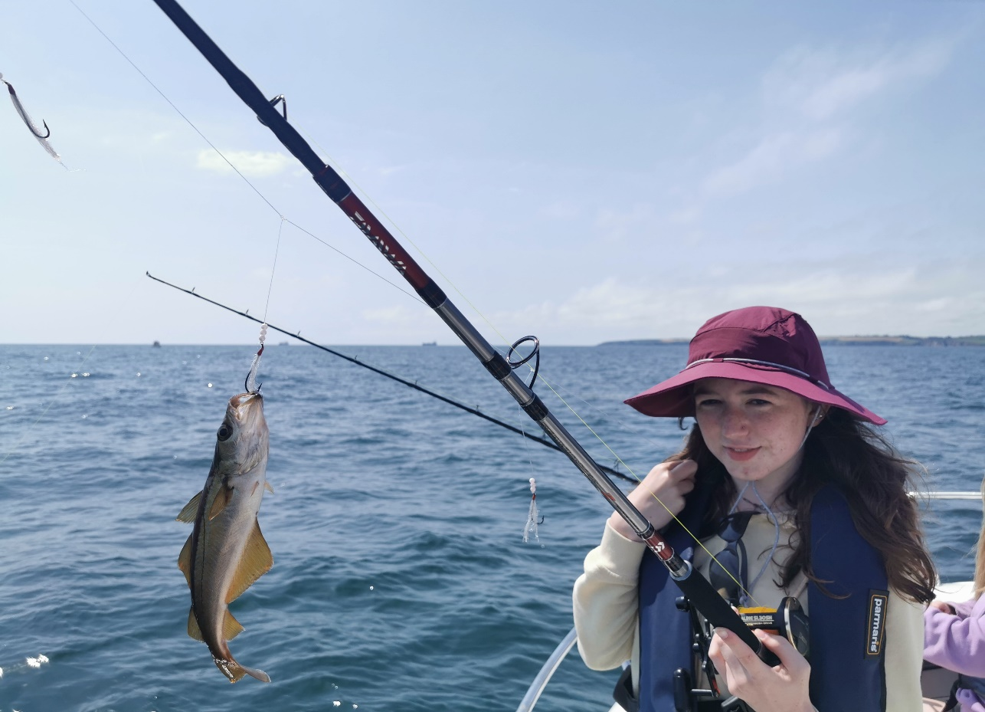

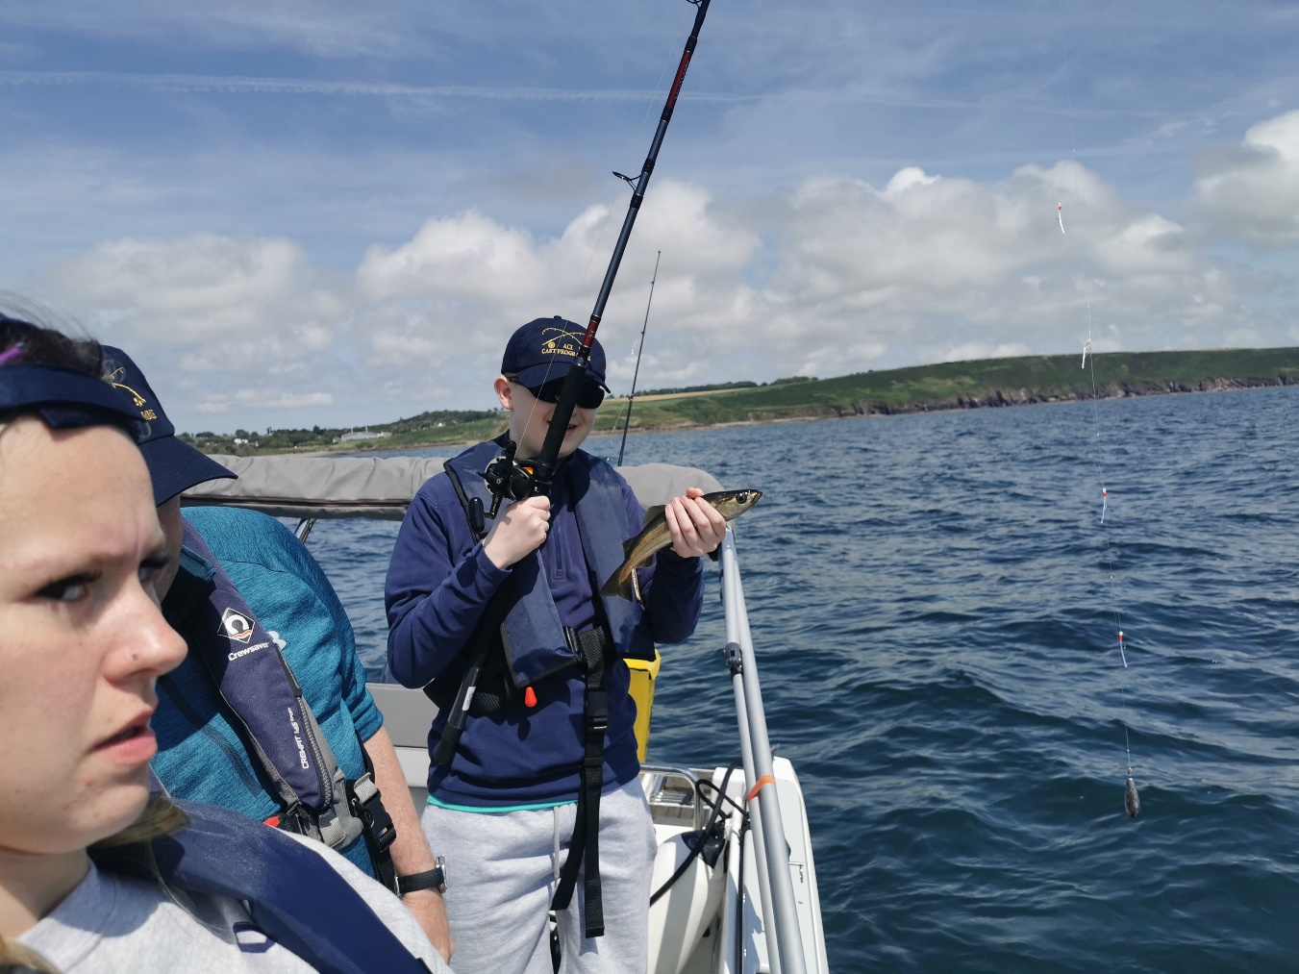

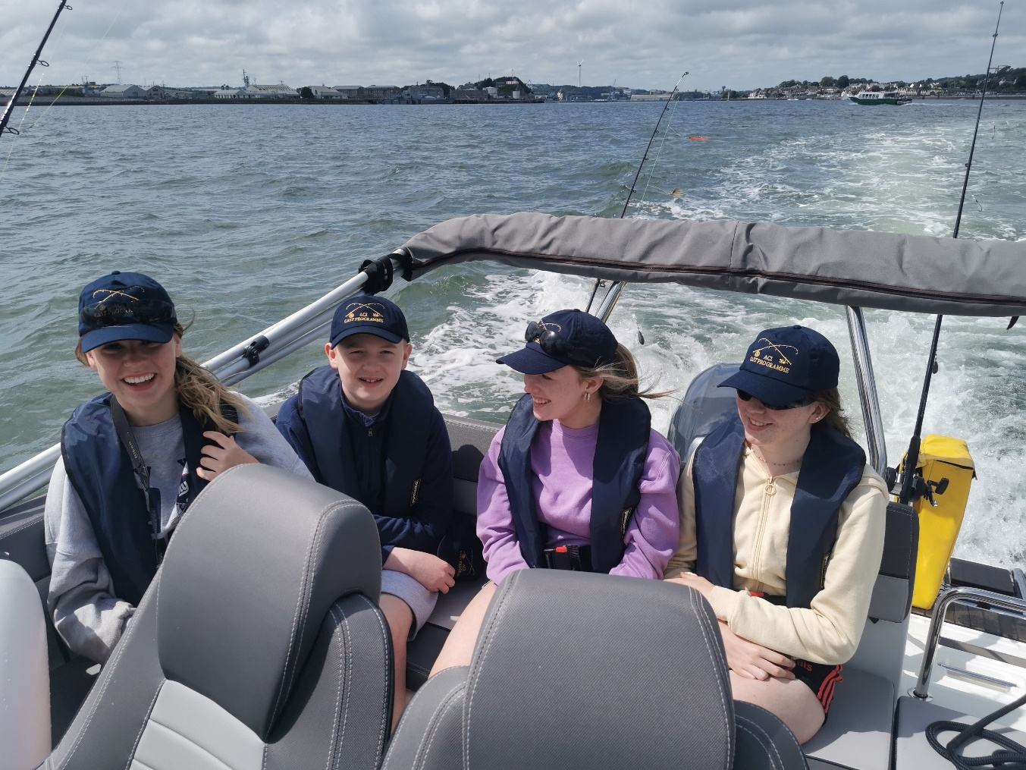

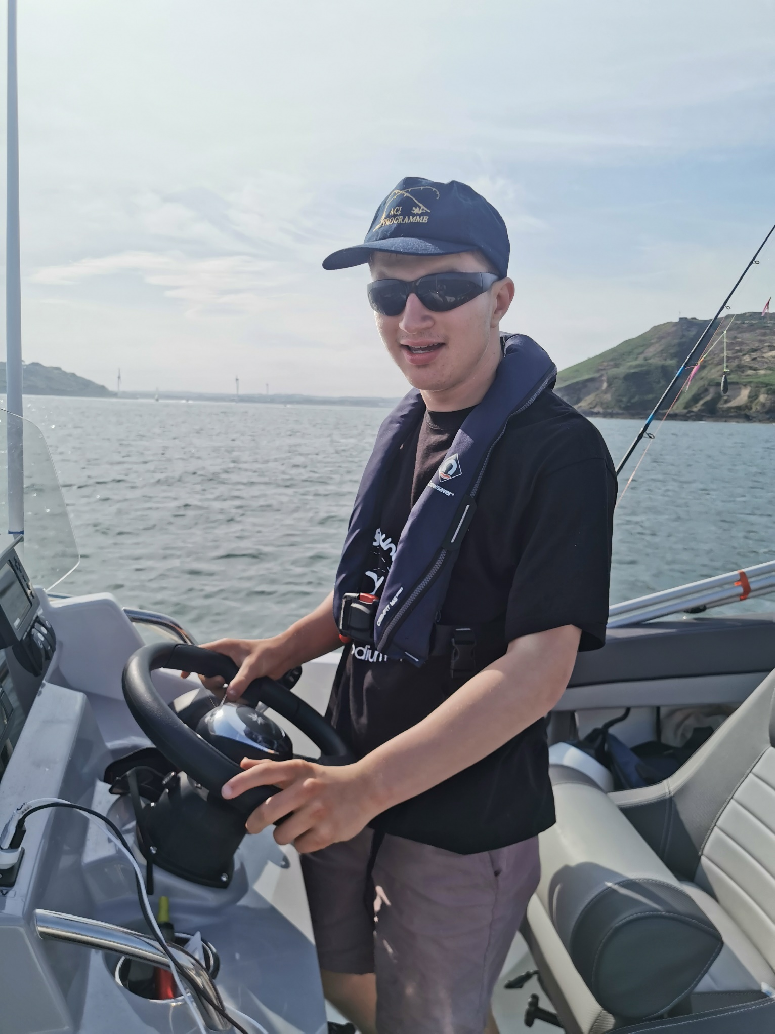

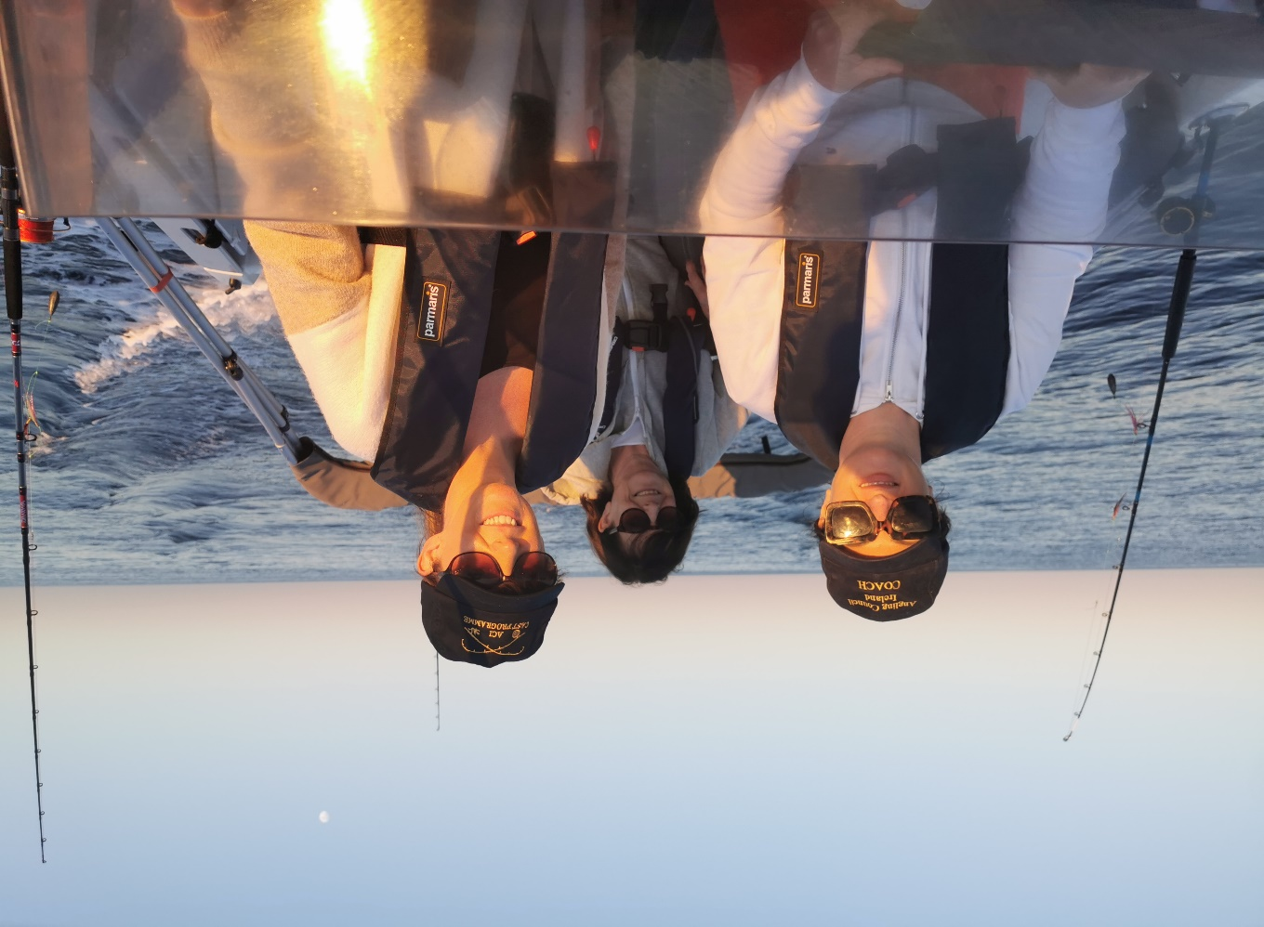

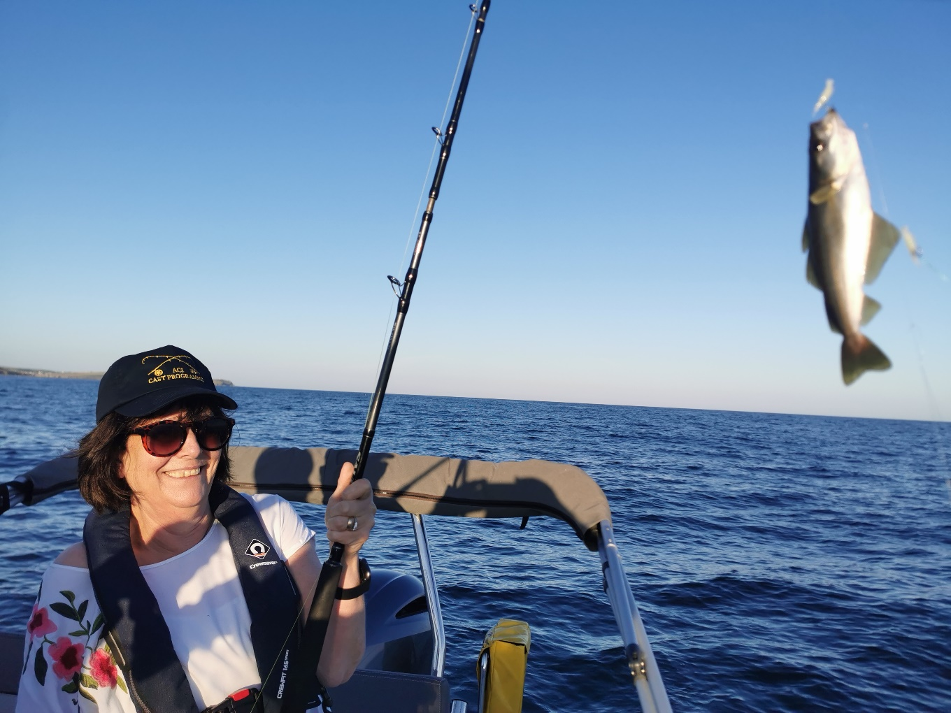
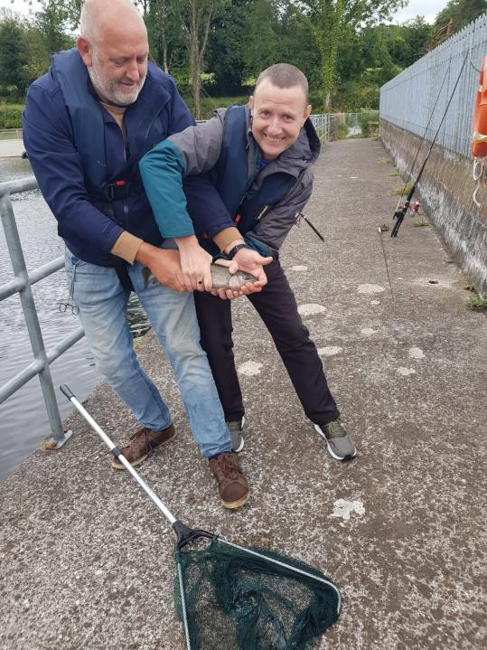
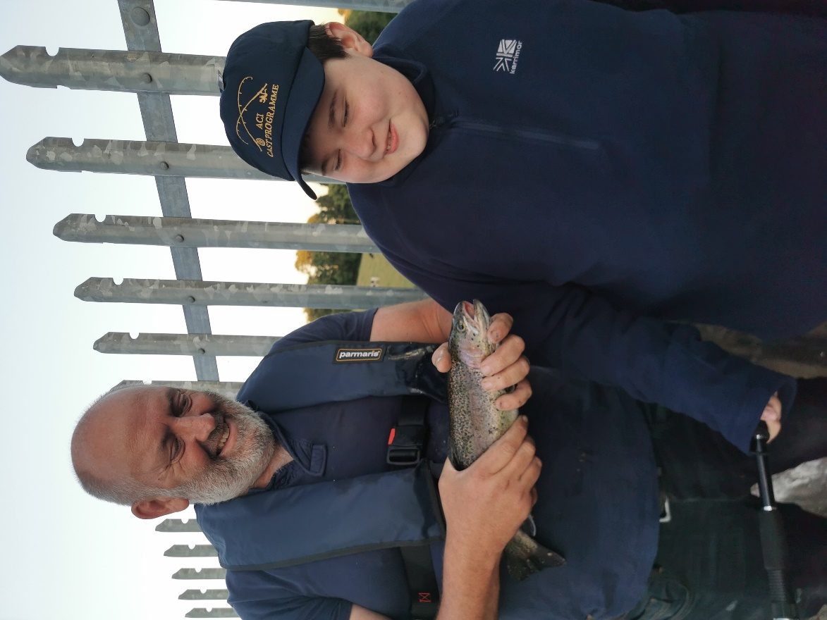

Not sure if they are wrestling or fishing, all smiles.

The fish was handled with wet hands, and they were just being careful to safely return the fish.

